AIR TRAFFIC AND NAVIGATION SERVICES CO. LTD

Request for QUOTATION FOR THE APPOINTMENT OF A SERVICE PROVIDER FOR TRIPOLI NAFISAT TERMINAL INSTALLATION, TESTING AND COMMISSION AT TRIPOLI INTERNATIONAL AIRPORT.

REQUEST FOR QUOTATION NO: ATNS-CS- TRIPOLI NAFISAT-020323

Tripoli NAFISAT VSAT Terminal Installation

Volume 2 - Part 1

TECHNICAL REQUIREMENT SPECIFICATIONS

02 March 2023

The information contained within this document is confidential to ATNS in all respects and it is hereby acknowledged that the information as provided shall only be used for the preparation of a response to this document. The information furnished will not be used for any other purpose than stated and that the information will not directly or indirectly, by agent, employee or representative, be disclosed either in whole or in part, to any other third party without the express written consent by the Company or its representative.

TABLE OF CONTENTS

1. SCOPE 3
2. INTRODUCTION 3
3. RFQ RESPONSE 3
4. requirements for ats/ds CIRCUIT connectivity 4
4.1 ATS/DS Circuit Connectivity 4
4.2 ATS/DS Circuit Requirements for the Tripoli 5
5. requirements for AFTN connectivity 7
5.1 AFTN Circuit Connectivity 7
5.2 AFTN Circuit Requirements for the Tripoli 7
6. requirements for ATN connectivity 10
6.1 ATN Circuit Connectivity 10
6.2 ATN Circuit Requirements for the Tripoli 11
7. requirements for engineering voice and data connectivity 12
7.1 Engineering Circuits Connectivity Requirements for the NAFISAT and SADC/2 Networks 12
8. ATNS vsat network CIRCUIT CONFIGURATIONS 14
8.1 General Requirement 14
8.2 Voice Circuit Requirement for ATS/DS Implementation on the NAFISAT and VSAT Networks 14
8.3 Data Circuit Requirements for AFTN Implementation on the NAFISAT and VSAT Networks 14
8.4 Data Circuit Requirements for ATN Implementation on the NAFISAT and VSAT Networks 14
8.5 Voice and Data Circuit Requirements for Engineering Circuit 15

SCOPE
- Air Traffic and Navigation Services Company Limited (ATNS) will be installing a VSAT terminal in Tripoli for the current private NAFISAT VSAT network that is used for fixed aeronautical ATS/DS, AFTN and ATN communications between main Air Traffic Control Centres in the North East African Regions (I).

- The NAFISAT network is operated and maintained by ATNS from the ATNS operational centre, situated at the OR Tambo International Airport Operational Complex (I).

- The terminal based on the ND Satcom technology platform (I).

INTRODUCTION
- This document describes the technical parameters and requirements for the installation services of the VSAT terminal. Installation services include satellite terminal outdoor and indoor installation, setting to use, training and commissioning.

RFQ RESPONSE
- Bidders shall provide a written response to each paragraph in this Volume 2: Technical Requirement Specifications (M).

- Requirements marked (I) are for information purposes and the bidders are required (M).

- Failure to respond as instructed in 3.1 and 3.2 will result in the bid being regarded as non-responsive and subsequently disqualified.

- Bidders are referred to the relevant paragraphs in Volume 1, stipulating the structure of the response to this tender and are advised to strictly follow these stipulations (M).

- Any additional or supportive information that the Bidder feels is necessary for clarification shall be included and referred to in the response. (M)

requirements for ats/ds CIRCUIT connectivity

ATS/DS Circuit Connectivity
4.1.1 The following diagram shows a graphical representation of the ATNS Network ATS/DS voice requirements within the North East African (NAFISAT) and SADC Regions (I).

ATS/DS Circuit Requirements for the Tripoli
4.2.1 The following diagram shows a graphical representation of the ATS/DS voice communication circuit requirements within the North East African Region. The focus is on Tripoli (M).

COMPLIANCE (C/PC/NC/Noted)

4.2.2 Table 1 below identifies the different ATS/DS voice circuits required from and between the Tripoli Air Traffic Control Centre in the North East African and adjacent Regions. The circuit interconnectivity requirements shall be correlated with the circuits depicted in the graphical representation under paragraph 4.1.1 above (M).
COMPLIANCE (C/PC/NC/Noted)

4.2.3 The ATS/DS circuits as shown shall be catered for (M).
COMPLIANCE (C/PC/NC/Noted)

Table 1: North East African State (Tripoli) ATD/DS communication circuits (NAFISAT Network) (M).

ATS Circuits for Voice Communications |  | VSAT  Network | Comments
Terminal A | Terminal B
Tripoli | Cairo | NAFISAT | To be implemented
 | Khartoum | NAFISAT | To be implemented
 | N’Djamena | NAFISAT & AFISNET | Circuit implemented via MCPC satellite ground terminal equipment installed at Tripoli.
 | Niamey | NAFISAT & AFISNET | Circuit implemented via MCPC satellite ground terminal equipment installed at Tripoli.

COMPLIANCE (C/PC/NC/Noted)

requirements for AFTN connectivity

AFTN Circuit Connectivity

5.1.1 The following diagram shows a graphical representation of the ATNS Network ATN requirements within the North East African (NAFISAT) and SADC Regions (I).

AFTN Circuit Requirements for the Tripoli
5.2.1 The following diagram shows a graphical representation of AFTN data communication circuit requirements within the North East African (NAFISAT) Region (Tripoli).

5.2.2 Table 2 below identifies the different AFTN data circuits required from and between Tripoli Air Traffic Control Centres in the North East African and adjacent Regions. The circuit interconnectivity requirements shall be correlated with the circuits depicted in the graphical representation under paragraph 5.1.1 above (M).
COMPLIANCE (C/PC/NC/Noted)

5.2.3 The AFTN circuits as shown shall be catered for (M).
COMPLIANCE (C/PC/NC/Noted)

Table 2: North East African States (Tripoli) AFTN communication circuits (NAFISAT Network) (M).

Data Circuits for AFTN Communications |  |  | Status | VSAT  Network |  | Remarks
Terminal A |  | Terminal B
LIBYA
Tripoli |  | Cairo | I | NAFISAT |  | To be implemented.
 |  | Khartoum | I | NAFISAT |  | To be implemented.
 |  | N’Djamena | I | NAFISAT & AFISNET |  | Circuit implemented via MCPC satellite ground terminal equipment installed at Tripoli.
 |  | Niamey | I | NAFISAT & AFISNET |  | Circuit implemented via MCPC satellite ground terminal equipment installed at Tripoli.
 | COMPLIANCE (C/PC/NC/Noted)

requirements for ATN connectivity

ATN Circuit Connectivity

6.1.1 The following diagram shows a graphical representation of the ATNS Network ATN requirements within the North East African (NAFISAT) and SADC Regions (I).

ATN Circuit Requirements for the Tripoli
6.2.1 The following diagram shows a graphical representation of ATN data communication circuit requirements within the North East African (NAFISAT) Region. The focus is on Tripoli (M).
COMPLIANCE (C/PC/NC/Noted)

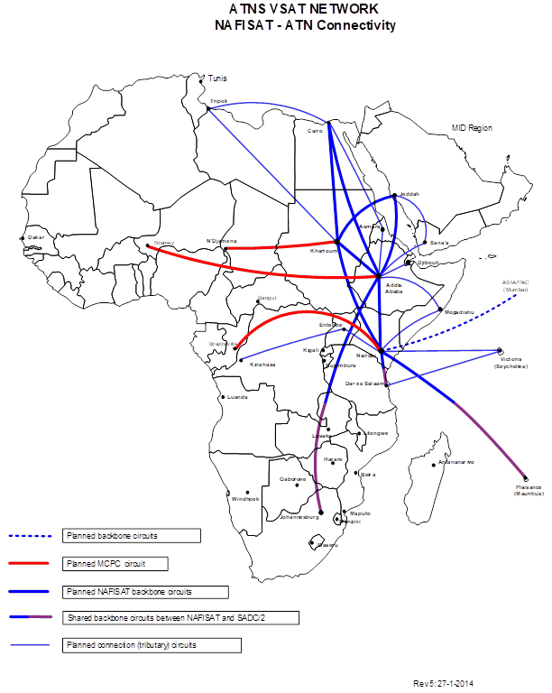

6.2.2 Table 3 below identifies the different ATN backbone data circuits required from and between the main Air Traffic Control Centres in the North East African and adjacent Regions. The circuit interconnectivity requirements with NAFISAT shall be correlated with the circuits depicted in the graphical representation under paragraph 6.1.1 above (M).
COMPLIANCE (C/PC/NC/Noted)

6.2.3 The ATN backbone circuits as shown shall be implemented through the NAFISAT replacement network (M).

COMPLIANCE (C/PC/NC/Noted)

Table 3: North East African States ATN backbone circuits (NAFISAT Network) (M).

Data Circuits for ATN Communications |  | VSAT Network | Comments
Terminal A | Terminal B
LIBYA
Tripoli | Cairo | NAFISAT | To be implemented.
 | Khartoum | NAFISAT | To be implemented.

COMPLIANCE (C/PC/NC/Noted)

requirements for engineering voice and data connectivity

Engineering Circuits Connectivity Requirements for the NAFISAT and SADC/2 Networks
- The following diagram shows a graphical representation of data communication circuit requirements between the ATNS NAFISAT maintenance support centre at Entebbe, Uganda and the ATNS NAFISAT maintenance support centre at Johannesburg engineering voice/speech between the remote sites and Johannesburg (M).
COMPLIANCE (C/PC/NC/Noted)

- Table 4 below identifies the different engineering voice and data circuits required from Tripoli and Johannesburg. (M).
COMPLIANCE (C/PC/NC/Noted)

- The engineering circuits as shown shall be implemented between Tripoli and Johannesburg (M).

COMPLIANCE (C/PC/NC/Noted)

Table 4: Tripoli and Johannesburg engineering circuits (NAFISAT & SADC/2 Network) (M)

Circuits for Data Communications |  |  | VSAT Network |  | Comments
Terminal A |  | Terminal B
UGANDA
SOUTH AFRICA
Johannesburg |  | Tripoli | SADC/2/  NAFISAT |  | Engineering circuits (½ Circuit allocated to NAFISAT, ½ Circuit allocated to SADC/2)
 | COMPLIANCE (C/PC/NC/Noted)

ATNS vsat network CIRCUIT CONFIGURATIONS

General Requirement
8.1.1 It is required that the one VSAT terminal be installed in Tripoli. The paragraphs below provide details of services provided. It is required that the installation will provide the services as described (M).
COMPLIANCE (C/PC/NC/Noted)

Voice Circuit Requirement for ATS/DS Implementation on the NAFISAT and VSAT Networks
8.2.1 The table under paragraph 4.0 above provide detailed information on the ATS/DS direct speech circuits implemented throughout the ATNS VSAT network. All voice circuits used for ATS/DS speech are at least ITU-T CS-ACELP G.729 or G.729A compliant. The end-user equipment are 2-Wire FXS/FXO compliant. Voice circuits are sized at 16 kbps duplex (each ½ circuit 8 kbps) (M).
COMPLIANCE (C/PC/NC/Noted)

Data Circuit Requirements for AFTN Implementation on the NAFISAT and VSAT Networks
8.3.1 The tables under paragraphs 5.0 above provide detailed information on the AFTN data circuits implemented throughout the ATNS VSAT network. The end-user AFTN equipment are RS-232 V.24/V.28 asynchronous serial data compliant. AFTN data circuits are sized at a maximum transmission burst rate of 9.6 kbps. The existing AFTN services shall be kept. (M).
COMPLIANCE (C/PC/NC/Noted)

Data Circuit Requirements for ATN Implementation on the NAFISAT and VSAT Networks
The tables under paragraph 6.0 above provide detailed information on the ATN data circuits required to be implemented through the ATNS VSAT network.

8.4.1 ATN backbone data circuits shall be deployed for IP based applications. Main ATN backbone circuits shall be sized at a transmission rate of 64 kbps or 19.2 kbps. A cross reference matrix shall be provided detailing the number of higher speed data ports per remote VSAT site (M).
COMPLIANCE (C/PC/NC/Noted)

8.4.2 ATN terminal or tributary data circuits shall be deployed for IP based applications. Secondary ATN terminal or tributary circuits shall be sized at a transmission rate of 9.6 kbps. A cross reference matrix shall be provided detailing the number of lower speed data ports per remote VSAT site (M).
COMPLIANCE (C/PC/NC/Noted)

Voice and Data Circuit Requirements for Engineering Circuit
8.5.1 Table 4 under paragraph 7.0 above provide detailed information on the existing engineering data circuit implemented between the Entebbe Standby Master site and the Johannesburg Master site. All engineering data circuits are V.35 and/or X.21, X.27 (V.11) HDLC type synchronous serial data compliant. Engineering data circuits are sized at a maximum transmission burst rate of 64 kbps. (M).
COMPLIANCE (C/PC/NC/Noted)

8.5.2 Table 4 under paragraph 7.0 also provides detailed information on the engineering voice circuits implemented between the Entebbe site and the Johannesburg site. All engineering voice circuits are at least ITU-T CS-ACELP G.729 or G.729A compliant. Only 2-Wire FXS/FXO are be provided. Voice circuits are sized at 16 kbps duplex (each ½ circuit 8 kbps). (M).

COMPLIANCE (C/PC/NC/Noted)

