Request for Quotation for goods and services for Air Traffic and Navigation Services
RFQ REFERENCE NUMBER: | ATNS/FALE/RFQ146/09/05/2023/2024 Fire Detection & Suppression and PA System
ISSUE DATE: | 11 May 2023
CLOSING DATE: | 30 May 2023
CLOSING TIME: | 12h00, CAT
COMPULSORY BRIEFING SESSION AND SITE INSPECTION: | Date: 24 May 2023  Time: 10h00 am  Venue: ATNS Control Tower  King Shaka Int. Airport,  International Trade Avenue,  Tongaat, Durban  29°36'27.8"S 31°06'42.6"E
QUOTATION VALIDITY PERIOD: | 60 Days
DESCRIPTION: | APPOINTMENT OF A SERVICE PROVIDER TO PROVIDE FIRE DETECTION & SUPPRESSION SYSTEM, FIRE FIGHTING EQUIPMENT SERVICE & PA SYTEM @ FALE CONTROL TOWER AND BLUFF RADAR FOR A PERIOD OF ONE (1) YEAR.
RFQ DOCUMENTS MAY BE ADDRESED TO: | Procurement Officer: Thoko Phukubye  Email address: RFQs@atns.co.za  NB: Please note our emails can only receive documents that are less 40MB, if documents are more, please send them in separate emails  NB: All responses must be submitted on the above dedicated mailbox. No hand delivery submissions will be considered.
REQUIRED RETURNABLE DOCUMENTS: | - Central Supplier Database (CSD) Report  - Duly completed and signed SBD Forms (SBD1, SBD 4, SBD 6.1)  - General conditions of contracts (GCCs) -Initialled and signed.  - ATNS Completed pricing schedule
REQUIRED ADMINISTRATIVE PRE-QUALIFICATION DOCUMENTS: | - Valid Tax Pin Status  - Valid B-BBEE Certificate or Sworn Affidavit – Certified  - Banking Details with a Bank Stamp  - Quotation on the Company Letterhead  - CIPC registration Documents
MANDATORY DOCUMENTS:  NB: FAILURE TO SUBMIT ALL OF THESE DOCUMENTS WILL RESULT ON YOUR QUOTATION BEING DISQUALIFIED. | - Provide five (5) letters of proof of Previous Relevant experience with contactable references. References must be in a form of a signed reference letters on a client’s business letterhead stating the scope and description of the services rendered, contract duration, with contact name, Contact number and position of the referee. Reference letters must not be older than 3 years by closing date of this RFQ.  - Providing a company profile indicating number of years rendering Fire suppression & detection system, Fire fighting equipment and PA System Maintenance Services, in a public and /or corporate sector (Required: Minimum 3 years.  - One Qualified SAQCC-Fire. ( Valid SAQCC - Commissioner level in detention and gas suppression) Min. 3 years experience.
PLEASE NOTE:

ATNS RESERVES THE RIGHT TO APPOINT MORE THAN ONE SERVICE PROVIDERS
Procurement Officer: | Thoko Phukubye
Telephone: | 011 607 1000
E-mail: | RFQs@atns.co.za
The ATNS requests your quotations on the services listed hereunder and/or on the available RFQ forms. Please furnish all information as requested and return your proposal on the date stipulated. Late submissions will not be considered. Incomplete / missing documentations will invalidate the proposal submitted. ATNS is not obliged to accept the lowest or any submission received. ATNS reserves the rights to accept the whole or any portion of a quotation.
This RFQ will be evaluated on the basis of the 80:20 preference point system as stipulated in the ATNS’ Procurement Policies and Procedures.

BIDDING STRUCTURE
Indicate the type of Bidding/Tendering Structure by marking with an ‘X’
Individual Bidder
Joint Venture
Consortium
With Sub-Contractors
Other
If Individual:
Name of Bidder
Registration Number
VAT Registration Number
Contact Person
Telephone Number
Fax Number
Cell Number(s)
E-mail Address
Postal Address
Physical Address
If Joint Venture or Consortium, indicate the name/s of the partners:
Company Name
Registration Number
VAT Registration Number
Contact Person
Telephone Number
E-mail Address
Fax Number
Postal Address
Physical Address

ANNEXURE A - SCOPE OF WORK

- SCOPE OF WORK

Appointment of a service provider is to provide for fire detection & suppression system, fire fighting equipment service, PA sytem for a period of One (1) year.

- OBJECTIVES

  - Fire detention & suppression system, Firefighting equipment bid is aimed at assisting ATNS accomplish its risk management objectives by ensuring that all ATNS King Shaka Int. Airport fire detention & suppression systems, firefighting equipment, and PA system are maintained, serviced, repaired and restored to their normal operating conditions.

  - The objective of this bid is to appoint a suitable fire detention & suppression system, firefighting equipment and PA system routine service and maintenance provider that can provide assurance to ATNS Management in discharging its responsibilities regarding fire detention & suppression system, firefighting equipment and PA system maintenance services. The bidder must demonstrate the capability to perform effective fire detention & suppresssion systems, firefighting equipment and PA system maintenance service in accordance with all legal and statutory requirements.

- DURATION OF THE CONTRACT

  - Service providers are herewith invited to submit proposal for the fire detetction & suppression systems, firefighting equipment and PA system at ATNS King Shaka International Airport local/ Bluff sites for a period of one (1) year.

- FORMAL BRIEFING

  - A compulsory pre-quotation site meeting and/or RFQ briefing will be conducted at the ATNS
- Offices: King Shaka Int. Airport,International Trade Avenue,Tongaat, Durban, on the 24th of May 2023, at 10h00 for a period of ± 2 hours.
- The briefing session will begin on time, and information will not be repeated for the advantage of bidders who arrive late.
- Failure to attend the to attend the compulsory RFQ briefing will result in disqualification.
- Bidders are encouraged to bring a copy of the RFQ to the site meeting and/or RFQ briefing.

ANNEXURE B

- THE PROPOSALS SHOULD BE FOR THE FOLLOWING:

  - Maintenance Services of the ATNS King Shaka Int Airport local/ Bluff Radr sites fire detection & suppression system and firefighting equipment; (fire detention & suppression systems Routine Checks are to be done every three (3) months – Quarterly Basis; details are listed hereto as APPENDIX A, Table A1 or as agreed with King Shaka Management). Also populate costing on APPENDIX B, table B1.

  - Quarterly Fire detention & suppression System Maintenance services: Bluff Radar sites (details are listed hereto as APPENDIX A, Table A2). Also populate costing on APPENDIX B, table B2.

  - Yearly servicing of Fire extinguishers, Fire Hoses and Fire hydrants (details are listed hereto as APPENDIX A, Table A3). Also populate costing on APPENDIX B, table B3.

  - Conduct AD-HOC Fire detention & suppression system and firefighting equipment repairs requested by management on quotation basis (populate costing on APPENDIX B, table B4). This includes callout and emergency responses.

  - Carry out any additional work over and above the scheduled maintenance service, which ATNS may require to maintain the sites in a proper and safe working condition.

  - Attendance and reporting to the ATNS King Shaka International Airport Management on a quarterly basis after inspection and service for any significant findings identified during the service and maintenance activities.
  - Supply any parts or components that may be required for maintenance purpose, during the period of this agreement.(market related prices)

  - If uneconomical to maintain or to repair; Supply new fire suppression & detetion systems, firefighting equipment Unit and PA system Item to replace the failed units on critical equipment and buildings.

  - Commissioning of the new fire suppression & detention system or firefighting equipment Unit and provide site acceptance test documents.

  - Recommend on required repairs after maintenance/inspections.

  - Conduct all necessary repair installation and provide certificate of compliance when necessary.

  - Provide a 12 Month maintenance and guarantee on all new installations.

- GENERAL

  - Provide all materials, labour, and transport to complete maintenance, the removal of existing items/units and the installation of the new items/units.

  - In the case of new installations; The contractor must remove existing items/units and install new units and leave area of work neat and tidy on completion. Disposed the replaced item and provide disposal certificates.

  - Provide quoted prices which is inclusive of all items (preparation, material, labour and transport costs).

  - Provide quoted price which Include VAT and be valid for 180 days from closing date of the quotation.

- DELIVERIES OF GOODS

  - Deliveries must take place within 7 working days of placing an official order, except in emergency circumstance; delivery must be immediate.

  - The service provider shall at all times remain fully and solely responsible for the timeous delivery of service/goods to ATNS.

  - Delivery address is ATNS Control Tower, King Shaka International Airport, International Trade Avenue, Tongaat, Durban. A special arrangement will be made for deliveries at remote sites.

  - Delivery of products must include the off-loading thereof at the service provider’s own risk and cost to the designated delivery addresses as indicated above.

  - Service provider must supply and ensure their own labour for the offloading of the products at the designated ATNS sites.

  - ATNS King Shaka will place orders as and when required during the contract period.

  - An official order must be issued before any delivery may be made to ATNS King Shaka Control Tower; Unless in an emergency.

- QUALITY

  - Quality Standards

    - In the event where ATNS King Shaka elects to accept an alternative item purported to be equal/similar by the tenderer, acceptance of the item(s) will be conditional on ATNS’s inspection and testing after receipt.

    - If, in the sole judgment of ATNS, the delivered items are determined not to be within SABS/SANS national specifications, the supplier will be requested to replace the items with the items that complies with SABS/SANS national specifications immediately at no additional cost to ATNS.

    - ATNS may from time to time test the quality of the products and services, non-compliance may result in the termination of the contract.

    - All product items should carry (minimum of 1 year) guarantees or warrantees and defects items will be replaced at the cost of the service provider. It will be the responsibility of the service provider to ensure that the products are replaced (Retailers to Manufacturers), where applicable.

- CONTRACTORS’ RESPONSIBILITIES

  - The Contractor shall

    - Provide all the necessary skills, resources, tools, equipment and experts, to carry out the works; as a minimum requirement, the successful supplier are to have a Qualified SAQCC personnel (commissioner level gas suppression and detention).

    - Review, familiarize and understand the proposed sites including all constraints and environmental factors.

    - Review, familiarize and understand the operational requirements of the facilities at all ATNS sites.

    - Conduct any other reasonable works required to successfully deliver the services to the Employer on time, on budget, at the accepted quality.

    - Hand over all documentation including condition reports after services, repairs and installations

    - Provide the list of items kept in the client premises,including contact numbers for reporting corrective faults .

    - Access permits should solely be service provider responsibility including the cost.

- TECHNICAL SPECIFICATIONS

  - ATNS local sites fire suppression systems

    - Below table is ATNS local sites fire detention & suppression systems details - Quarterly Service.

Area | QTY | Date of last HTP | Sizes | Additional Requirements
King Shaka Main Tower – Floor & Tower Staircase
FM 200 (HFC 227ea) | 5 | 16/08/2009 | 41kg
FM 200 (HFC 227ea) | 5 | 19/07/2018 | 70kg
King Shaka OPS Centre - ERB
FM 200 (HFC 227ea) | 4 | 11/09/2009 | 43kg
King Shaka OPS Centre Reception/Canteen Foyer Cable Shaft - Floor
FM 200 (HFC 227ea) | 6 | 11/09/2009 | 11kg
King Shaka OPS Centre – Gas Compartment – Outside ERA (ERA & UPS Room)
FM 200 (HFC 227ea) | 2 | 04/09/2019 | 175kg
FM 200 (HFC 227ea) | 2 | 04/09/2019 | 155kg
FM 200 (HFC 227ea) | 1 | 04/09/2019 | 121kg
TOTAL: | 25
Table A 1: ATNS local sites fire suppression systems details

  - ATNS Bluff site fire suppression systems

    - Below table is ATNS remote site fire suppression systems details - Quarterly Service. Requires site visit every quarter. The Distance to the remote sites is measured from King Shaka international airport.

Site | QTY | Date of last HTP | Sizes | Additional Requirements
Bluff Radar (70km)
FM 200 (HFC 227ea) | 1 | 21/08/2020 | 251kg
FM 200 (HFC 227ea) | 1 | 21/08/2020 | 20kg
TOTAL: | 2
Table A 2: ATNS remote sites fire suppression systems details

  - ATNS fire extinguisher service and certification

    - Below table is ATNS fire extinguisher service and certification details - Yearly Service

ITEMS | QTY
5KG CO2 | 30
2.5KG DCP | 15
HOSE REEL | 8
BUILDING HYDRANT | 1
HYDRANT VALVE/CONNECTOR | 2
9KG DCP | 15
3KG | 2
4.5KG CO2 | 5
1KG DCP | 2
Total | 80
Table A 3: ATNS fire extinguisher service and certification detai

ANNEXURE C

PRICING SCHEDULe

- ATNS King Shaka OPS Centre site fire detention & suppression, PA systems

  - Below is ATNS local sites fire suppression systems costing table (Costs must be VAT Inclusive) - Quarterly Service

Table B 1: ATNS OPS Building fire detention & suppression systems costing

ATNS KING SHAKA OPS CENTRE SITES FIRE SUPPRESSION SYSTEMS - MAINTENACE COST SCHEDULE
Area | QTY | Year 1 |  | Year 2 |  |  |  |  | Year 3 |  |  | Year 4 |  |  |  | Year 5
 |  | Price per Qtr | Total price - 4 Qtr's | Annual Cost Year 1 |  | Price per Qtr | Total price - 4 Qtr's | Annual Cost Year 2 | Price per Qtr | Total price - 4 Qtr's | Annual Cost Year 3 | Price per Qtr | Total price - 4 Qtr's | Annual Cost Year 4 |  | Price per Qtr | Total price - 4 Qtr's | Annual Cost Year 5
King Shaka Main Tower – Floor & Tower Staircase
FM 200 (HFC 227ea) | 5 | R | R | R | R |  | R | R | R | R | R | R | R | R |  | R | R | R
FM 200 (HFC 227ea) | 5 | R | R | R | R |  | R | R | R | R | R | R | R | R |  | R | R
King Shaka OPS Centre - ERB
FM 200 (HFC 227ea) | 4 | R | R | R | R |  | R | R | R | R | R | R | R | R |  | R | R | R
King Shaka OPS Centre Reception/Canteen Foyer Cable Shaft - Floor
FM 200 (HFC 227ea) | 6 | R | R | R | R |  | R | R | R | R | R | R | R | R |  | R | R | R
King Shaka OPS Centre – Gas Compartment – Outside ERA (ERA & UPS Room)
FM 200 (HFC 227ea) | 2 | R | R | R | R |  | R | R | R | R | R | R | R | R |  | R | R | R
FM 200 (HFC 227ea) | 2 | R | R | R | R |  | R | R | R | R | R | R | R | R |  | R | R | R
FM 200 (HFC 227ea) | 1 | R | R | R | R |  | R | R | R | R | R | R | R | R |  | R | R | R
Totals R |  |  | R | R | R |  | R | R | R | R | R | R | R | R | R |  | R | R
OVERALL TOTAL COST FIRE SUPPRESSION SYSTEMS SUPPORT |  |  |  |  |  |  |  |  |  |  |  |  |  |  |  |  | R

- ATNS Bluff Radar site fire detentionsuppression system and PA System

  - Below is ATNS remote site fire detention & suppression systems and OPS Building PA system costing(BiAnnual service) table (Costs must be VAT Inclusive) - Quarterly Service. Requires site visit every quarter. The Distance to the remote sites is measured from ATNS Control Tower, King Shaka international Airport.

Table B 2: ATNS Bluff Radar fire detention & suppression, PA systems costing:
ATNS BLUFF RADARSITE FIRE SUPPRESSION SYSTEMS - QUARTERLY SERVICE
Area | QTY | Year 1 |  |  | Year 2 |  |  |  | Year 3 |  |  | Year 4 |  |  | Year 5
 |  | Price per Qtr | Total Cost - 4 Qtr's | Annual Cost Year 1 | Price per Qtr | Total Cost - 4 Qtr's | Annual Cost Year 2 | Price per Qtr | Price per Qtr | Total Cost - 4 Qtr's | Annual Cost Year 3 | Price per Qtr | Total Cost - 4 Qtr's | Annual Cost Year 4 | Price per Qtr | Total Cost - 4 Qtr's | Annual Cost Year 5
Bluff Radar (70km)
FM 200 (HFC 227ea) | 1 | R | R | R | R | R | R |  | R | R | R | R | R | R | R | R | R
FM 200 (HFC 227ea) | 1 | R | R | R | R | R | R |  | R | R | R | R | R | R | R | R | R
TOTAL: R |  |  | R | R | R | R | R | R |  | R | R | R | R | R | R | R | R
OVERALL TOTAL COST FIRE SUPPRESSION SYSTEM SUPPORT |  |  |  |  |  |  |  |  |  |  |  |  |  |  |  | R
ATNS OPS BUILDING PA SYSTEM - BIANUUAL SERVICE
Area | QTY | Year 1 |  |  | Year 2 |  |  |  | Year 3 |  |  | Year 4 |  |  | Year 5
 |  | Bi Annual 1 | Bi Annual 2 | Annual Cost Year 1 | Bi Annual 1 | Bi Annual 2 | Annual Cost Year 2 | Price per Qtr | Bi Annual 1 | Bi Annual 2 | Annual Cost Year 3 | Bi Annual 1 | Bi Annual 2 | Annual Cost Year 4 | Bi Annual 1 | Bi Annual 2 | Annual Cost Year 5
ATNSOPS BLD | 1 | R | R | R | R | R | R |  | R | R | R | R | R | R | R | R | R
TOTAL COST PA SUPPORT |  |  |  |  |  |  |  |  |  |  |  |  |  |  |  | R

- ATNS fire extinguisher service and certification

FIRE EXTINGUISHER SERVICE AND CERTIFICATION - YEARLY SERVICE
ITEMS |  |  | QTY |  | Year 1 | Year 2 | Year 3 | Year 4 | Year 5
5KG CO2 |  |  | 30 |  | R | R | R | R | R
2.5KG DCP |  |  | 15 |  | R | R | R | R | R
HOSE REEL |  |  | 8 |  | R | R | R | R | R
BUILDING HYDRANT |  |  | 1 |  | R | R | R | R | R
HYDRANT CONNECTOR/VALVE |  |  | 2 |  | R | R | R | R | R
3KG CO2 |  |  | 3 |  | R | R | R | R | R
9KG DCP |  |  | 15 |  | R | R | R | R | R
4.5KG CO2 |  |  | 5 |  | R | R | R | R | R
1KG DCP |  |  | 2 |  | R | R | R | R | R
TOTAL EACH YEAR (VAT INCLUSIVE): |  |  |  |  | R | R | R | R | R
OVERALL TOTAL FIRE EXTINGUISHER SERVICE AND CERTIFICATION OVER 5 YEARS |  |  |  |  |  |  |  | R
  - Below is ATNS fire extinguisher service and certification costing table (Costs must be VAT Inclusive) - Yearly Services
Table B 3: ATNS fire extinguisher service and certification costing, Supplier must cost per unit, as per table below

- AD-HOC Repairs Services

  - Supplier are to provide AD-HOC (As and When Required)service costing table containing call out rates, repair hourly rates, travel rates per kilo, Pressure testing rates, Refilling rates at any listed ATNS site as required (Costs must be VAT inclusive).
ITEMS |  | Year 1 | Year 2 | Year 3 | Year 4 | Year 5
Normal Hours | Repairs hours within Normal Time (Labour Hourly Rate) 07:30 - 16:00 (VAT Inclusive) | R | R | R | R | R
 | Pressure testing rates Per Bottle (Labour Hourly Rate) 07:30 - 16:00 (VAT Inclusive) | R | R | R | R | R
 | Refilling rates per bottle (Labour Hourly Rate) 07:30 - 16:00 (VAT Inclusive) | R | R | R | R | R
After Hours (Overtime) | Fire Detention & Suppression,PA Systems Repairs outside Normal Time (Labour Hourly Rate) After 16:00 (VAT Inclusive) | R | R | R | R | R
Saturdays | Fire Detention & Suppression, PA Systems Repairs outside Normal Time (Labour Hourly Rate) (VAT Inclusive) | R | R | R | R | R
Holidays/ Sundays | Fire Detention & Suppression, PA Systems Repairs outside Normal Time (Labour Hourly Rate) (VAT Inclusive) | R | R | R | R | R
Travelling Rates | The cost of all travelling (Rate/Kilometer) | R | R | R | R | R
Table B 4: Ad-Hoc Costing for during the week

- PA System

  - RCF PA SYSTEM-SE5120/SE5121-LIFE SAFETY VOICE ALARM SYSTEM
    - Ad-hoc repair services (repairs rates will align to the rates on 4.1 rating) (as & when required)
    - Repair spares quotation will be issued than PO granted for spares
Biannual inspection and service on the PA system annually
    - Corrective faults in between services must be attended when reported.

  - Speaker type for each room and pictures provided below:
 | PA SYSTEM SPEAKER TYPE REPORT
ROOM NO. | BUILDING LOCATION | SOUND AVAILABILITY
 | TOWER CONTROL CENTRE | 5 SPEAKERS AVAILABLE
 | TOWER RESTROOM | 2 SPEAKERS
 | TOWER KITCHEN AREA | 1 SPEAKER
 | TOWER MALE TOILET | 1 SPEAKER
 | TOWER FEMALE TOILET | 1 SPEAKER
 | SAWS OFFICE (TOWER AREA) | 1 SPEAKER
 | ENTRANCE DOOR TO RESTROOM | 1 SPEAKER
 | BEFORE ENTRANCE TOWER DOOR | 1 SPEAKER
 | A/C CHILLER PLANT ROOM | 2 LOUD HAILERS
 | ERB | 2 SPEAKERS
 | STAIRCASE TOP | 1 LOUD HAILER
 | BOTTOM STAIRCASE | 1 LOUD HAILER
 | ATNS RECEPTION AREA | 2 LOUD HAILERS
 | BEFORE ATNS KITECHEN ENTRANCE DOOR | 1 LOUD HAILER
 | ATNS CANTEEN | 1 SPEAKER
 | ATNS OFFICE AREA NEXT MTS OFFICE | 1 LOUD HAILER
 | ATNS OFFCE AREA NEXT POOL MAN. OFF | 1 LOUD HAILER
 | RADAR HALL | 1 SPEAKER
 | ERA | 1 LOUD HAILER
 | OUTSIDE ELECTRONIC W/SHOP | 1 LOUD HAILER
 | UPS ROOM | 1 LOUD HAILER
 | OUTSIDE MECHANICAL W/SHOP | 1 LOUD HAILER
 | SAWS FORECASTING ROOM | 2 SPEAKERS
 | SAWS CANTEEN | 1 SPEAKER
 | OUTSIDE SAWS TOILET AREA | 1 SPEAKER
 | SAWS OFFICE AREA | 1 LOUD HAILER

Roof mounted speaker type & loud hailers:

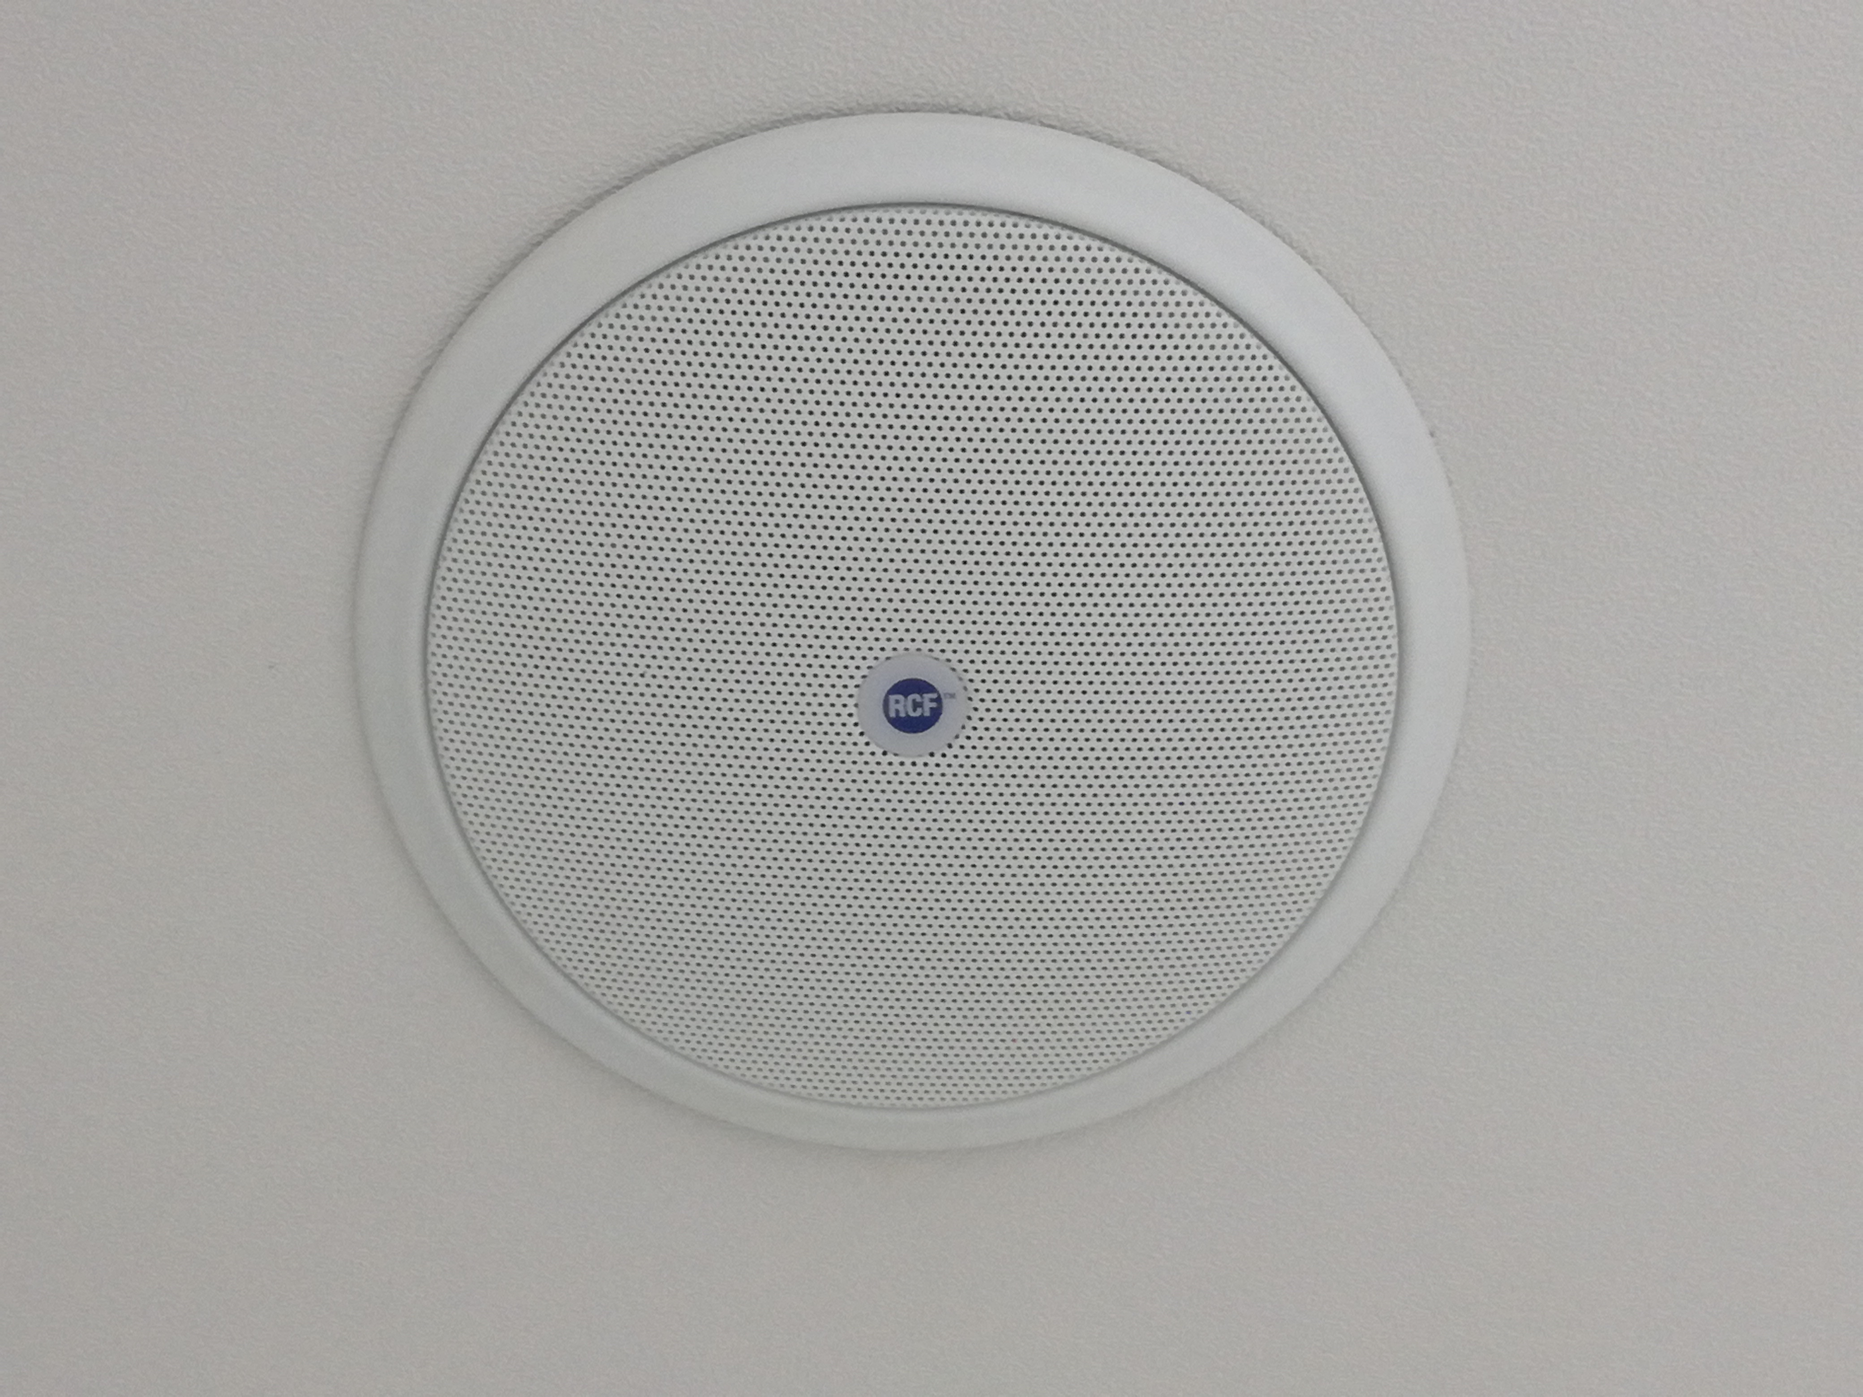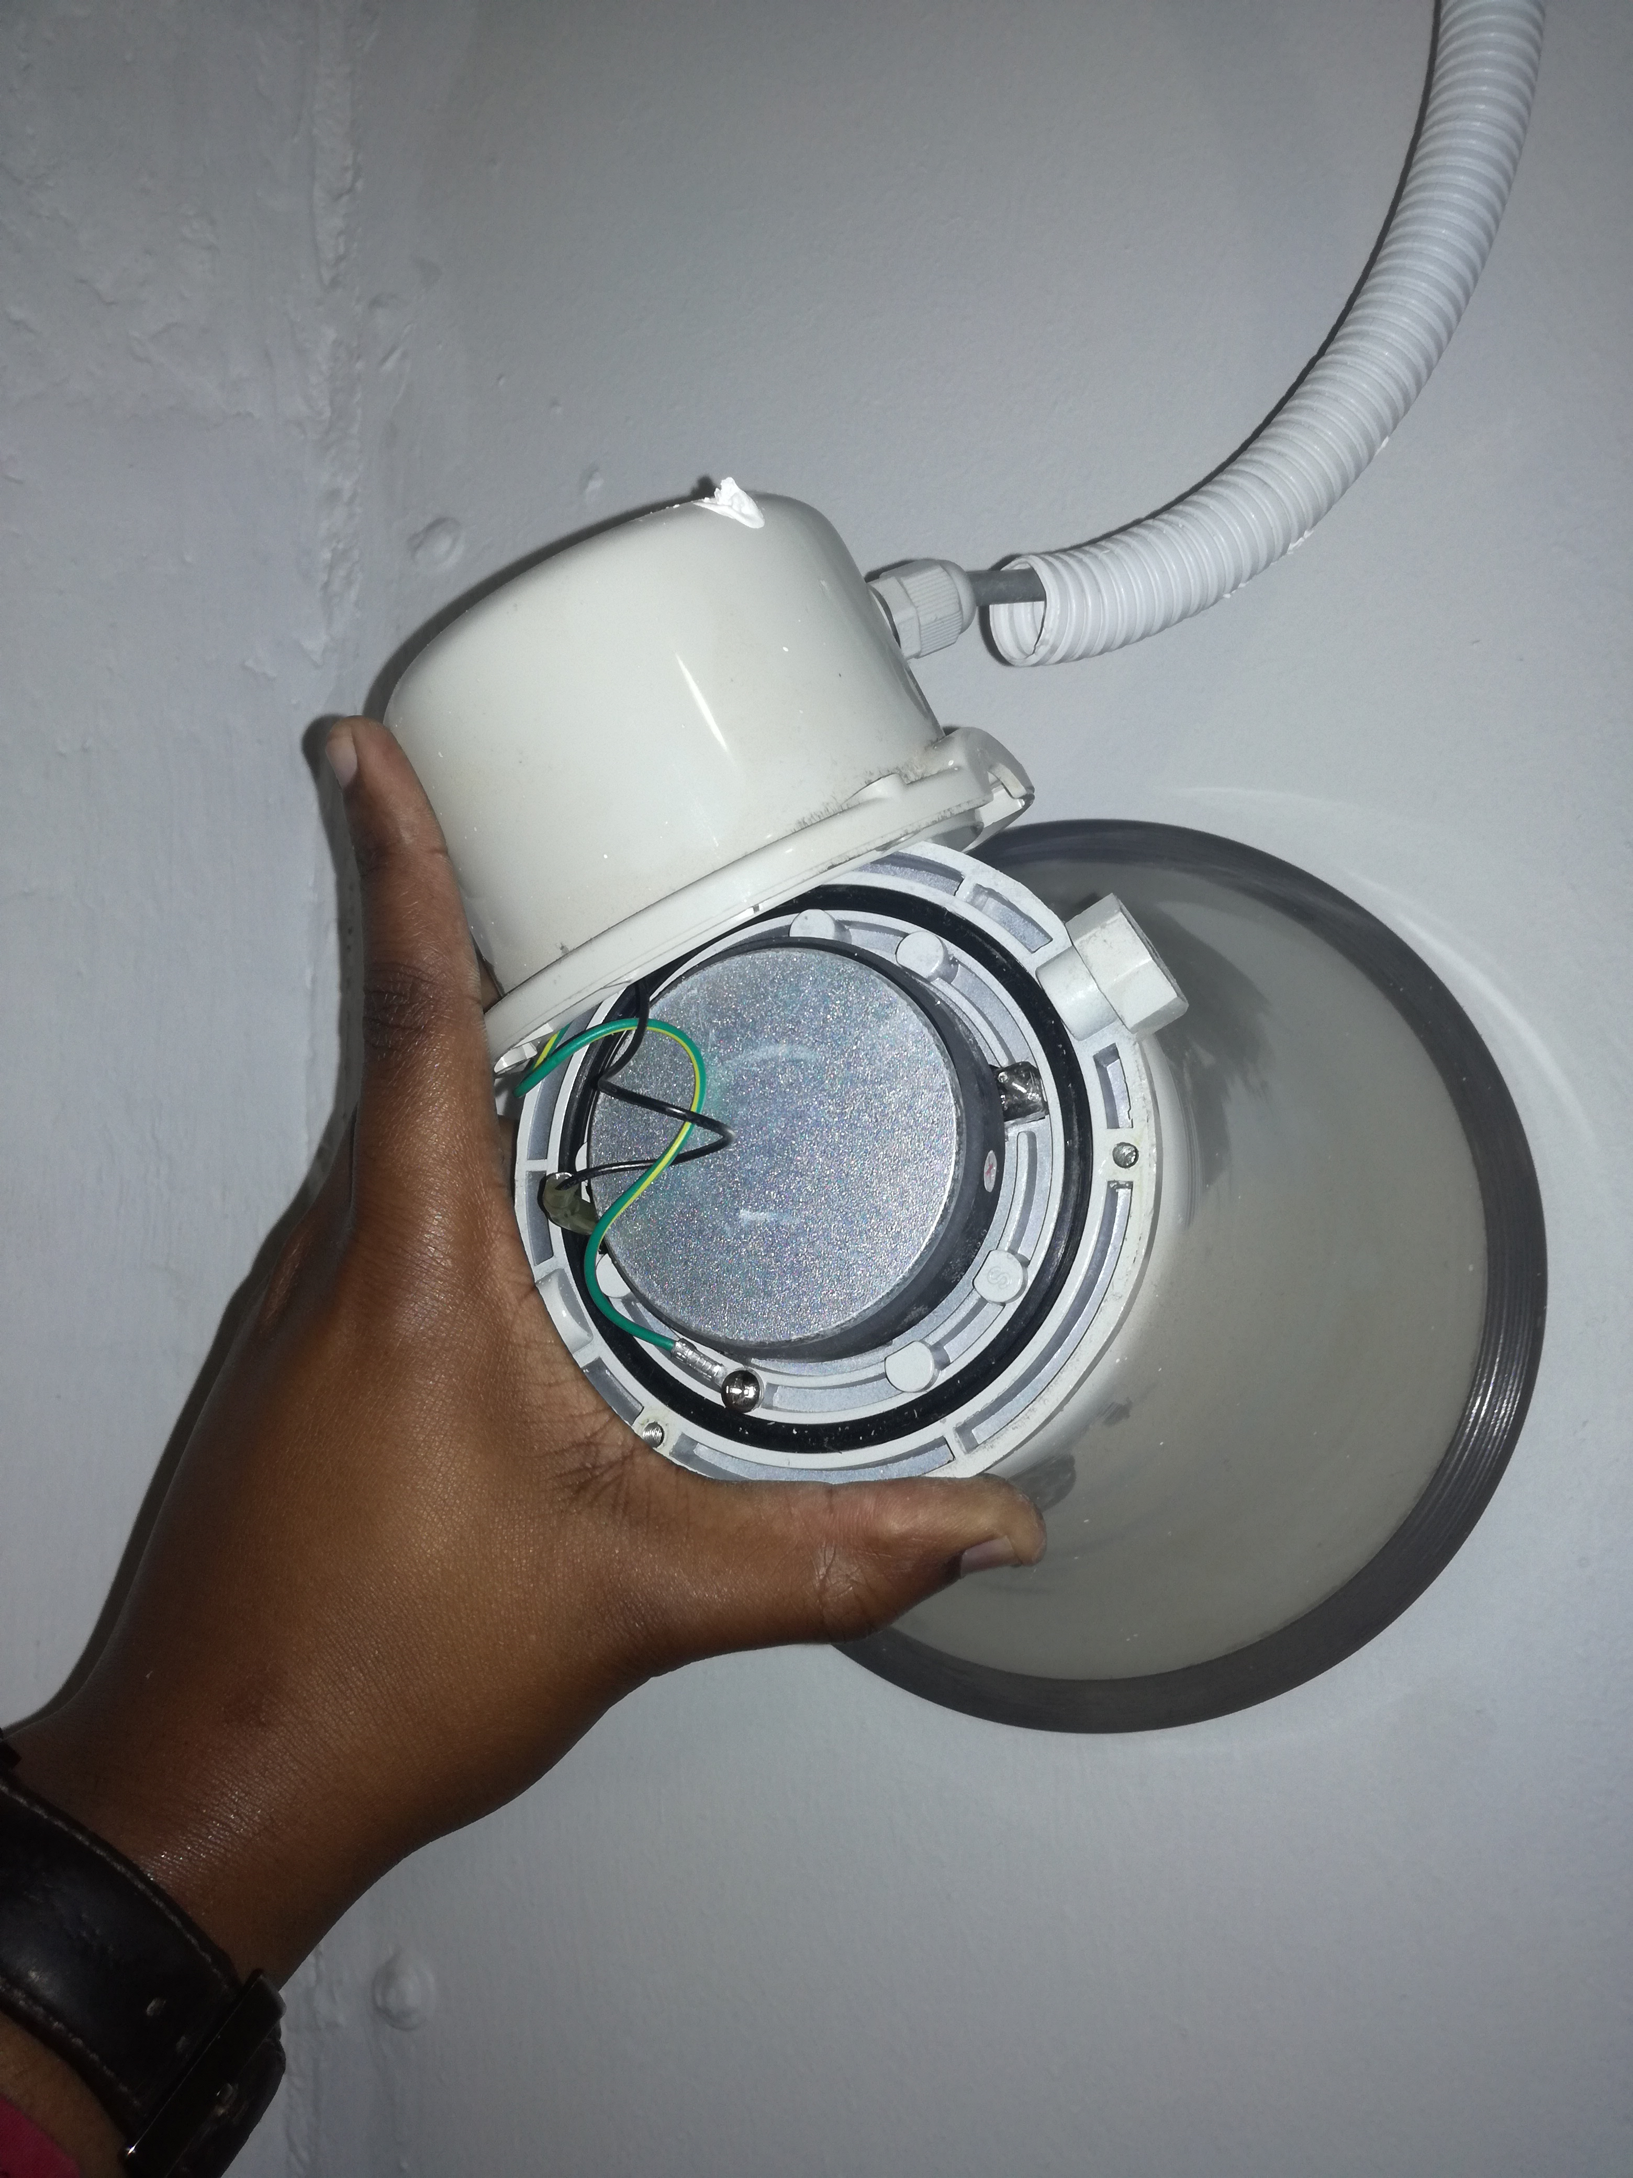
PA System type in pictures:

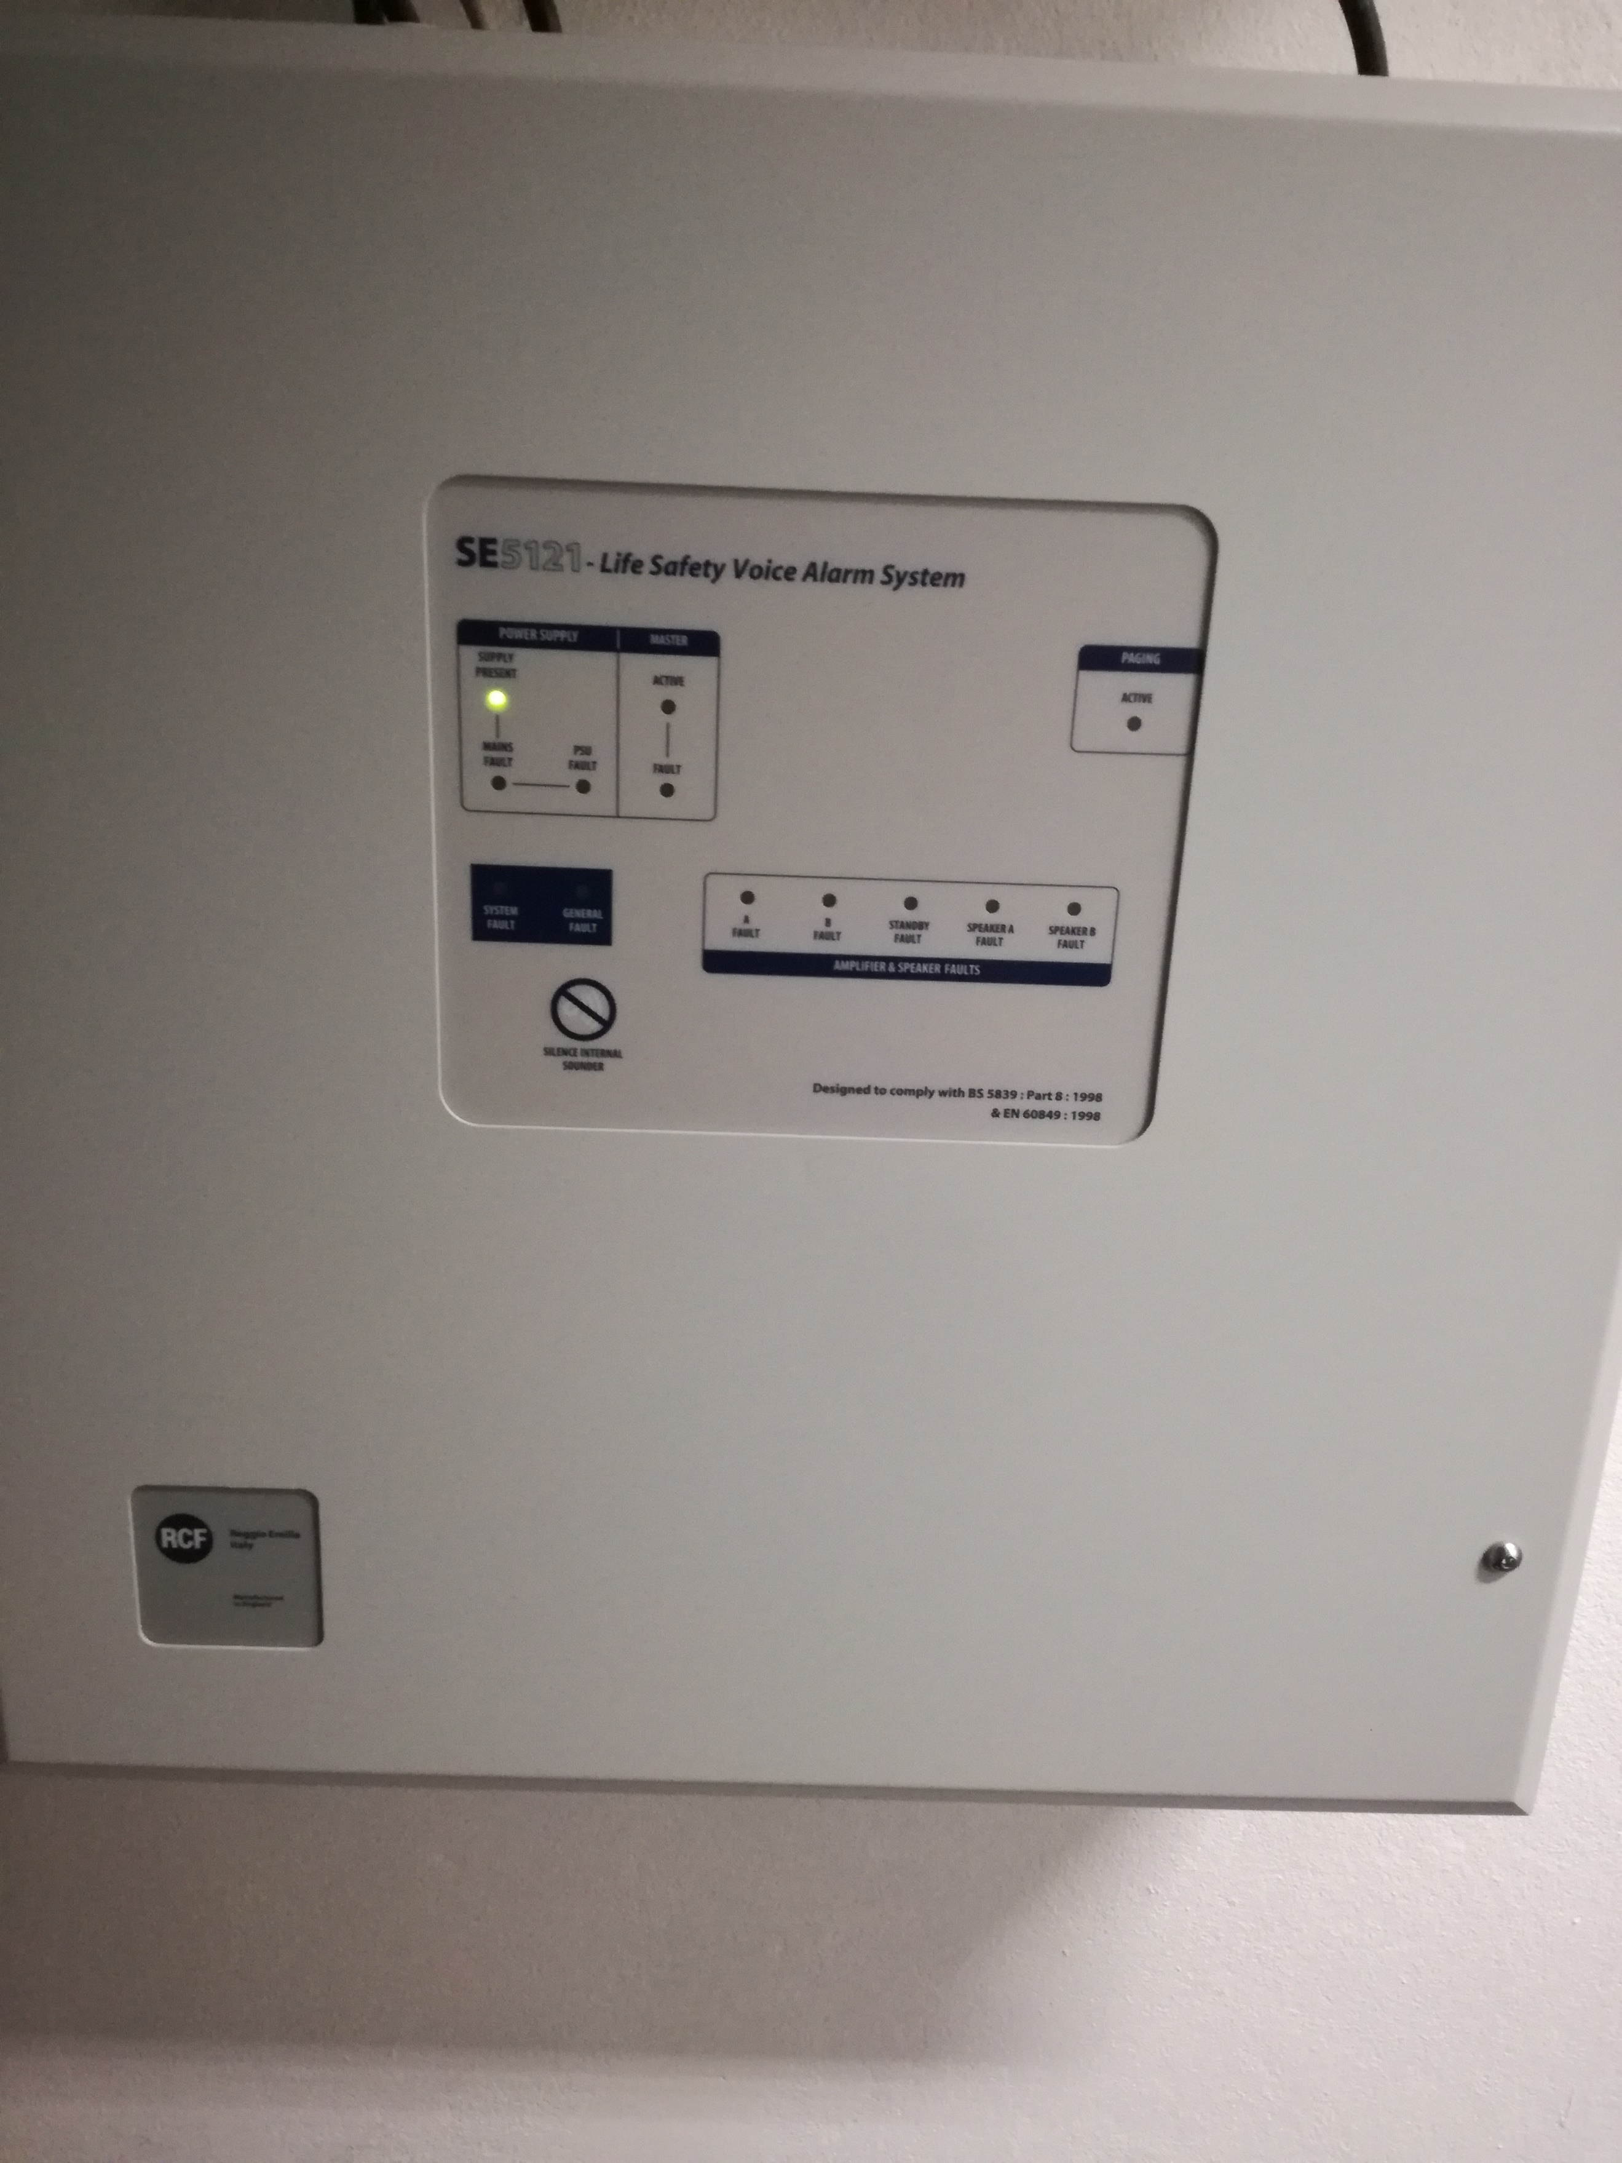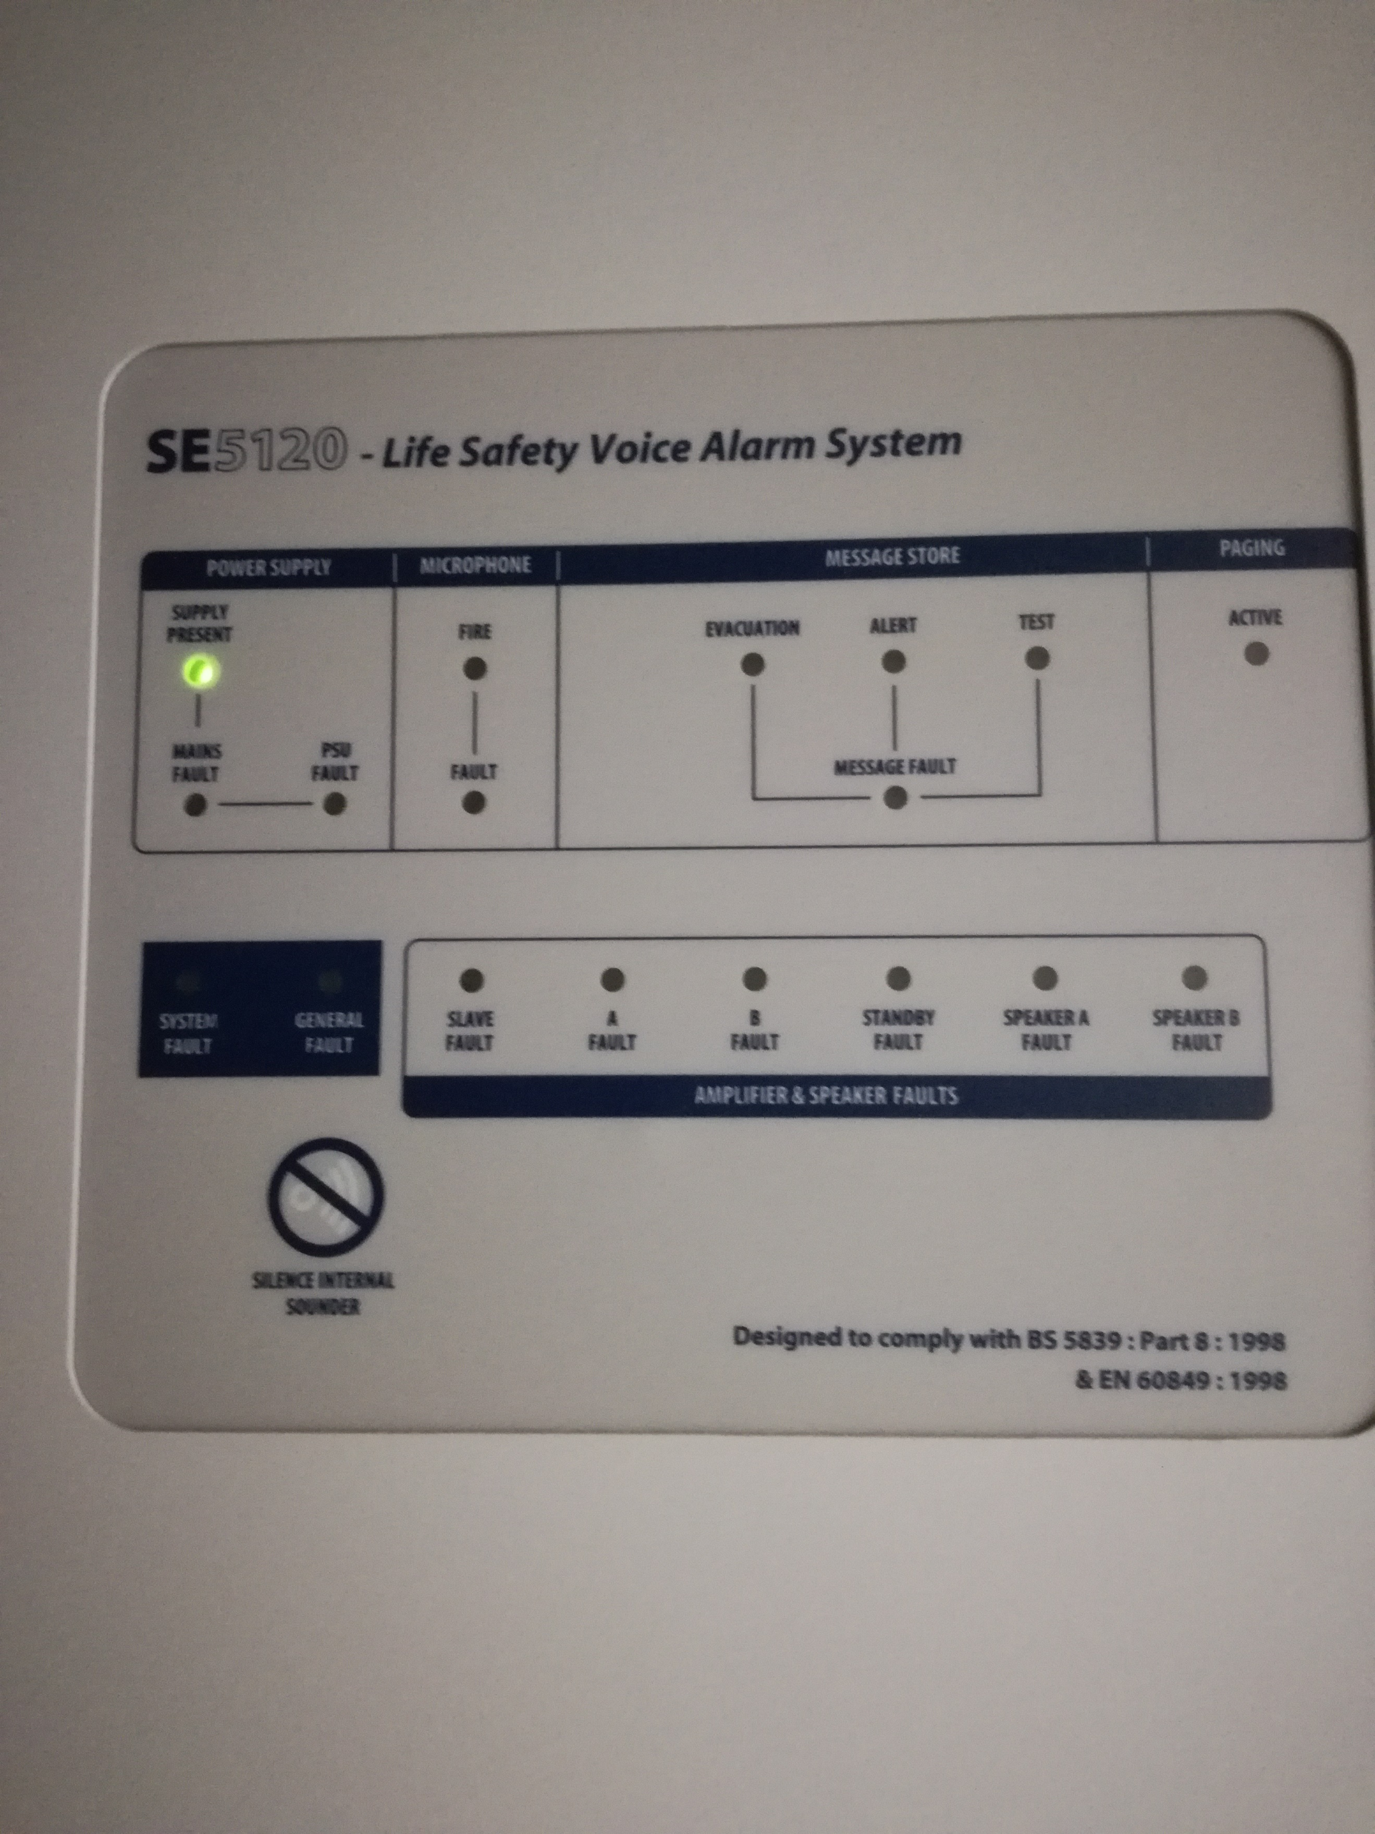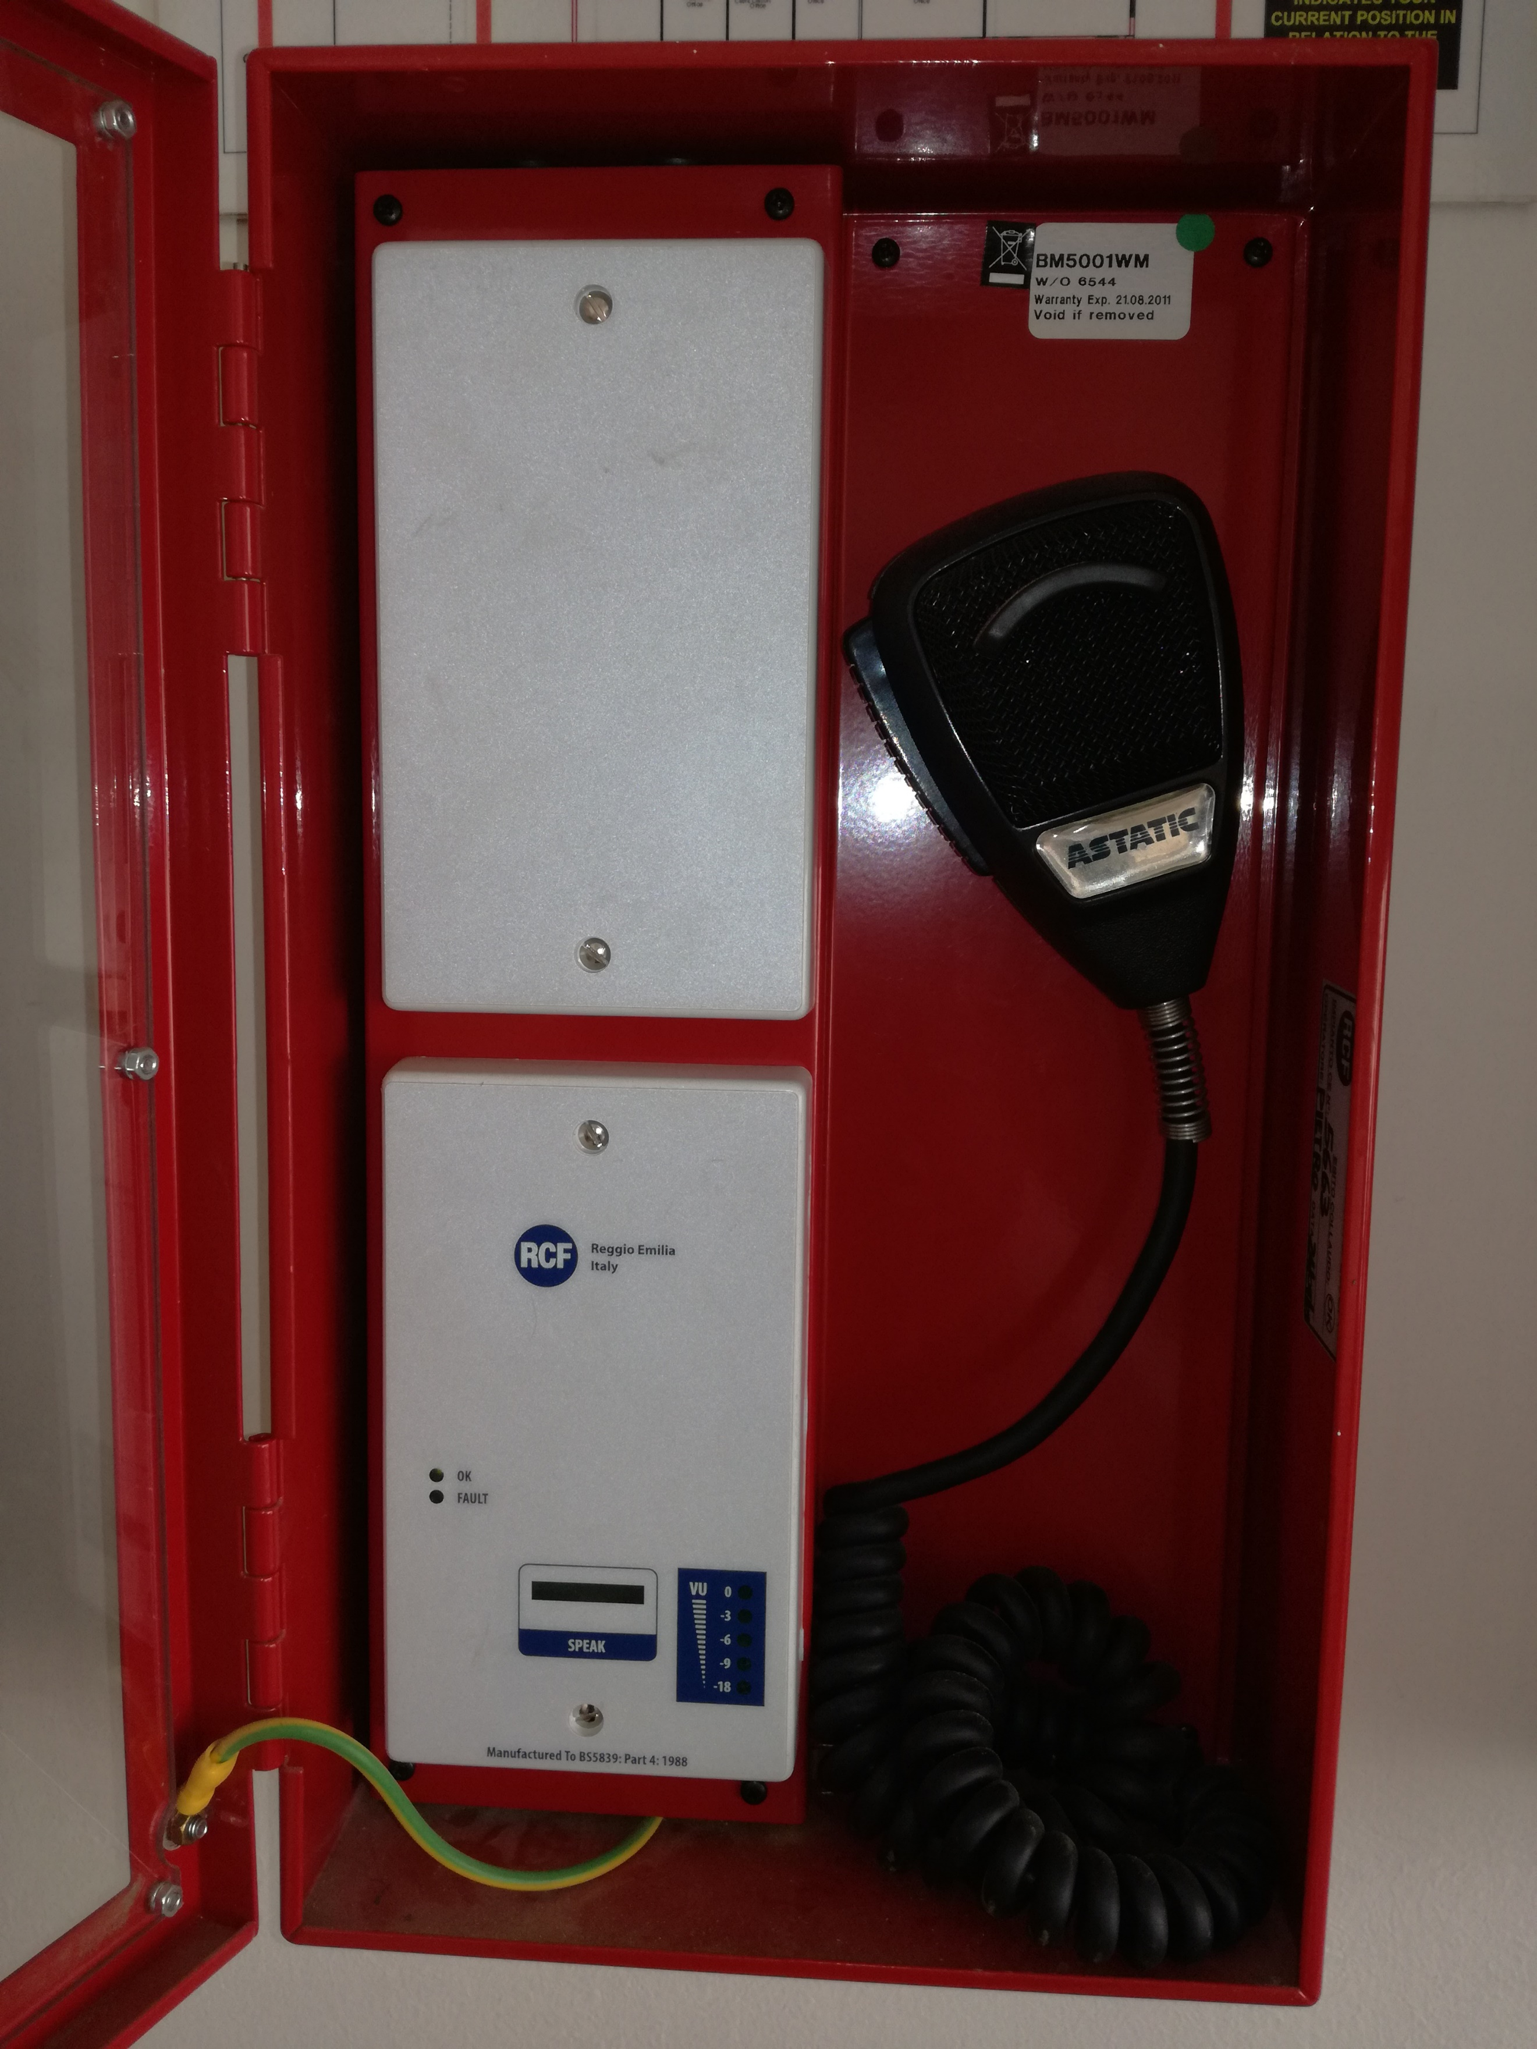

NAME OF THE COMPANY……………………………………………………………………………
DESIGNATION…………………………………………………………………………………………
SIGNATURE…………………………………………………………………………………………….
CSD NUMBER………………………………………………………………………………………….

PREFERENTIAL PROCUREMENT REFORM:

The Preferential Procurement Regulations, 2022 pertaining to the Preferential Procurement Policy Framework Act, Act No 5 of 2000.

ATNS Preferential Procurement (PP) requirements as per the ATNS Supply Chain Management Policy, states that ATNS shall deal with suppliers in accordance with the ATNS specific goals. The application of the specific goals will be per request, per tender up to the maximum points as per the applicable pricing formula, the 80/20 system.

Suppliers not meeting the requirements of the Preferential Procurement are required to clearly identify any possible teaming arrangement which could be established with South African B-BBEE compliant enterprises Any workable plan to train and promote black businesses or individuals through meaningful participation in this project will be considered favorably by the Company during the Tender evaluation process.

Partnership must be in the form of Joint Venture Agreement or Consortium Agreement between compliant B-BBEE and non-B-BBEE Organisation/or foreign supplier in order to meet the policy requirements.

All responsive tender offers shall be evaluated in terms of Price and ATNS specific goals. The 80/20 Preference Point System shall be applicable in accordance with the Preferential Procurement Framework Act (No.5) of 2000.

THE EVALUATION OF THE RFQ:

STAGE 1 | ADMINISTRATIVE PRE-QUALIFICATION REQUIREMENTS
STAGE 2 | MANDATORY REQUIREMENTS
STAGE 3 | PRICE AND ATNS SPECIFIC GOALS

The bidder must qualify for each stage to be eligible to proceed to the next stage of the evaluation.

STAGE 1: ADMINISTRATIVE PRE-QUALIFICATION REQUIREMENTS

The bidder must comply with ALL of the bid pre-qualification requirements in order for the bid to be accepted for evaluation.
If the Bidder failed to comply with any of the administrative pre-qualification requirements, or if ATNS is unable to verify whether the pre-qualification requirements are met, then ATNS reserves the right to-
      - Reject the bid and not evaluate it, or
      - Accept the bid for evaluation, on condition that the Bidder must submit within 7 (seven) days any supplementary information to achieve full compliance, provided that the supplementary information is administrative and not substantive in nature.

STAGE 2: MANDATORY REQUIREMENTS AND FUNCTIONALITY EVALUATION

FAILURE TO SUBMIT ALL OF THE BELOW REQUIREMENTS WILL RESULTS ON YOUR QUOTATION BEING DISQUALIFIED

Mandatory Criteria | Proof Required
Provide five (5) letters of proof of Previous Relevant experience with contactable references. References must be in a form of a signed reference letters on a client’s business letterhead stating the scope and description of the services rendered, contract duration, with contact name, Contact number and position of the referee. Reference letters must not be older than 3 years by closing date of this RFQ. | Yes  5 Letters
Providing a company profile indicating number of years rendering Fire suppression systems and Fire Estinguishers Maintenance Services, in a public and /or corporate sector (Required: Minimum 3 years | Yes
One Qualified SAQCC-Fire. (Valid SAQCC Commissioner level on detention and suppression. Min: 3yrs experience | Yes

STAGE 3: PRICE AND ATNS SPECIFIC GOALS:
Evaluation for Price and ATNS specific goals

Quotations will be evaluated in terms of the ATNS’ Procurement Policies and Procedures using the 80:20 point system. 80 points will be awarded for price and 20 points for ATNS specific goals claimed.

PRICE | 80
ATNS SPECIFIC GOALS | 20

B-BBEE rating certificates are applicable, and points will be allocated in terms of the ATNS specific goals as indicated in the table below. Bidders must submit valid B-BBEE Certificates, requested declarations, utility statements and any other supporting information that may be required to claim ATNS specific goals.

Financial proposals will be compared on the basis of their total amount inclusive of
VAT and all other related costs. Bidders are required to submit pricing schedule as
per the table below on a company

Note to tenderers: The tenderer must indicate how they claim points for each preference point system in the provided SBD 6.1 attached.
The specific goals allocated points in terms of this tender | Number of points  allocated  (80/20 system)  (To be completed by the organ of state) | Number of points claimed (80/20 system)
51% Black Owned Suppliers (Section 2(1)(d)(i) of the PPPFA) | 10 | (To be completed by the tenderer in SBD 6.1 attached)
30% Black Woman Owned Suppliers. (Section 2(1)(d)(i) of the PPPFA) | 10 | (To be completed by the tenderer in SBD 6.1 attached)

This RFQ will be evaluated according to the above on ATNS specific goals. Failure to submit supporting documents may result to a bidder being allocated zero (0) points. Bidders are required to claim ATNS specific goals in the provided SBD 6.1 attached.

CONTRACT TERMS
Whilst ATNS have taken every reasonable step to ensure the accuracy of this brief, the Company accepts no liability in relation to the accuracy of any representations made. Tenderer should accept that their tender response is on the basis and reliance of its own judgment and information. ATNS reserves the right to vary the scope and terms as described in this document. If any variation does take place tenderer will be advised as soon as possible in writing.
The successful tenderer will be engaged subject to acceptance of a contract containing the standard Terms and Conditions as given. The contract contains standard clauses including a retention clause for non-satisfactory completion, breach of contract and confidentiality clauses and a requirement for the tenderer to have adequate professional indemnity insurance. All Tenderers must bear in mind that if circumstances dictate, ATNS reserves its right to withdraw from any commitments that will be entered into within this statement of work.
All designs and documentation submitted by the tenderer will be treated as confidential.

ATNS reserves the right to reject, withdraw or cancel any or all Proposals/Tenders, to undertake discussions with one or more Tenderers and to accept that tender or modified tender which in its sole judgment, will be most advantageous to the Company, price and other evaluation factors having been considered.

SBD1

PART A

INVITATION TO BID
YOU ARE HEREBY INVITED TO BID FOR REQUIREMENTS OF THE (NAME OF DEPARTMENT/ PUBLIC ENTITY)
BID NUMBER: |  |  |  | CLOSING DATE: |  |  |  |  | CLOSING TIME:
DESCRIPTION
BID RESPONSE DOCUMENTS MAY BE DEPOSITED IN THE BID BOX SITUATED AT (STREET ADDRESS)
Email address: RFQs@atns.co.za
BIDDING PROCEDURE ENQUIRIES MAY BE DIRECTED TO |  |  |  |  | TECHNICAL ENQUIRIES MAY BE DIRECTED TO:
CONTACT PERSON |  |  | Thoko Phukubye |  | CONTACT PERSON
TELEPHONE NUMBER |  |  | 011 607 1000 |  | TELEPHONE NUMBER
FACSIMILE NUMBER |  |  |  |  | FACSIMILE NUMBER
E-MAIL ADDRESS |  |  | thokop@atns.co.za |  | E-MAIL ADDRESS
SUPPLIER INFORMATION
NAME OF BIDDER
POSTAL ADDRESS
STREET ADDRESS
TELEPHONE NUMBER |  | CODE |  |  |  | NUMBER
CELLPHONE NUMBER
FACSIMILE NUMBER |  | CODE |  |  |  | NUMBER
E-MAIL ADDRESS
VAT REGISTRATION NUMBER
SUPPLIER COMPLIANCE STATUS |  | TAX COMPLIANCE SYSTEM PIN: |  |  | OR |  | CENTRAL SUPPLIER DATABASE No: | MAAA
B-BBEE STATUS LEVEL VERIFICATION CERTIFICATE |  | TICK APPLICABLE BOX]  Yes No |  |  | B-BBEE STATUS LEVEL SWORN AFFIDAVIT |  |  |  |  | [TICK APPLICABLE BOX]  Yes No
[A B-BBEE STATUS LEVEL VERIFICATION CERTIFICATE/ SWORN AFFIDAVIT (FOR EMES & QSEs) MUST BE SUBMITTED IN ORDER TO QUALIFY FOR PREFERENCE POINTS FOR B-BBEE]
ARE YOU THE ACCREDITED REPRESENTATIVE IN SOUTH AFRICA FOR THE GOODS /SERVICES /WORKS OFFERED? |  | Yes No  [IF YES ENCLOSE PROOF] |  |  | ARE YOU A FOREIGN BASED SUPPLIER FOR THE GOODS /SERVICES /WORKS OFFERED? |  |  |  |  | Yes No  [IF YES, ANSWER THE QUESTIONNAIRE BELOW ]
QUESTIONNAIRE TO BIDDING FOREIGN SUPPLIERS
IS THE ENTITY A RESIDENT OF THE REPUBLIC OF SOUTH AFRICA (RSA)? YES NO
DOES THE ENTITY HAVE A BRANCH IN THE RSA? YES NO
DOES THE ENTITY HAVE A PERMANENT ESTABLISHMENT IN THE RSA? YES NO
DOES THE ENTITY HAVE ANY SOURCE OF INCOME IN THE RSA? YES NO
IS THE ENTITY LIABLE IN THE RSA FOR ANY FORM OF TAXATION? YES NO
IF THE ANSWER IS “NO” TO ALL OF THE ABOVE, THEN IT IS NOT A REQUIREMENT TO REGISTER FOR A TAX COMPLIANCE STATUS SYSTEM PIN CODE FROM THE SOUTH AFRICAN REVENUE SERVICE (SARS) AND IF NOT REGISTER AS PER 2.3 BELOW.

PART B

TERMS AND CONDITIONS FOR BIDDING

- BID SUBMISSION:
  - BIDS MUST BE DELIVERED BY THE STIPULATED TIME TO THE CORRECT ADDRESS. LATE BIDS WILL NOT BE ACCEPTED FOR CONSIDERATION.
  - ALL BIDS MUST BE SUBMITTED ON THE OFFICIAL FORMS PROVIDED–(NOT TO BE RE-TYPED) OR IN THE MANNER PRESCRIBED IN THE BID DOCUMENT.
  - THIS BID IS SUBJECT TO THE PREFERENTIAL PROCUREMENT POLICY FRAMEWORK ACT, 2000 AND THE PREFERENTIAL PROCUREMENT REGULATIONS, 2017, THE GENERAL CONDITIONS OF CONTRACT (GCC) AND, IF APPLICABLE, ANY OTHER SPECIAL CONDITIONS OF CONTRACT.
  - THE SUCCESSFUL BIDDER WILL BE REQUIRED TO FILL IN AND SIGN A WRITTEN CONTRACT FORM (SBD7).

- TAX COMPLIANCE REQUIREMENTS
- BIDDERS MUST ENSURE COMPLIANCE WITH THEIR TAX OBLIGATIONS.
- BIDDERS ARE REQUIRED TO SUBMIT THEIR UNIQUE PERSONAL IDENTIFICATION NUMBER (PIN) ISSUED BY SARS TO ENABLE THE ORGAN OF STATE TO VERIFY THE TAXPAYER’S PROFILE AND TAX STATUS.
- APPLICATION FOR TAX COMPLIANCE STATUS (TCS) PIN MAY BE MADE VIA E-FILING THROUGH THE SARS WEBSITE WWW.SARS.GOV.ZA.
- BIDDERS MAY ALSO SUBMIT A PRINTED TCS CERTIFICATE TOGETHER WITH THE BID.
- IN BIDS WHERE CONSORTIA / JOINT VENTURES / SUB-CONTRACTORS ARE INVOLVED, EACH PARTY MUST SUBMIT A SEPARATE TCS CERTIFICATE / PIN / CSD NUMBER.
- WHERE NO TCS PIN IS AVAILABLE BUT THE BIDDER IS REGISTERED ON THE CENTRAL SUPPLIER DATABASE (CSD), A CSD NUMBER MUST BE PROVIDED.
- NO BIDS WILL BE CONSIDERED FROM PERSONS IN THE SERVICE OF THE STATE, COMPANIES WITH DIRECTORS WHO ARE PERSONS IN THE SERVICE OF THE STATE, OR CLOSE CORPORATIONS WITH MEMBERS PERSONS IN THE SERVICE OF THE STATE.”

NB: FAILURE TO PROVIDE / OR COMPLY WITH ANY OF THE ABOVE PARTICULARS MAY RENDER THE BID INVALID.

SIGNATURE OF BIDDER: ……………………………………………

CAPACITY UNDER WHICH THIS BID IS SIGNED: ……………………………………………
(Proof of authority must be submitted e.g. company resolution)

DATE:

