Item description | Quantity | Cost ZAR Per Unit (estimated)
Pick set: Head + Handle | 8 | R580 each  =R4640 | 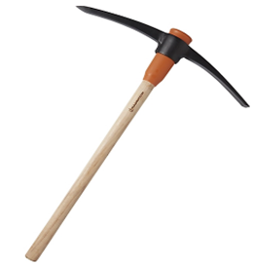
Spade | 10 | R210 each  =R2100 | 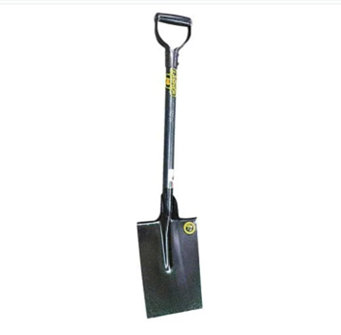
Fork | 10 | R300  =R3000 | 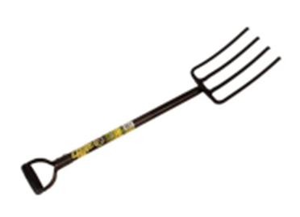
2-piece handset (trowel & fork) | 5 | R210 | 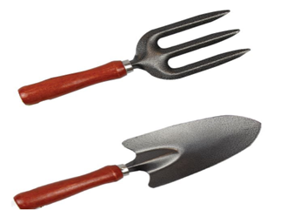
Garden Rake Steel | 10 | R280 ach  =R2800 | 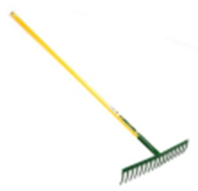
Gloves chrome leather | 15 | R55 each  =R825 | 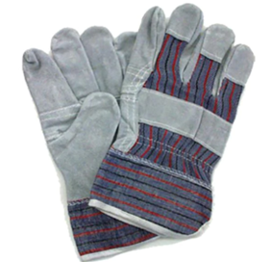
Plastic Watering Can (10 liter) | 10 | R130 each  =R1300 | 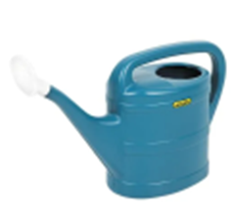
Hoe set: head + handle | 8 | R1000 | 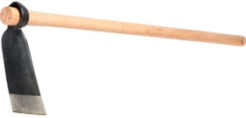
Hose Pipe Set with Fittings and Sprinkler (20m) | 3 | R500 | 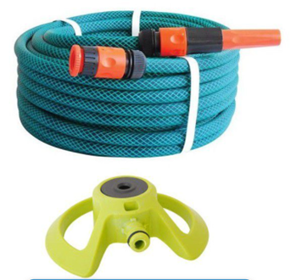
Wheelbarrow | 4 | R2200 | 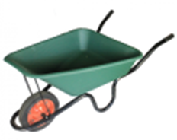
Vegetable seedlings x 6:  - Tomato  - Spinach  - Cabbage  - Beetroot  - Butternut  - Onion | 16 Trays Per Seedling | 1x tray is about R40 - R75 | 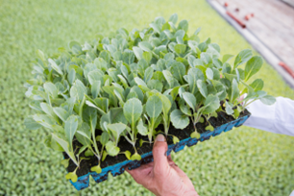
Fruit plant trees x 4:  - Avocado  - Apple  - Peaches  - Naartjie | 2 of each tree | 1x tree is about R100 – R350 (Size: 9L) | 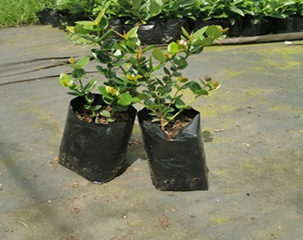
All Purpose Fertilizer | 6 x 5kg | R120 each (5kg) | 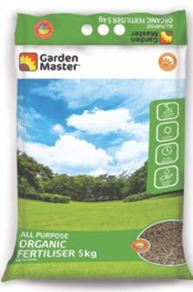
Garden Net (Keep Birds Away) | 1 x Mash Block – Green  55m x 6m  110 GSM  80-90 UV Block | R3000,00 | 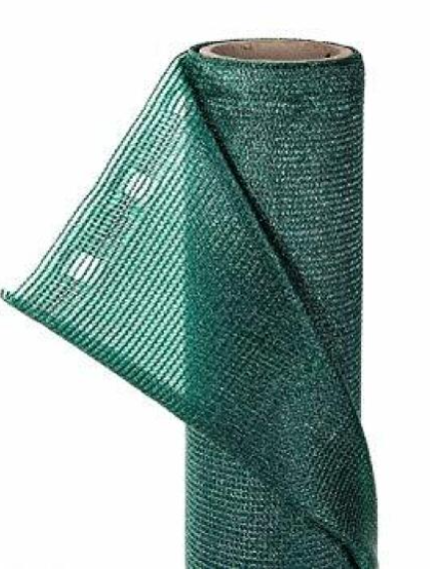
Compost Bins | x 2 Units – Green/Black  Size - 420 L  Weight – 6.6 kg  Height – 80 cm  Width – 88.5 cm  Depth – 88.8 cm | R2000 each  =R4000,00 | 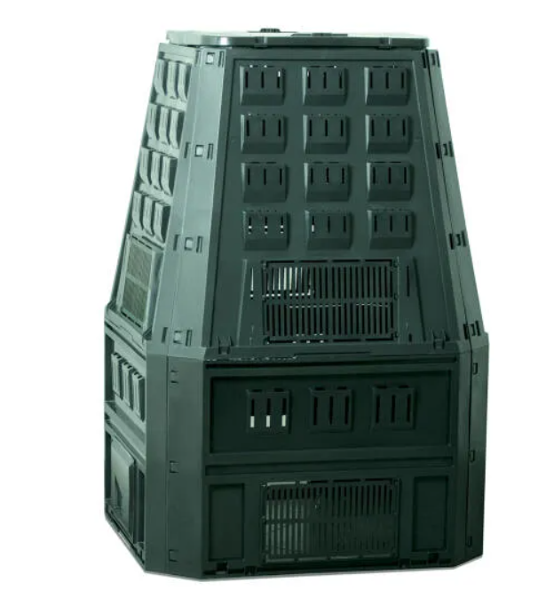
Brush Cutters | x 2  - Engine: 42.7cc / 2 Stroke  - Rated Power: 1.25kW  - RPM: 9000  - Blade Cutting Width: 255mm  - Nylon Cutting Width: 420mm  - Nylon Head: 2 Nylon Line / 2.4mm  - Fuel Mix: Synthetic 2.5% (40/1) / Non-Synthetic 4% (25/1)  - Fuel Capacity: 1.0l  - Net Weight: 7.2kg  To include:  - 1 x 43cc Brush Cutter  - 1 x Nylon Bumphead with Nylon Line  - 1 x 3 Tooth Blade  - 1 x Fuel Mixing Bottle  - 1 x Harness  - 1 x Tool Kit | R3000,00 Each | 