Golf- Cart with all weather-enclosure item

Golf Cart Specification
Item | Quantity | Specification | Picture used as an example
Golf Cart with all weather-enclosure item | 1 | - The golf cart must be a 4-seater with all-weather enclosure.  - Golf-Cart must be new  - Five-year warranty  - Maintenance plan  - Battery powered.  - Side Mirrors  - Storage compartment/Box | 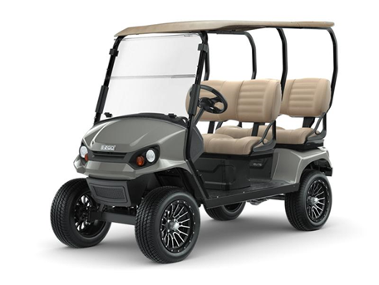
 |  |  | 