AIR TRAFFIC AND NAVIGATION SERVICES SOC. LTD
REPUBLIC OF SOUTH AFRICA

REQUEST FOR BID/TENDER: ATNS/RFP043/22/23/VHF COASTAL COVERAGE

VHF COASTAL COVERAGE PROJECT

Replacement of VHF Infrastructure and equipment shelters

VOLUME 0

INFORMATION SHEET

Version 1

September 2022

The information contained within this document is confidential to ATNS in all respects and it is hereby acknowledged that the information as provided shall only be used for the preparation of a response to this document. The information furnished will not be used for any other purpose than stated and that the information will not directly or indirectly, by agent, employee or representative, be disclosed either in whole or in part, to any other third party without the express written consent by the Company or its representative.

TABLE OF CONTENTS

TABLE OF CONTENTS 2
ABBREVIATIONS 3
1 PRELIMINARY 4
1.1 Background 4
1.2 Coverage 6
1.3 Existing Communication infrastructure 7
2 SCOPE OF WORK 8
2.1 Programme Goal 8
2.2 Scope of work overview 8
3 REQUIREMENTS PER SITE 9
3.1 King Shaka International Airport (FALE) Sites 9
3.1.1 FALE Transmitter site (King Shaka International Airport) 9
3.1.2 FALE Receiver Site 9
3.1.3 FALE Emergency Radios 10
3.1.4 Pietermaritzburg (FAPM) FRS 10
3.1.5 Virginia (FAVG) FRS 11
3.1.6 Richards Bay (FARB) FRS 11
3.1.7 Louwsburg FRS 12
3.1.8 Mount Ayliffe FRS 12
3.2 Port Elizabeth International Airport (FAPE) 13
3.2.1 FAPE Transmitter Site 13
3.2.2 FAPE Receiver Site 13
3.2.3 FAPE Emergency Radios 14
3.2.4 Humansdorp FRS 14
3.3 East London Airport (FAEL) 15
3.3.1 FAEL Transmitter Site 15
3.3.2 FAEL Receiver Site 15
3.3.3 FAEL Emergency Radios 16
3.3.4 Mthatha FRS 16
3.3.5 Queenstown FRS 17
3.4 George Airport (FAGG) 18
3.4.1 FAGG Transmitter Site 18
3.4.2 FAGG Receiver Site 18
3.4.3 FAGG Emergency Radios 19
3.4.4 Potjiesburg FRS 19
3.5 Aviation Training Academy 20

ABBREVIATIONS

AC Alternating Current
ACC Area Control
APP Approach Control
ATC Air Traffic Controller
ATCC Air Traffic Controller Centre
ATIS Automatic Terminal Information Service
ATM Air Traffic Management
ATNS Air Traffic and Navigation Services SOC Ltd
ATS Air Traffic Service
COTS Commercially off the Shelf
DB Distribution Board
DC Direct Current
DSB Double Side Band
EIA Environmental Impact Assessment
EMC Electromagnetic compatibility
FAT Factory Acceptance Test
FIR Flight Information Region
FIS Flight Information Service
FRS Forward Relay Station
ICAO International Civil Aviation Organization
LRU Line Replaceable Units
OEM Original Equipment Manufacturer
PBU Period of Beneficial Use
P, H, S & T Packaging, Handling, Storage and Transportation
RF Radio Frequency
RCMMS Remote Control Monitoring and Maintenance System
RSE Remote Switching Equipment
RX Receiver
SACAA South African Civil Aviation Authority
SAT Site Acceptance Test
SLA Service Level Agreement
TCP/IP Transmission Control Protocol/Internet Protocol
TWR Tower
TX Transmitter
URS User Requirement Statement
VHF Very High Frequency
V-SAT Very Small Aperture Terminal
VoIP Voice over Internet Protocol

PRELIMINARY

Background
ATNS is currently busy with the upgrading of the VHF transmitters and receivers’ sites in the inland part of the country. This project has been initiated to address the requirement for the end-of-life replacement of the VHF transmitters and receivers at existing sites, and the enhancement of the VHF services to ensure sufficient coverage along the coastal route between King Shaka and George.
The existing sites were analyzed to confirm the requirement for replacement as well as identifying shortcomings in delivering the required VHF communication services.
The VHF costal coverage project is intended for:
- Replacement of aging VHF equipment.
- Maintenance and refurbishment of supporting infrastructure.
- Improving service delivery, by improving VHF coverage.
- Supporting new technology (VoIP)
The current VHF system configuration can be divided into:
- Transmitter Sites: Installed at local sites and consisting of all transmitters for the day-to-day operations, Forward Relay Operations and ATIS Operations with a Main/Standby System.
- Receiver Sites: Installed at terminal facilities and consisting of all receivers for the day-to-day operations and Forward Relay Operations with a Main/Standby System.
- Emergency Site: Installed at the terminal facility and consisting of all the transmitters and receivers for the Emergency Operations.

Table 1 below provides a list of the existing VHF coastal sites, associated equipment and their geographical locations.
Site Name | Type  (TX, RX) | Building/Shelter (Brick/Container) | Geographical Coordinates
King Shaka Int’l Airport | TX | Radar Site Brick building | 29 35 56 S | 31 07 14 E
King Shaka Int’l Airport | RX | ATC Tower | 29 36 27 S | 31 06 43 E
King Shaka Int’l Airport Emergency | TX/RX | ATC Tower | 29 36 27 S | 31 06 43 E
Pietermaritzburg Airport | TX/RX | ATC Tower | 29 38 36 S | 30 23 48 E
Virginia Airport | TX/RX | ATC Tower | 29 46 24 S | 31 03 21 E
Louwsburg FRS | TX/RX | Brick building | 27 33 43 S | 31 16 22 E
Mount Ayliffe FRS | TX/RX | Brick building | 30 50 11 S | 29 23 41 E
Port Elizabeth Transmitter site | TX | Radar Site Brick building | 33 59 36 S | 25 36 40 E
Port Elizabeth Receiver site | RX | Brick building | 33 59 01 S | 25 36 25 E
Port Elizabeth Emergency | TX/RX | ATC Tower | 33 59 01 S | 25 36 45 E
Humansdorp FRS | TX/RX | Brick building | 34 57 95 S | 24 46 44 E
East London Transmitter Site | TX | Old container | 33 01 41 S | 27 47 56 E
East London Receiver Site | RX | Old container | 33 01 41 S | 27 47 56 E
East London Emergency | TX/RX | ATC Tower | 33 01 58 S | 27 49 26 E
Bisho FRS | TX/RX | Brick building | 32 53 43 S | 27 1716 E
Umthatha FRS | TX/RX | Brick building | 31 32 47 S | 28 40 31 E
Queenstown Mount Madeira FRS | TX/RX | Rented Brick building | 31 52 23 S | 26 49 45 E
George Transmitter site | TX | Brick building | 34 00 08 S | 22 22 26 E
George Receiver site | RX | Brick building | 34 00 37 S | 22 22 33 E
George Emergency | TX/RX | ATC Tower | 34 00 06 S | 22 22 56 E
Potjiesberg FRS | TX/RX | Old Container (1997) | 33 43 25 S | 23 03 03 E
Table 1: VHF Coastal Facilities

The following new site, as tabulated in Table 2, will be established as a FRS to cater for short comings and to provide coverage improvement for the King Shaka control centre.
Site Name | Type  (TX, RX) | Building/Shelter (Brick/Container) | Geographical Coordinates
Richards Bay Airport | TX/RX | Shelter | 28 44 11 S | 32 05 39 E
Table 2: New VHF site to be established

The ATNS Aviation Training Academy will be equipped with a training system as indicated in Table 3 below, in order to provide training for technical staff and to be used as a test facility.
Site Name | Type (TX, RX) | Building/Shelter | Geographical Coordinates
Aviation Training Academy (ATA)
ATA Transmitter | TX | Brick building | 26 08 13 S | 28 14 59 E
ATA Receiver | RX | Brick building | 26 08 13 S | 28 14 59 E
Table 3: Training Facility

Coverage
The current VHF coastal coverage for the forward relay stations (FRS) and on-airport transmitters and receivers are presented in Figure 1 below. At some stations the transmitters and receivers are co-located, hence will be depicted as one coverage.
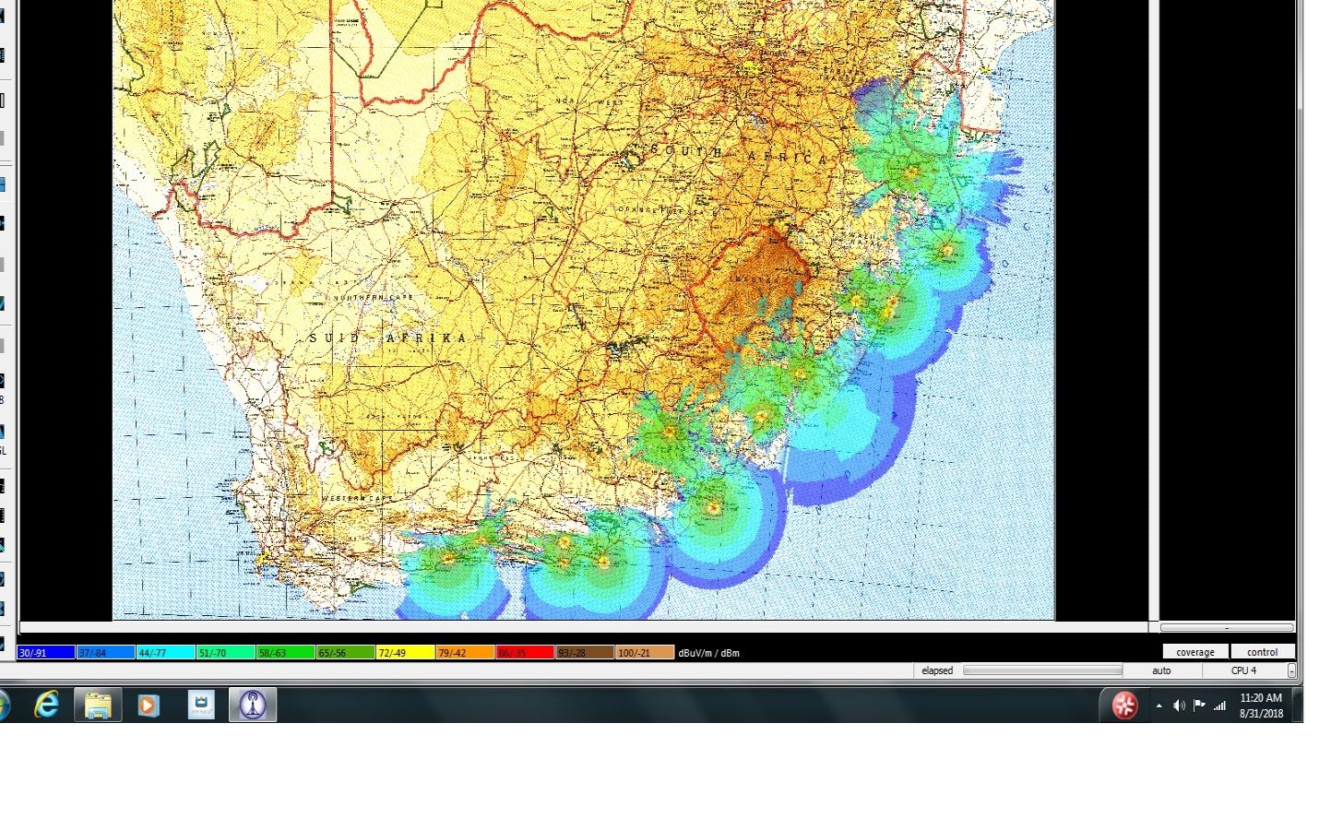Figure 1 : VHF Coverage at 1500 feet

The anticipated coverage for the proposed location of the new FRS at Richards Bay airport is provided in Figure 2 below. The height of the antenna was assumed to be 5 metres above ground level to cater for the restrictions of the nearby VOR facility.

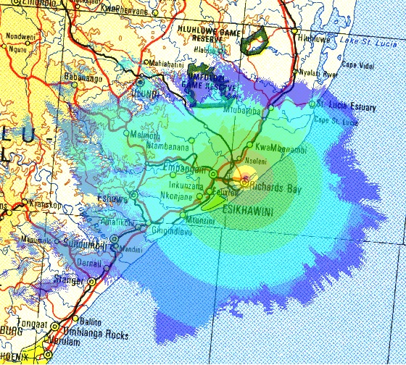Figure 2 : Richard Bay (FARB) FRS Coverage at 1500 feet

Existing Communication infrastructure
An integral part of the VHF system is the RCMS (Remote Control and Monitoring System) communication infrastructure, that enables maintenance personnel to perform maintenance activities on the VHF system from a remote maintenance position.
A fixed line fibre optic communications network (OTN – Open Transport Network) is used to connect the local on airport VHF system to the operational center.
The Forward Relay Stations (FRS) are remotely controlled radio stations housing transmitter/receiver combinations which are controlled by the ATC at the main centres. They are linked to the appropriate ATCC using leased terrestrial circuits.
Figure 3 below, provides a pictorial view of the current configuration of the communication layout for a terminal facility (on-airport) and Forward Relay Stations (remote site).

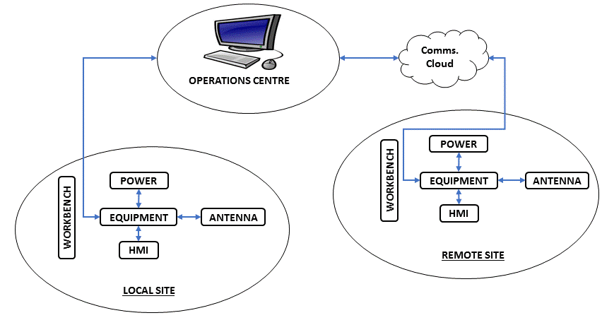
Figure 3 : VHF System Overview

SCOPE OF WORK

Programme Goal
The goal of the project is to replace the existing VHF system in the coastal areas, as identified herein, including the supporting infrastructure to address the end of life problems and enhance the coverage to ensure seamless communication between the ATCs and the pilots.

Scope of work overview
The scope of the project can be defined as the replacement of the existing VHF network within the coastal area between George Airport and King Shaka International Airport and expanding the network to support the required coverage, while at the same time ensuring that the supporting infrastructure is upgraded to support the VHF system for the next 15 years.
The project will also include:
- Civil works, where required;
- Decommissioning of existing equipment;
- Installation of backup power, where required
- Communication links interfacing;
- Initial environmental screenings for identifying any environmental authorizations that may be required;
- Replacement of shelter or refurbishment of building (where applicable);
- Establishment of new sites (if operationally required and motivated);
- Lease agreement review/renewal and new lease agreements (where applicable);
- Replacement or enhancement of site security, where required;
- Replacement of the existing Remote-Control Monitoring and Maintenance System (RCMMS);
- Provision of basic and advanced training to maintenance personnel; and
- Maintenance and support of the VHF systems.

REQUIREMENTS PER SITE

King Shaka International Airport (FALE) Sites

FALE Transmitter site (King Shaka International Airport)
GENERAL
Classification: | Transmitter site
Location: | FALE Radar Building
Maintenance Centre: | FALE
VHF Equipment and Services: | 18 Transmitters (TX)  118.450 MHz Aerodrome Tower (Main & Standby)  121.650 MHz Ground Movement Control (Main & Standby)  125.750 MHz Approach (Main & Standby)  129.100 MHz FAOR ACC-East (Main & Standby)  127.000 MHz DATIS (Main & Standby)  131.000 MHz Alternative (Main & Standby)  124.200 MHz TIBA (Main & Standby)  121.500 MHz Emergency (Main & Standby)  123.400 MHz Spare (Main & Standby)
Antennas: | 4
Communication Medium: | OTN Fiber for RCMS (MARC) and OTN for 4 Wire E&M
Mast: | Antennas mounted around the railing of the walkway on the Radar balcony
Supporting Infrastructure
Backup Power Supply | Not required.  (Fed via the building UPS which is backed by generator. No need to include in this project as there is currently another project working on the UPS replacement for FALE building)
Air Conditioner: | Replace air conditioner (dual operation)
OTHER
Refurbishment: | None required.
Electrical: | All lights to be replaced with LED lighting, connection of mains, lightning protection, DB board, earthing, ECC
Access: | Permit required
Access Road | Road in good condition
Furniture and Fire Protection: | Workbench, storage compartment and portable fire extinguisher

FALE Receiver Site
GENERAL
Classification: | Receiver site
Location: | FALE Control Tower Building
Maintenance Centre: | FALE
VHF Equipment and Services: | 16 Receivers (RX)  118.450 MHz Aerodrome Tower (Main & Standby)  121.650 MHz Ground Movement Control (Main & Standby)  125.750 MHz Approach (Main & Standby)  129.100 MHz FAOR ACC-EAST (Main &Standby)  131.000 MHz Alternative (Main &Standby)  124.200 MHz TIBA (Main &Standby)  121.500 MHz Emergency (Main &Standby)  123.400 MHz Spare (Main &Standby)
Antennas: | 2
Communication Medium: | OTN Fiber for RCMS (MARC) and OTN for 4 Wire E&M
Mast: | Antennas mounted on roof of FALE Control Tower
Supporting Infrastructure
Backup Power Supply | Not required.  (Fed via the building UPS which is backed by generator. No need to include in this project as there is currently another project working on the UPS replacement for FALE building)
Air Conditioner: | None require as they use the building HV/AC
OTHER
Refurbishment: | None required.
Electrical: | All lights to be replaced with LED lighting, connection of mains, lightning protection, DB board, earthing, ECC
Access: | Permit required
Access Road | Road in good condition
Furniture and Fire Protection: | Workbench, storage compartment and portable fire extinguisher

FALE Emergency Radios
GENERAL
Classification: | Transmitter/Receiver site
Location: | FALE Control Tower Building
Maintenance Centre: | FALE
VHF Equipment and Services: | 7 Transmitters (TX) + 7 Receivers (RX)  118.450 MHz Aerodrome Tower (TX & RX)  121.650 MHz Ground Movement Control (TX & RX)  125.750 MHz Approach (TX & RX)  131.000 MHz Alternative (TX & RX)  124.200 MHz TIBA (TX & RX)  121.500 MHz Emergency (TX & RX)  123.400 MHz Spare (TX & RX)
Antennas: | 2
Communication Medium: | Fiber Multiplexer for 4 Wire E&M and OTN (fiber) for RCMS (MARC)
Mast: | Antennas mounted on roof of FALE Control Tower
Supporting Infrastructure
Backup Power Supply | Not required.  (Fed via the building UPS which is backed by generator. No need to include in this project as there is currently another project working on the UPS replacement for FALE building)
Air Conditioner: | None required as they use the building HV/AC
OTHER
Refurbishment: | Painting of walls, lighting required, site evaluation required
Electrical: | All lights to be replaced with LED lighting, connection of mains, lightning protection, DB board upgrade, earthing, ECC
Access: | Permit required
Access Road | Road in good condition
Furniture and Fire Protection: | Workbench, storage compartment and portable fire extinguisher

Pietermaritzburg (FAPM) FRS
GENERAL
Classification: | Forward Relay Station
Location: | FAPM Control Tower Building
Maintenance Centre: | FALE
VHF Equipment and Services: | 7 Transmitters (TX) + 7 Receivers (RX)  122.000 MHz Aerodrome Tower (Main & Standby)  125.750 MHz FALE APP (Main & Standby)  124.200 MHz TIBA  124.400 MHz GFA  121.500 MHz Emergency
Antennas: | 4
Communication Medium: | Local frequency is connected via copper cable (4Wire E&M) to the VCS onsite. The RCMS (MARC) is copper cable via the Telkom MARTIS node to the Telkom MARTIS node at FALE and copper to the VCCS. FRS also uses 4Wire E&M on MARTIS to FALE.
Mast: | Antennas mounted on roof of FAPM Control Tower
Supporting Infrastructure
Backup Power Supply | UPS must be replaced.
Air Conditioner: | Dual system.  (Evaluation would need to be done on site to determine replacement need)
OTHER
Refurbishment: | Needs to be evaluated and if antenna is to be placed on the roof, safe access to the roof must be provided for maintenance in future.  (Site evaluation required)
Electrical: | Building owned by municipality.
Access: | No permit required
Access Road | Road in good condition
Furniture and Fire Protection: | Workbench, storage compartment and portable fire extinguisher

Virginia (FAVG) FRS
GENERAL
Classification: | Forward Relay Station
Location: | FAVG Control Tower Building
Maintenance Centre: | FALE
VHF Equipment and Services: | 5 TRANSMITTERS (TX) + 5 RECEIVERS (RX)  120.600 MHz Aerodrome Tower (Main & Standby)  124.200 MHz TIBA  124.400 MHz GFA  121.500 MHz Emergency
Antennas: | 2
Communication Medium: | 4 wire E&M to local VCS and RCMS via MARTIS link to FALE tower
Mast: | Antennas mounted on roof of FAVG Control Tower
Supporting Infrastructure
Backup Power Supply | UPS must be replaced.
Air Conditioner: | Dual air-conditioning required.
OTHER
Refurbishment: | Hatch and ladder to the roof needs to be made for access to the roof where the antennas are located.
Electrical: | All lights to be replaced with LED lighting, connection of mains, lightning protection, testing and certification of DB for the equipment room, earthing (FALE has experienced many earth leakages problems at this site), ECC
Access: | No permit required
Access Road | Road in good condition
Furniture and Fire Protection: | Workbench, storage compartment and portable fire extinguisher

Richards Bay (FARB) FRS
GENERAL
Classification: | Forward Relay Station
Location: | FARB CVOR site (New Location)
Maintenance Centre: | FALE
VHF Equipment and Services: | 7 TRANSMITTERS (TX) + 7 RECEIVERS (RX)  125.750 MHz FALE APP (Main & Standby)  120.600 MHz Aerodrome Tower (Main & Standby)  124.200 MHz TIBA  124.400 MHz GFA  121.500 MHz Emergency
Antennas: | TBC
Communication Medium: | TBC
Mast: | TBC (Swivel Treated Pole with Antenna)
Supporting Infrastructure
Backup Power Supply | UPS must be replaced.
Air Conditioner: | Dual air conditioner (inverter type units)
OTHER
Refurbishment: | Container to be replaced, security, access door, equipment cabinets, skirting and cable routing trays/ducts, lighting
Electrical: | All lights to be replaced with LED lighting, connection of mains, lightning protection, DB board, earthing, ECC
Access: | No permit required
Access Road | Road in good condition
Furniture and Fire Protection: | Workbench, storage compartment and portable fire extinguisher

Louwsburg FRS
GENERAL
Classification: | Forward Relay Station
Location: | Sentech site (Brick building)
Maintenance Centre: | FALE
VHF Equipment and Services: | 4 TRANSMITTERS (TX) + 4 RECEIVERS (RX)  129.100 MHz FAOR ACC-EAST (Main & Standby)  132.150 MHz FAOR ACC-S/E (Main & Standby
Antennas: | 2
Communication Medium: | MARTIS link for 4Wire E&M and RCMS
Mast: | Sentech mast
Supporting Infrastructure
Backup Power Supply | UPS replacement required.
Air Conditioner: | Dual air conditioner (inverter type units)
OTHER
Refurbishment: | None required site owned by Sentech
Electrical: | All lights to be replaced with LED lighting, Connection of mains, Lightning protection, DB board, Earthing, ECC
Access: | Security gate with locks
Access Road | Road in good condition (maintained by Sentech)
Furniture and Fire Protection: | Workbench, storage compartment and portable fire extinguisher

Mount Ayliffe FRS
GENERAL
Classification: | Forward Relay Station
Location: | Sentech site  (ATNS Container)
Maintenance Centre: | FALE
VHF Equipment and Services: | 2 TRANSMITTERS (TX) + 2 RECEIVERS (RX)  121.900 MHz FAOR ACC-EAST (Main & Standby)
Antennas: | 2
Communication Medium: | MARTIS link for 4Wire E&M and RCMS
Mast: | Sentech mast
Supporting Infrastructure
Backup Power Supply | UPS replacement required.
Air Conditioner: | Dual A/C needed (inverter type 12000BTU or greater)
OTHER
Refurbishment: | New container required
Electrical: | All lights to be replaced with LED lighting, connection of mains, lightning protection, DB board, earthing, ECC
Access: | Security gate with locks
Access Road | Road in good condition (Road maintained by Sentech)
Furniture and Fire Protection: | Workbench, storage compartment and portable fire extinguisher

Port Elizabeth International Airport (FAPE)

FAPE Transmitter Site
GENERAL
Classification: | Transmitter Site
Location: | FAPE Terminal Radar Site  (Brick Building)
Maintenance Centre: | FAPE
VHF Equipment and Services: | 16 TRANSMITTERS (TX)  118.100 MHz Aerodrome Tower (Main & Standby)  120.400 MHz Approach (Main & Standby)  122.100 MHz Clearance Delivery (Main & Standby)  124.700 MHz FACT ACC-EAST (Main & Standby)  127.575 MHz FACT FIS-EAST (Main & Standby)  126.800 MHz DATIS (Main & Standby)  121.500 MHz Emergency (Main & Standby)  123.400 MHz Spare (Main & Standby)
Antennas: | 18
Communication Medium: | Fibre Optic via OTN
Mast: | 2X TX Mast (Good condition)
Supporting Infrastructure
Backup Power Supply | UPS replacement not required  (UPS recently installed, only batteries need replacement).
Air Conditioner: | Second Air Conditioner required for redundancy
OTHER
Refurbishment: | Repair roof leaks, painting of walls, replace floor tiles, replace doors and windows, repair vents, clean cable ducts, replace cable skirting, replace lights
Electrical: | All lights to be replaced with LED lighting, connection of mains, lightning protection, DB board, earthing, ECC  (All electrical tubing, DB Boards and lightning protection needs to be done)
Access: | Permit required
Access Road | Road in good condition
Furniture and Fire Protection: | Workbench, storage compartment and portable fire extinguisher

FAPE Receiver Site
GENERAL
Classification: | Receiver Site
Location: | FAPE Terminal  (Brick Building)
Maintenance Centre: | FAPE
VHF Equipment and Services: | 14 Receivers (RX)  118.100 MHz Aerodrome Tower (Main & Standby)  120.400 MHz Approach (Main & Standby)  122.100 MHz Clearance Delivery (Main & Standby)  124.700 MHz FACT ACC-EAST (Main & Standby)  127.575 MHz FACT FIS-EAST (Main & Standby)  121.500 MHz Emergency (Main & Standby)  123.400 MHz Spare (Main & Standby)
Antennas: | 18
Communication Medium: | Fibre Optic via OTN
Mast: | 2X RX Mast (Good condition)
Supporting Infrastructure
Backup Power Supply | UPS replacement not required  (UPS recently installed, only batteries need replacement).
Air Conditioner: | Air Conditioner replacement not required  (Will be replaced as the need arises)
OTHER
Refurbishment: | Security, painting of walls, replace lights
Electrical: | All lights to be replaced with LED lighting, connection of mains, lightning protection, DB board, earthing, ECC
Access: | Permit required
Access Road | Road in good condition
Furniture and Fire Protection: | Workbench, storage compartment and portable fire extinguisher

FAPE Emergency Radios
GENERAL
Classification: | Transmitter/Receiver Site
Location: | FAPE Control Tower Building
Maintenance Centre: | FAPE
VHF Equipment and Services: | 5 TRANSMITTERS (TX) + 5 RECEIVERS (RX)  118.100 MHz Aerodrome Tower  120.400 MHz Approach  122.100 MHz Clearance Delivery  121.500 MHz Emergency  123.400 MHz Spare
Antennas: | Using the same antennas as RX site.
Communication Medium: | Direct to Cape Town via Telkom Martis
Mast: | FAPE Control Tower Building
Supporting Infrastructure
Backup Power Supply | UPS replacement required
Air Conditioner: | Air Conditioner replacement required
OTHER
Refurbishment: | No refurbishment required for FAPE Tower building
Electrical: | None required
Access: | Permit required
Access Road | Road in good condition
Furniture and Fire Protection: | Workbench, storage compartment and portable fire extinguisher

Humansdorp FRS
GENERAL
Classification: | Forward Relay Station
Location: | Brick Building
Maintenance Centre: | FAPE
VHF Equipment and Services: | 6 TRANSMITTERS (TX) + 6 RECEIVERS (RX)  120.400 MHz FAPE Approach (Main & Standby)  124.700 MHz FACT ACC-EAST (Main & Standby)  125.575 MHz FACT FIS-EAST (Main & Standby)
Antennas: | 4
Communication Medium: | Comms via Eskom Links
Mast: | Good condition
Supporting Infrastructure
Backup Power Supply | UPS replacement not required  (New UPS recently installed at the site)
Air Conditioner: | Dual Air Conditioner system required
OTHER
Refurbishment: | Repair roof leaks, painting of walls, replace floor tiles, replace doors and windows, repair vents, clean cable ducts, replace cable skirting, replace lights
Electrical: | None required
Access: | Security fence, gates and barbed wire need replacement
Access Road | Road in good condition
Furniture and Fire Protection: | Workbench, storage compartment and portable fire extinguisher

East London Airport (FAEL)

FAEL Transmitter Site
GENERAL
Classification: | Transmitter Site
Location: | FAEL Terminal Radar site  (Equipment container)
Maintenance Centre: | FAEL
VHF Equipment and Services: | 14 TRANSMITTERS (TX)  118.300 MHz Aerodrome Tower (Main & Standby)  120.100 MHz Approach (Main & Standby)  124.700 MHz FACT ACC-EAST (Main & Standby)  127.575 MHz FACT FIS (Main & Standby)  126..650 MHz ATIS (Main & Standby)  121.500 MHz Emergency (Main & Standby)  123.400 MHz Spare (Main & Standby) (currently not in use)
Antennas: | 10 antennae (excluding the spare)
Communication Medium: | TX – Telkom Martis (microwave link)
Mast: | Mast in good condition (needs inspection and painting)
Supporting Infrastructure
Backup Power Supply | Not required  (New UPS currently procured)
Air Conditioner: | One A/C due for replacement
OTHER
Refurbishment: | Container to be replaced (A bigger container needed or old radar building used alternatively)  Security, access door (through old radar building door), equipment cabinets, skirting and cable routing trays/ducts. lighting
Electrical: | Connection of mains, lightning protection, isolators, breakers, DB board(refurbishment or new installation), earthing, ECC
Access: | Lock pads are in place, and the building is secured for intrusion detection installed in the old Radar building
Access Road | Road in good condition
Furniture and Fire Protection: | Workbench, storage compartment and portable fire extinguisher

FAEL Receiver Site
GENERAL
Classification: | Receiver Site
Location: | FAEL Terminal  (Equipment container)
Maintenance Centre: | FAEL
VHF Equipment and Services: | 12 RECEIVERS (RX)  118.300 MHz Aerodrome Tower (Main & Standby)  120.100 MHz Approach (Main & Standby)  124.700 MHz FACT ACC-EAST (Main & Standby)  121.500 MHz Emergency (Main & Standby)  127.575 MHz FACT FIS (Main & Standby)  123.400 MHz Spare (Main & Standby)
Antennas: | 12 antennae
Communication Medium: | OTN
Mast: | Mast in good condition (needs inspection and painting)
Supporting Infrastructure
Backup Power Supply | UPS replacement required
Air Conditioner: | Not required
OTHER
Refurbishment: | Container to be replaced
Electrical: | Connection of mains, lightning protection, DB board, earthing, ECC
Access: | Container padlock
Access Road | Road in good condition
Furniture and Fire Protection: | Workbench, storage compartment and portable fire extinguisher

FAEL Emergency Radios
GENERAL
Classification: | Transmitter/Receiver Site
Location: | FAEL Control Tower Building
Maintenance Centre: | FAEL
VHF Equipment and Services: | 6 TRANSMITTERS (TX) + 6 RECEIVERS (RX)  118.300 MHz Aerodrome  120.100 MHz Approach  121.500 MHz Emergency  124.700 MHz FACT area East  127.575 MHz FACT FIS  123.400 MHz Spare
Antennas: | 12 antennae (one antenna for TX and RX, so 2 antennae per frequency)
Communication Medium: | No interface needed/direct connection via RF cable
Mast: | Antennas installed on rails (new mast needed )
Supporting Infrastructure
Backup Power Supply | Not required
Air Conditioner: | Installation of an extra A/C unit required
OTHER
Refurbishment: | Replace doors and windows (door leading to equipment room due for replacement), clean cable ducts, new skirting lights for Tower
Electrical: | Connection of mains, lightning protection, isolator, breakers, earthing, ECC
Access: | No permit required
Access Road | Road in good condition
Furniture and Fire Protection: | Equipment cabinets

Mthatha FRS
GENERAL
Classification: | Forward Relay Station
Location: | FAUT Terminal
Maintenance Centre: | FAEL
VHF Equipment and Services: | 4 TRANSMITTERS (TX) + 4 RECEIVERS (RX)  121.300 MHz Aerodrome (Main & Standby)  121.500 MHz Emergency (Main & Standby)
Antennas: | 6 Antennae
Communication Medium: | Currently the communication medium is direct to VCS
Mast: | Mast in good condition (cable skirting for mast)
Supporting Infrastructure
Backup Power Supply | UPS upgrade required
Air Conditioner: | A/C replacement required
OTHER
Refurbishment: | None required
Electrical: | Connection of mains, lightning protection, DB to be upgraded to accommodate new capacity, earthing to be reviewed (whole building not earthed), ECC required
Access: | Permit not required
Access Road | Road in good condition (Radios at the airport premises inside the terminal building)
Furniture and Fire Protection: | Workbench, storage compartment and portable fire extinguisher

Queenstown FRS
GENERAL
Classification: | Forward Relay Station
Location: | Transnet Site (Brick Building)
Maintenance Centre: | FAEL
VHF Equipment and Services: | 4 TRANSMITTERS (TX) + 4 RECEIVERS (RX)  127.575 MHz FACT FIS-E (Main & Standby)  124.700 MHz FACT Area East (Main & Standby)
Antennas: | 4
Communication Medium: | Telkom Martis to Cape Town (Marc system needed for FAEL)
Mast: | Mast in good condition
Supporting Infrastructure
Backup Power Supply | UPS replacement required
Air Conditioner: | Non-required
OTHER
Refurbishment: | Painting of walls (needed through permission of the Landlord), cable route on the wall needs to be sealed, repair vents, replace lights with energy efficient lights
Electrical: | Connection of mains, lightning protection, DB board needs upgrade, earthing, ECC
Access: | Site access and security controlled by the farmer
Access Road | Site at the mountain and road in a bad condition/ road full of rocks and there’s risk of rocks falling (road maintained by Transnet)
Furniture and Fire Protection: | Workbench, storage compartment and portable fire extinguisher

George Airport (FAGG)

FAGG Transmitter Site
GENERAL
Classification: | Transmitter Site
Location: | FAGG Airfield (Brick building)
Maintenance Centre: | FAGG
VHF Equipment and Services: | 12 TRANSMITTERS (TX)  118.900 MHz Tower (Main & Standby)  128.200 MHz Approach (Main & Standby)  126.225 MHz ATIS (Main& Standby)  125.100 MHz FACT FRS (Main &Standby)  121.500 MHz Emergency (Main & Standby)  123.400 MHz Spare (Main & Standby)
Antennas: | 4
Communication Medium: | OTN
Mast: | Mast in good condition
Supporting Infrastructure
Backup Power Supply | UPS replacement required  (Current UPS installed in 2014. Lifespan 7-10 years)
Air Conditioner: | (Currently using extractor fan)
OTHER
Refurbishment: | Repair roof leaks, painting of walls, replace floor tiles, replace doors and windows, repair vents, clean cable ducts, replace cable skirting, replace lights
Electrical: | All lights to be replaced with LED lighting, connection of mains, lightning protection, DB board, earthing, ECC
Access: | Permit required
Access Road | Road is in good condition
Furniture and Fire Protection: | Workbench, storage compartment and portable fire extinguisher

FAGG Receiver Site
GENERAL
Classification: | Receiver Site
Location: | FAGG Airfield (Brick building)
Maintenance Centre: | FAGG
VHF Equipment and Services: | 10 Receivers (RX)  118.900 MHz Tower (Main & Standby)  128.200 MHz Approach (Main & Standby)  125.100 MHz FACT FRS (Main & Standby)  121.500 MHz Emergency (Main & Standby)  123.400 MHz Spare (Main & Standby)
Antennas: | 4
Communication Medium: | OTN
Mast: | Mast in good condition
Supporting Infrastructure
Backup Power Supply | UPS replacement required  (Current UPS installed in 2014. Lifespan 7-10 years)
Air Conditioner: | (Currently using extractor fan)
OTHER
Refurbishment: | Repair roof leaks, painting of walls, replace floor tiles, replace doors and windows, repair vents, clean cable ducts, replace cable skirting, replace lights
Electrical: | All lights to be replaced with LED lighting, connection of mains, lightning protection, DB board, earthing, ECC
Access: | Permit required
Access Road | Road is in good condition
Furniture and Fire Protection: | Workbench, storage compartment and portable fire extinguisher

FAGG Emergency Radios
GENERAL
Classification: | Transmitter/Receiver Site
Location: | FAGG Airfield (Brick building) Control Tower Building
Maintenance Centre: | FAGG
VHF Equipment and Services: | 4 TRANSMITTERS (TX) + 4 RECEIVERS (RX)  118.900 MHz Tower  128.200 MHz Approach  121.500 MHz EMR  123.400 MHz Spare
Antennas: | 4
Communication Medium: | OTN
Mast: | (RX emergency, same mast as the receivers)
Supporting Infrastructure
Backup Power Supply | UPS replacement required  (Current UPS installed in 2014. Lifespan 7-10 years)
Air Conditioner: | (Currently using extractor fan)
OTHER
Refurbishment: | Repair roof leaks, painting of walls, replace floor tiles, replace doors and windows, repair vents, clean cable ducts, replace cable skirting, replace lights
Electrical: | All lights to be replaced with LED lighting, connection of mains, lightning protection, DB board, earthing, ECC
Access: | Permit required
Access Road | Road is in good condition
Furniture and Fire Protection: | Workbench, storage compartment and portable fire extinguisher

Potjiesburg FRS
GENERAL
Classification: | Forward Relay Station
Location: | Sentech Site  Equipment container
Maintenance Centre: | FAGG
VHF Equipment and Services: | 2 TRANSMITTERS (TX) + 2 RECEIVERS (RX)  128.200 MHz FAGG Approach (Main & Standby)  128.200 MHz FAGG Approach (Main & Standby)
Antennas: | 2
Communication Medium: | Telkom
Mast: | Poor needs replacement
Supporting Infrastructure
Backup Power Supply | UPS Replacement not required  (Current UPS installed in 2019)
Air Conditioner: | (Currently using extractor fan)
OTHER
Refurbishment: | Repair roof leaks, painting of walls, replace floor tiles, replace doors and windows, repair vents, clean cable ducts, replace cable skirting, replace lights
Electrical: | All lights to be replaced with LED lighting, connection of mains, lightning protection, DB board, earthing, ECC
Access: | Site is on a farm with locked gate, Container also uses a lock pad
Access Road | (Road is drivable, maintained by Sentech because the site belongs to Sentech. ATNS have the container as a building)
Furniture and Fire Protection: | Workbench, storage compartment and portable fire extinguisher

Aviation Training Academy
GENERAL
Classification: | Training
Location: | Aviation Training Academy OR Tambo International Airport
Maintenance Centre: | FAOR
VHF Equipment and Services: | 6 TRANSMITTERS (TX)  Varied (118.000 – 136.975 MHz)  6 RECEIVERS (RX)  Varied (118.000 – 136.975 MHz)
Antennas: | 2
Communication Medium: | N/A
Mast: | No Mast required
Supporting Infrastructure
Backup Power Supply | UPS Replacement not required
Air Conditioner: | Air Conditioner not required
OTHER
Refurbishment: | Non-required
Electrical: | All lights to be replaced with LED lighting, Connection of mains, Lightning protection, DB board, Earthing, ECC
Access: | None
Access Road | Road in good condition
Furniture and Fire Protection: | Non-required

--- END OF VOLUME 0 ---

