Request for Quotation for goods and services for Air Traffic and Navigation Services
RFQ REFERENCE NUMBER: | ATNS/IRM/RFQ Acquisition of Hardware and Software for RFID pilot project /FY22.23 _ 091122
CLOSING DATE: | 30 NOVEMBER 2022
CLOSING TIME: | 12h00 CAT
NON-COMPULSORY BRIEFING SESSION: | Date: 16 November 2022  Time: 11h00  Venue: Microsoft Teams  Bidders who are interested to be part of the non-compulsory briefing session are encouraged to send an e-mail to CharlesS@atns.co.za to receive the Microsoft Teams Link no later than the 15 November 2022 @ 15h00.
QUOTATION VALIDITY PERIOD: | 90 Days
DESCRIPTION: | THE APPOINTMENT OF AN EXPERIENCED SERVICE PROVIDER FOR THE ACQUISITION OF HARDWARE AND SOFTWARE TO BE USED FOR RADIO FREQUENCY IDENTIFICATION (RFID) ASSET TRACKING PILOT PROJECT FOR THE ATA, FAOR, MOKOPANE AND FALE.
RFQ DOCUMENTS MAY BE HAND DELIVERED OR E-MAILED TO: | Procurement Officer: Charles Sekgobela  ATNS Company Limited,  Eastgate Office Park, Block C,  South Boulevard Road,  Bruma,2298  OR  Email address: CharlesS@atns.co.za  NB: Please note our emails can only receive documents that are less 5MB, if documents are more, please send them in separate emails
REQUIRED RETURNABLE DOCUMENTS | - Valid Tax Pin Status  - Valid BEE Certificate or Sworn Affidavit –Certified  - Banking Details with a Bank Stamp  - CSD Report  - Completed SBD Forms  - Quotation on The Company Letterhead  - CK Documents  - Company audited financial statement
PLEASE NOTE:

ATNS RESERVES THE RIGHT TO APPOINT MORE THAN ONE SERVICE PROVIDERS

Procurement Officer: | Charles Sekgobela
Telephone: | 011 607 1282
E-mail: | CharlesS@atns.co.za
The ATNS requests your quotations on the services listed hereunder and/or on the available RFQ forms. Please furnish all information as requested and return your proposal on the date stipulated. Late and incomplete / missing documentations will invalidate the proposal submitted. ATNS is not obliged to accept the lowest or any submission received. ATNS reserves the rights to accept the whole or any portion of a quotation.

This RFQ will be evaluated on the basis of the 80:20-point system as stipulated in the ATNS’ Procurement Policies and Procedures.

BIDDING STRUCTURE
Indicate the type of Bidding/Tendering Structure by marking with an ‘X’
Individual Bidder
Joint Venture
Consortium
With Sub-Contractors
Other
If Individual:
Name of Bidder
Registration Number
VAT Registration Number
Contact Person
Telephone Number
Fax Number
Cell Number(s)
E-mail Address
Postal Address
Physical Address
If Joint Venture or Consortium, indicate the name/s of the partners:
Company Name
Registration Number
VAT Registration Number
Contact Person
Telephone Number
E-mail Address
Fax Number
Postal Address
Physical Address

PURPOSE OF THE BID

- ATNS invites experienced and qualified suppliers to submit quotations for the supply, delivery, installation, commission and integration of the RFID software (middleware and database) and hardware to be used for asset tracking trial/pilot.

- The purpose of this RFQ is to contract with a suitably qualified supplier with specific product knowledge and the requisite capacity to execute this project within the desired quality, scope, timeframe and cost-effectiveness for ATNS.

ANNEXURE A: SCOPE OF WORK

EXTENT OF WORK
The scope of the project is for supply, Installation, commission and integration of the RFID Software and Hardware

The scope of this project Is including the following items.
- Design, Supply, Delivery, Installation, Commission and integration of the RFID software and hardware at ATNS Aviation Training Academy (ATA), OR Tambo Johannesburg Centre (FAOR), King Shaka International (FALE), Mokopane Radar Site.
Phases | Phase description | Proposed Installation Dates | Installation Location
Phase 1 | Tagging of non-critical assets | 2022/2023 Financial year | ATA and FAOR
Phase 2 | Tagging of critical and non-critical assets | 2023/2024 Financial Year | ATA, FAOR, FALE and Mokopane

Proposed RFID System Design

RFID System Architectural Design
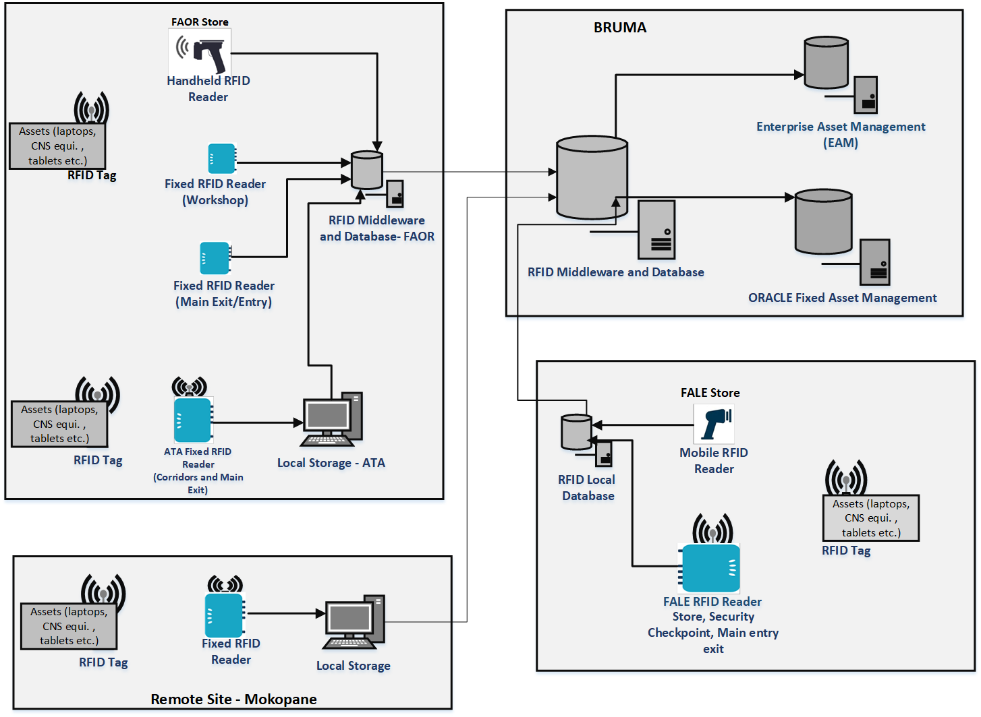
Figure 1: Architectural diagram

FAOR/ATA Installation
- For the pilot project, two (2) fixed RFID readers shall be installed at the FAOR technical workshop exit door and main entry/exit door to track all tagged assets and items that will be passing through the door as per figure 3.
- At ATA, one (1) fixed RFID reader shall be installed at the main entry/exit door and two (2) shall be installed at the corridors (Tugela and Room 116) as per figure 4.
- The fixed RFID reader will be transmitting RFID signal continuously with the coverage area and read passive RFID tags as soon as they pass through the reader,
- A handheld RFID reader will be used by FAOR Stores Assistants when issuing spares and for annual stock count for RFID-tagged spares.
- A local storage database shall be used to store and retrieve all asset data. The database shall be kept up-to-date with fixed asset register and enterprise asset management data.
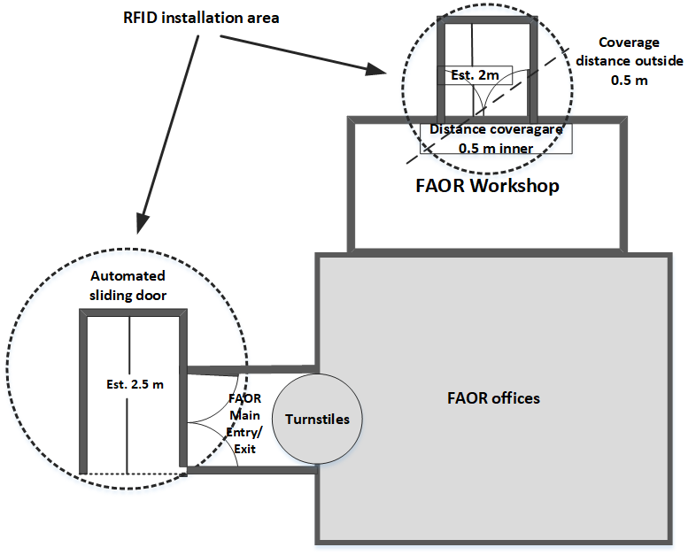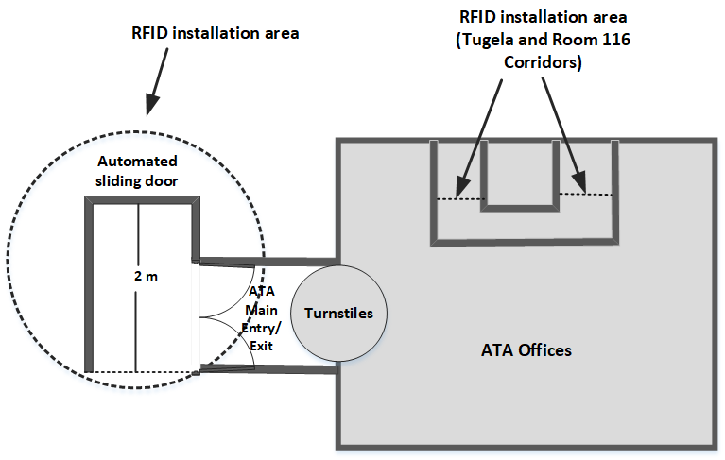
Figure 2: FAOR Installation Figure 3: ATA Installation

FALE Installation
- For the pilot project, one (1) fixed RFID reader shall be installed at the main entry/exit door, one (1) fixed reader shall be installed at stores, one(1) fixed reader shall be installed the security checkpoint to track all tagged assets and items that will be passing through the door.
- The fixed RFID reader installed at the security checkpoint shall be able to read assets that are inside the car.
- The fixed RFID reader will be transmitting RFID signal continuously with the coverage area and capture passive RFID tags as soon as they pass through the reader,
- A handheld RFID reader will be used by Stores Assistants when issuing spares and annual stock count for RFID tagged items.
- A local storage database shall be used to store and retrieve all asset data. The database shall be kept up-to-date with fixed asset register and enterprise asset management data.
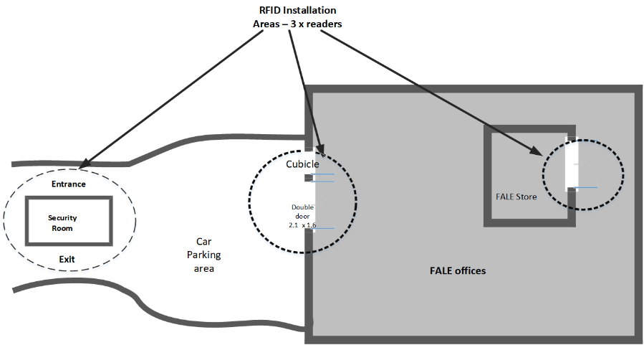
Figure 4: FALE Installation

Mokopane Remote station
- For the pilot project, a fixed RFID reader shall be installed at the main entry/exit door to track all tagged assets and items that will be passing through the door.
- The fixed RFID reader will be transmitting RFID signal continuously with the coverage area and capture passive RFID tags as soon as they pass through the reader,
- A local storage database shall be used to store and retrieve all asset data. The database shall be kept up-to-date with fixed asset register and enterprise asset management data.
- Data from the remote site will be configured such that the RFID tagging information is synchronized with the main database in Bruma. In the event that the network is not available, RFID tagging information shall be stored in the local database and shall update the main database in Bruma as soon as the network is available.

Bruma Installation
- The supplier shall provide the main RFID middleware and hardware required for the Bruma installation.
- The supplier shall ensure that the main RFID middleware shall integrate with the Enterprise Asset Management system.
- The supplier shall ensure that the main RFID middleware shall integrate with the Oracle Fixed Asset Management system.

Detailed SYSTEM REQUIREMENTS

General Requirements for the RFID pilot project

- The RFID system shall be installed at identified exits/points at FAOR, FALE, ATA and remote sites.
- The RFID system shall be configured to be able to track the movement of assets between identified locations.
- The RFID system shall be able to integrate with ORACLE fixed asset register and Enterprise Asset Management system

Functions and Capabilities Requirements

Core Functions

- The RFID system shall be able to track the movement of assets and update the location in the database for recordkeeping and reporting purposes.

System Functionality

      - RFID Reader requirements

- The RFD system shall include the ability to perform asset check-in/check-out functions using an RFID reader.
- The solution must include the ability to perform an inventory function using a portable handheld RFID reader.
- Handheld RFID readers must support 802.11 Wi-Fi standards and USB tethering for connection to the RFID software and the internal network.
- The recommended RFID hardware must support the use of the handheld RFID reader when it is not attached to the ATNS network, allowing the asset transaction to complete and submit the transaction data the next time the handheld device is attached to the ATNS network.
- The RFID system shall allow ATNS personnel to issue an asset using a handheld RFID reader.
- The RFID system shall allow the real-time stock update when the asset is tagged in/out of stores.
- The RFID reader shall only read RFID tags that are linked with ATNS assets.
- For ATA installation, the RFID reader shall send a signal to authorizing personnel when selected unauthorized assets are leaving the building.

      - RFID Tags Requirements

- The RFID system tags used for the assets shall be passive and only activated when there is an RFID reader in range.
- The RFID system shall provide tags that operate at a frequency of 860-960 MHz.
- The RFID system must provide re-writable RFID tags that will be able to store asset related data such as Purchase Order number, project Number, date procured, Date put into service etc.
- The RFID system tags must provide both security and inventory control functionality.
- The RFID system tags must use an anti-collision algorithm that does not limit the number of tags which can be simultaneously identified and read.
- The RFID system shall make provision for accommodating different types of tags i.e. Metallic and Non-metallic tags.
- The RFID System must support the replacement of failed RFID tags on existing assets.
- The RFID system shall be able to provide non-operation status when it is faulty or not working.
- The RFID system shall allow ATNS to print RFID tags in-house.
- The RFID tag shall be reprogrammable to allow for tag information update.

System Subsystems/Components

The following are the subcomponents of the RFID system:

- RFID Fixed Reader
- RFID antennas
- RFID Handheld reader
- RFID Tags
- RFID Printer for printing inlays
- RFID Middleware and database

Power requirements
- All hardware must run on standard power (220 V)
- All hardware shall run on UPS power.
- Any additional power requirements shall be specified for each item of the hardware.

Network and IT infrastructure requirements

- ATNS Network and IT security shall not be compromised by the addition of any RFID-enabled equipment. Supplier to specify what measures are in place to ensure this.
- ATNS CNS network infrastructure (airfield, Centre and Remote sites) shall not be compromised by the addition of any RFID enabled equipment. Frequency interference testing shall be performed during the pilot project.
- The supplier shall provide the hardware requirements for their proposed solution. State the specifications, recommended operating system, your access requirements and management responsibilities.
- The supplier shall state the anticipated lifespan of all hardware proposed and the details of the recommended maintenance programme shall be provided.
- The network and bandwidth requirements of the proposed RFID system shall be stated together with any prioritization recommended to maximize transaction speed and reliability.

Reliability and Availability
The RFID system shall have a high level of reliability and availability. The requirements will consist of the following items:
- Reliability: 95%
- Availability: 95%

Operating and Configuration Environment

- The RFID system hardware shall operate in a high-altitude environment
- The RFID system hardware shall operate in environments where there are different transmission signals. These transmission signals include but are not limed to microwave signals, VHF signals, UHF signals.

System Usage

- The system shall be used to track assets and for annual spares stock taking.

System Restrictions

- The system shall not operate within the following frequency range of CNS equipment listed in table 2.

System Interfaces
- The RFID system shall interface with the Enterprise Asset Management system for easier tagging and verification of assets during maintenance, issuing and inventory count.
- The RFID system shall be able to interface with ORACLE fixed asset register for updating the location of the tagged asset.

LOGISTIC Requirements

Training Requirements
- For pilot purposes, formal training of staff shall be required on the RFID system and provision must be made for at least three (3) technical maintenance personnel, Two (2) Stores assistant and one (1) financial accountant.
- The supplier shall indicate during the request for quotation (RFP) what the training prerequisites are for this trial purposes.
- The supplier shall, depending on the extent of the training, provide the training plan required for the trial project.

Software Training
- The software and hardware shall be installed and configured in such a way that after the system has been commissioned for pilot, there will be no frequent reliance on the service provider for the operation and maintenance of the system.
- Technical training is required to enable ATNS personnel to check and rectify the system parameter settings for the duration of the trial.

Spares Plan

- The supplier shall indicate what spares will be required to meet the required system availability for the duration of the trial.
- An itemized spares plan is required from the supplier. The plan is to be based on maintaining the required availability and reliability figures for the period of 12 months (Pilot period).

Software Licenses

- The supplier should indicate what software licenses will be required for the system for the duration of pilot.

Warrantee

- A Three-year period of warrantee starting at the date of site acceptance shall cover all repairs and replacements of hardware, as well as all corrections or modifications to software required for reasons of non-compliance with specifications or errors not detected during acceptance tests.
- System operation will be monitored and evaluated at set intervals during the warrantee period.
The supplier shall be committed to the evaluation process.
- The supplier shall indicate what support is offered during the warrantee period.

Testing and Verification
- A test and verification procedure will be required to illustrate that the system performs according to specifications.
- The report detailing the performance of the system shall be required after the pilot test period.

Support

- A support contract for software is required from the supplier during the piloting of the system.
- A proposal is required before the order is placed clearly detailing the present-day costs.

Installation and Transitioning

- Supplier shall supply, deliver, install, configure and provide training for RFID system as per requirement for the system.

Documentation
- All user manual documents will be required as part of this pilot project.

General and Project Requirements

- All hardware and software (including the operating system) required to make programming changes to the systems supplied shall be included with the system.
- Hard copies of all licenses shall be provided.
- The Supplier shall repair at no cost to ATNS, any equipment or structures damaged by the execution of their contract to its original condition.

DURATION
The project duration is estimated to be completed within the period of Twelve (12) months.

FORMAL BRIEFING
A compulsory briefing Session will be conducted virtually on Microsoft Teams on the 16 November 2022, at 11h00 for a period of ± 1 hours. Respondents who would have not attended the compulsory briefing session will be automatically disqualified.

EVALUATION CRITERIA AND METHODOLOGY

The evaluation of responsive quotations shall be conducted by the ATNS SCM and Engineering Projects following a three-stage process as follows:

The Evaluation of the RFQ:
Stage 1 | Pre-qualification Criteria
Stage 2 | Technical Functionality Evaluation
Stage 3 | Price and BBBEE

STAGE 1: PRE-QUALIFICATION CRITERIA

During this stage bids will be evaluated for the stipulated Pre-Qualification Criteria prescribed in Preferential Procurement Regulations. Only bids that meet Preferential Procurement requirements will be considered for further evaluation: In particular,

ATNS shall give preference to local EME or QSE B-BBEE suppliers with B-BBEE contribution level 1 to level 4.

STAGE 2: TECHNICAL FUNCTIONALITY EVALUATION
During this stage Bid response documentation will be evaluated against compliance to the Technical Specifications. The Functionality Evaluation is sub-divided into the following steps:
The bidder is encouraged to note that each requirement contains a certain weight according to its importance. The total sum of the weights is 100% and there is a set functional threshold of 80% that the bidder should meet to proceed to the next step of the adjudication process.
Criteria | Measurement | Weighting
- SERVICE PROVIDER ABILITY AND CAPABILITY | Demonstrate expertise & capacity to deliver on the objectives of the project. Provide the following documents:  - Project plan for the RFID Pilot/trial has been submitted (The project plan shall include scope breakdown, project timelines, risks, deliverables, and human resources)  No project plan provided- 0 points  Project plan provided but without all the required information or does not highlight the service provider’s understanding of the project- 10 points  Comprehensive project plan with all required information – 20 points | 20
- REFERENCE LETTERS | At least three (3) Signed Reference letters indicating that the supplier has done the supply, installation, commissioning and integration of RFID hardware and software. The reference letter shall be in the company’s letter head, signed, dated and with contactable reference.  No reference letter provided – 0 points  At least two (2) reference letters provided- 15 points  At least three (3) reference letters provided- 30 points | 30
- PERSONNEL EXPERIENCE AND KNOWLEDGE | - Bidders shall submit resumes and qualifications of suitably qualified and certified Software Development or Support personnel with 3 – 5 years’ experience.  No experience submitted- 0 point  One (1) to Two (2) years’ experience- 3 points Three (3) to Five (5) years’ experience- 5 points | 5
 | - Bidders shall submit a resume of suitably qualified and certified project manager with 3 – 5 years of experience.  No experience personnel submitted- 0 point  One (1) to Two (2) years’ experience- 3 points  Three (3) to Five (5) years’ experience- 5 points | 5
- SYSTEM FUNCTIONALITY | - The RFID system shall be able to track the movement of assets and update the location in the database for recordkeeping and reporting purposes. | 2
 | - The RFID system tags used for the assets shall be passive and only activated when there is an RFID reader in range. | 2
 | - The supplier shall state the anticipated lifespan of all hardware proposed and the details of the recommended maintenance programme shall be provided. | 3
 | - Handheld RFID readers must support 802.11 Wi-Fi standards and USB tethering for connection to the RFID software and the internal network. | 5
 | - The RFID system shall operate within 860 – 960 MHz frequencies. | 3
 | - The RFID system shall be able to integrate with ORACLE fixed asset register and Maintenance Management system (MMS) for asset location updating and data exchange.  No integration provided- 0 point  Only Oracle or MMS integration- 5 points  ORACLE and MMS integration- 10 points | 10
 | - The RFID system must run on the Microsoft platforms, preferably Windows OS (Server 2016 and above) and Windows SQL database (Server 2016 and above).  No Microsoft platform -0 points  Windows Operating system (2016 and above) – 5 points  SQL Database (2016 and above) or SQL Database – 10 points | 10
- TRAINING | - The OEM/Contractor/Supplier shall provide both basic and advanced training to a defined number of technical, stores and finance personnel. | 3
- LOGISTICS REQUIREMENTS | - The RFID system shall be configured in such a way that after the system has been commissioned, experienced or qualified computer programmers (coders) are not required for the operation and maintenance of the system | 2
TOTAL |  | 100
MINIMUM THRESHOLD |  | 80%
PRICING SCHEDULE
Items | Qty | Unit Price | Total
- RFID fixed Readers | 9
- RFID Handheld readers | 2
- RFID printer | 1
- Printable Non-metallic UHF RFID tags to stick on assets | 1000
- Printable On-Metallic UHF RFID tags to stick on assets | 1000
- Software  - Database  - Middleware  - Licences | 1
- Workstations for installing middleware and database | 5
- Integration
- Training Costs (All training costs to allow users to use/maintain/manage the system. This must be broken down by roles, if required.)
 |  | Total (excl.- VAT)
 |  | Total (Incl. VAT)

STAGE 4: PRICE AND B-BBEE:
Evaluation for Price and BBBEE

Quotations will be evaluated in terms of the ATNS’ Procurement Policies and Procedures using the 80:20 point system. 80 points will be awarded for price and 20 points for B-BBEE points claimed.

PRICE | 80
B-BBEE COMPLIANCE | 20

B-BBEE rating certificates are applicable and points allocated in terms of the B-BBEE Codes of Good Practice guideline as indicated in the table below. Bidders must submit valid B-BBEE Certificates and Statements which will be verified.

BBBEE Status Level of Contributor | Number of Points (80/20 System)
1 | 20
2 | 18
3 | 14
4 | 12
5 | 8
6 | 6
7 | 4
8 | 2
Non-compliant contributor | 0

ATNS shall evaluate suppliers in accordance with the B-BBEE Codes of Good Practice.

All responsive tender offers shall be evaluated in terms of functionality and scoring system for Price and B-BBEE. The 80/20 Point System shall be applicable in accordance with the ATNS’ Procurement Policies and Procedures.

CONTRACT TERMS
Whilst ATNS have taken every reasonable step to ensure the accuracy of this brief, the Company accepts no liability in relation to the accuracy of any representations made. Tenderer should accept that their tender response is on the basis and reliance of its own judgment and information. ATNS reserves the right to vary the scope and terms as described in this document. If any variation does take place tenderer will be advised as soon as possible in writing.

The successful tenderer will be engaged subject to acceptance of a contract containing the standard Terms and Conditions as given. The contract contains standard clauses including a retention clause for non-satisfactory completion, breach of contract and confidentiality clauses and a requirement for the tenderer to have adequate professional indemnity insurance. All Tenderers must bear in mind that if circumstances dictate, ATNS reserves its right to withdraw from any commitments that will be entered into within this statement of work.

All designs and documentation submitted by the tenderer will be treated as confidential.

ATNS reserves the right to reject, withdraw or cancel any or all Proposals/Tenders, to undertake discussions with one or more Tenderers and to accept that tender or modified tender which in its sole judgment, will be most advantageous to the Company, price and other evaluation factors having been considered.

PART A
INVITATION TO BID
YOU ARE HEREBY INVITED TO BID FOR REQUIREMENTS OF THE AIR TRAFFIC AND NAVIGATION SERVICES SOC Ltd
BID NUMBER: |  |  |  | CLOSING DATE: |  |  | CLOSING TIME:
DESCRIPTION
BID RESPONSE DOCUMENTS MAY BE DEPOSITED IN THE BID BOX SITUATED AT (STREET ADDRESS)
RFQ can be sent by email to: charlesS@atns.co.za or Hand Delivered at ATNS head Office:
Eastgate Office Park, South Boulevard
BIDDING PROCEDURE ENQUIRIES MAY BE DIRECTED TO |  |  |  |  | TECHNICAL ENQUIRIES MAY BE DIRECTED TO:
CONTACT PERSON |  |  |  |  | CONTACT PERSON
TELEPHONE NUMBER |  |  |  |  | TELEPHONE NUMBER
FACSIMILE NUMBER |  |  |  |  | FACSIMILE NUMBER
E-MAIL ADDRESS |  |  |  |  | E-MAIL ADDRESS
SUPPLIER INFORMATION
NAME OF BIDDER
POSTAL ADDRESS
STREET ADDRESS
TELEPHONE NUMBER |  | CODE |  |  |  | NUMBER
CELLPHONE NUMBER
FACSIMILE NUMBER |  | CODE |  |  |  | NUMBER
E-MAIL ADDRESS
VAT REGISTRATION NUMBER
SUPPLIER COMPLIANCE STATUS |  | TAX COMPLIANCE SYSTEM PIN: |  |  | OR | CENTRAL SUPPLIER DATABASE No: | MAAA
B-BBEE STATUS LEVEL VERIFICATION CERTIFICATE |  | TICK APPLICABLE BOX]  Yes No |  |  | B-BBEE STATUS LEVEL SWORN AFFIDAVIT |  |  | [TICK APPLICABLE BOX]  Yes No
[A B-BBEE STATUS LEVEL VERIFICATION CERTIFICATE/ SWORN AFFIDAVIT (FOR EMES & QSEs) MUST BE SUBMITTED IN ORDER TO QUALIFY FOR PREFERENCE POINTS FOR B-BBEE]
ARE YOU THE ACCREDITED REPRESENTATIVE IN SOUTH AFRICA FOR THE GOODS /SERVICES /WORKS OFFERED? |  | Yes No  [IF YES ENCLOSE PROOF] |  |  | ARE YOU A FOREIGN BASED SUPPLIER FOR THE GOODS /SERVICES /WORKS OFFERED? |  |  | Yes No  [IF YES, ANSWER THE QUESTIONNAIRE BELOW ]
QUESTIONNAIRE TO BIDDING FOREIGN SUPPLIERS
IS THE ENTITY A RESIDENT OF THE REPUBLIC OF SOUTH AFRICA (RSA)? YES NO
DOES THE ENTITY HAVE A BRANCH IN THE RSA? YES NO
DOES THE ENTITY HAVE A PERMANENT ESTABLISHMENT IN THE RSA? YES NO
DOES THE ENTITY HAVE ANY SOURCE OF INCOME IN THE RSA? YES NO
IS THE ENTITY LIABLE IN THE RSA FOR ANY FORM OF TAXATION? YES NO
IF THE ANSWER IS “NO” TO ALL OF THE ABOVE, THEN IT IS NOT A REQUIREMENT TO REGISTER FOR A TAX COMPLIANCE STATUS SYSTEM PIN CODE FROM THE SOUTH AFRICAN REVENUE SERVICE (SARS) AND IF NOT REGISTER AS PER 2.3 BELOW.

PART B
TERMS AND CONDITIONS FOR BIDDING
- BID SUBMISSION:
  - BIDS MUST BE DELIVERED BY THE STIPULATED TIME TO THE CORRECT ADDRESS. LATE BIDS WILL NOT BE ACCEPTED FOR CONSIDERATION.
  - ALL BIDS MUST BE SUBMITTED ON THE OFFICIAL FORMS PROVIDED–(NOT TO BE RE-TYPED) OR IN THE MANNER PRESCRIBED IN THE BID DOCUMENT.
  - THIS BID IS SUBJECT TO THE PREFERENTIAL PROCUREMENT POLICY FRAMEWORK ACT, 2000 AND THE PREFERENTIAL PROCUREMENT REGULATIONS, 2017, THE GENERAL CONDITIONS OF CONTRACT (GCC) AND, IF APPLICABLE, ANY OTHER SPECIAL CONDITIONS OF CONTRACT.
  - THE SUCCESSFUL BIDDER WILL BE REQUIRED TO FILL IN AND SIGN A WRITTEN CONTRACT FORM (SBD7).

- TAX COMPLIANCE REQUIREMENTS
- BIDDERS MUST ENSURE COMPLIANCE WITH THEIR TAX OBLIGATIONS.
- BIDDERS ARE REQUIRED TO SUBMIT THEIR UNIQUE PERSONAL IDENTIFICATION NUMBER (PIN) ISSUED BY SARS TO ENABLE THE ORGAN OF STATE TO VERIFY THE TAXPAYER’S PROFILE AND TAX STATUS.
- APPLICATION FOR TAX COMPLIANCE STATUS (TCS) PIN MAY BE MADE VIA E-FILING THROUGH THE SARS WEBSITE WWW.SARS.GOV.ZA.
- BIDDERS MAY ALSO SUBMIT A PRINTED TCS CERTIFICATE TOGETHER WITH THE BID.
- IN BIDS WHERE CONSORTIA / JOINT VENTURES / SUB-CONTRACTORS ARE INVOLVED, EACH PARTY MUST SUBMIT A SEPARATE TCS CERTIFICATE / PIN / CSD NUMBER.
- WHERE NO TCS PIN IS AVAILABLE BUT THE BIDDER IS REGISTERED ON THE CENTRAL SUPPLIER DATABASE (CSD), A CSD NUMBER MUST BE PROVIDED.
- NO BIDS WILL BE CONSIDERED FROM PERSONS IN THE SERVICE OF THE STATE, COMPANIES WITH DIRECTORS WHO ARE PERSONS IN THE SERVICE OF THE STATE, OR CLOSE CORPORATIONS WITH MEMBERS PERSONS IN THE SERVICE OF THE STATE.”

NB: FAILURE TO PROVIDE / OR COMPLY WITH ANY OF THE ABOVE PARTICULARS MAY RENDER THE BID INVALID.
SIGNATURE OF BIDDER: ……………………………………………
CAPACITY UNDER WHICH THIS BID IS SIGNED: ……………………………………………
(Proof of authority must be submitted e.g. company resolution)
DATE. …………………………………………..
- PROTECTION OF PERSONAL INFORMATION

  - The Service Provider shall ensure that its employees, representatives and officers, comply with the provisions of the Protection of Personal Information Act, 2013 (“POPIA”) and all other applicable data protection laws and, without limitation to the aforegoing, shall ensure the security and confidentiality of all Personal Information processed by that Party is in accordance with POPIA and all other applicable data protection laws.

  - The Service Provider must only process personal information of the Company and third parties on behalf of the Company, with the Company’s knowledge or authorisation, treat such information which comes to their knowledge as confidential and must not disclose it unless required by law or in the course of the proper performance of the Service Provider’s duties. The Service Provider must comply with the responsible party’s obligations in clause section 19 of POPIA.

  - Where the Service Provider, its agents, subcontractors, officers, directors, shareholders, representatives, or employees has/have access to any Personal Information held by the Company for any reason in connection with this Agreement or is/are supplied with or otherwise provided with Personal Information by the Company or on behalf of the Company for any purpose, or are supplied with or otherwise provided with Personal Information relating to the Services, the Service Provider shall:

    - process such Personal Information only for purposes of performing its/their obligations under this Agreement and shall not otherwise modify, amend or alter the contents of such Personal Information or disclose or permit the disclosure of such Personal Information to any third party, unless specifically authorised to do so by the Company or as required by law or any regulatory authority, and shall take all such steps as may be necessary to protect and safeguard such Personal Information.

    - without prejudice to the generality of the foregoing, ensure that appropriate, reasonable technical and organisational measures shall be taken by it/them to prevent –

      - the unauthorised or unlawful processing of such Personal Information; and
      - the accidental loss or destruction of, or damage to, such Personal Information; and
      - promptly notify the Company when it becomes aware of any unauthorised, unlawful or dishonest conduct or activities, or any breach of the terms of this Agreement relating to Personal Information.

  - The Service Provider shall be liable for all claims, demands, actions, costs, expenses (including but not limited to reasonable legal costs and disbursements), fines, losses and damages arising from or incurred by reason of any wrongful processing of any Personal Information by the Service Provider (including its agents, subcontractors, officers, representatives or employees) for any breach of its obligations or warranties in terms of clause.

  - Both Parties will comply with their obligations under POPIA in relation to personal information for which they are the responsible party.

  - The Service Provider must notify the Company immediately where there are reasonable grounds to believe that personal information has been accessed or acquired by any unauthorised person (Data Breach) and must assist the Company, at its own cost: a) with any investigation or notice to the Regulator or data subjects that the Company may make in relation to a Data Breach; and b) in responding to any directions by the Regulator to publicise the Data Breach, including assisting the Company to make public announcements if required.

  - The Service Provider indemnifies the Company against any civil or criminal action or administrative fine or other penalty or loss as a result of the Service Provider’s breach of this clause.

- POPIA CONSENT

  - The Service Provider, by submitting its proposal/ quotation, consents to the use of his/her personal information contained therein and confirms that:

    - The information is voluntarily supplied, without undue influence from any party; and
    - The information is necessary for the purposes of the engagement with ATNS.

  - The tenderer acknowledges that he /she is aware of his/her right to:

    - Access the information at any reasonable time for the purposes of rectification thereof.
    - Object to the processing of the information.
    - Lodge a complaint with the Information Regulator.

