REQUEST FOR QUOTE (RFQ)

REQUEST FOR QUOTATION FOR SUPPLY AND DELIVERY OF REFLECTOR JACKETS AT ATNS KING SHAKA INTERNATIONAL AIRPORT.
Date: | 02 November 2022
Department | ATNS: FALE
RFQ Number | ATNS/RFQ005/31/10/2022/2023 Reflector Jckets
Description of Goods/Service: | Please see below on page 4,5,and 6
Closing Date and Time: | 09 November 2022 @ 15h00pm
Expected delivery date | TBC with the appointed bidder.
Validity Period | 90 days from the closing date
Compulsory Requirements: | - B-BBEE Certificate  - Tax Pin  - CSD Report  - Banking Details with bank stamp  - ID copies of members/directors  - CK Documents  - Pricing Schedule/Quotation  - Signed and completed SBD Forms
Non Compulsory Briefing / Site Inspection | N/A
Description | REQUEST FOR QUOTATION FOR SUPPLY AND DELIVERY OF REFLECTOR JACKETS AT ATNS KING SHAKA INTERNATIONAL AIRPORT.
Quotation Delivery Address | Moletem@atns.co.za
Enquiries | Procurement Officer: Moletem@atns.co.za
The ATNS requests your quotation on the goods and/or services listed hereunder and/or on the available RFQ forms. Please furnish all information as requested and return your quotation on the date stipulated. Late and incomplete / missing documentations will invalidate the quotation submitted. Suppliers which are not registered on the government central supplier database will not be considered. ATNS is not obliged to accept the lowest or any submission received. ATNS reserves the rights to accept the whole or any portion of a quotation.

This RFQ will be evaluated on the basis of the 80:20-point system as stipulad in the Preferential Procurement Policy Framework Act (Act number 5 of 2000) & the ATNS’ Procurement Policies and Procedures.

BIDDING STRUCTURE
Indicate the type of Bidding/Biding Structure by marking with an ‘X’
Individual Bidder
Joint Venture
Consortium
With Sub-Contractors
Other

If Individual:
Name of Bidder
Registration Number
VAT Registration Number
Contact Person
Telephone Number
Fax Number
Cell Number(s)
E-mail Address
Postal Address
Physical Address

If Joint Venture or Consortium, indicate the name/s of the partners:
Company Name
Registration Number
VAT Registration Number
Contact Person
Telephone Number

E-mail Address
Fax Number
Postal Address
Physical Address

HAS AN VALID TAX CLEARANCE CERTIFICATE AND PIN BEEN SUBMITTED FOR CONSORTIUM, JOINT VENTURE AND/OR SUB CONTRACTORS
YES | NO

PLEASE INDICATE THE TYPE OF YOUR COMPANY E.G. PRIVATE COMPANY OR CLOSED CORPORATION OR OTHER
Indicate the Type of Company

SIGNATURE OF BIDDER:
………………………………………………………… DATE: ……………………

…………………………………………………………
CAPACITY UNDER WHICH THIS BID IS SIGNED:

- PURPOSE OF BID

REQUEST FOR QUOTATION FOR SUPPLY AND DELIVERY OF REFLECTOR JACEKTS AT ATNS KING SHAKA INTERNATIONAL AIRPORT.

- SCOPE OF WORK

The scope as indicated in this document includes, the supply and delivery of the following items;
- 10 REFLECTOR JACKETS

NB: For ease of reference of the product needed, see also Annexure A attached.
- Please pay attention to the specifications of the Reflector Jackets, as you should quote according to the product specification.
- The products sourced should be 100% local products.

ANNEXURE A: Specifications of the reflector jackets

STANDARD AND SPECIFICATION OF HIGH VISIBILITY REFLECTIVE JACKET

- The colour of the retro reflective jacket or tabard shall be lime green for normal operations and bright orange for Emergency Departments as per the EN471 colour match.
- The jacket or tabard shall have one reflective stripe vertically along the shoulders (similar to braces).
- The jacket or tabard shall have one reflective stripe horizontally cross the waist
- The company logo/name shall be embossed at the back of the jacket or tabard and be visible from a distance
- The logo / name shall be in black unless the corporate colours dictate otherwise
- Where required the designation of the person can be embossed at the bottom of the back of the jacket in black with an Arial font.
- The retro reflective garment shall conform to the EN471 standard Class 2 as a minimum requirement. The retro reflective strip shall be a while vinyl encapsulated high gloss 55mm wide certified tape and conform to EN471 Class 2 standards
- A high visibility day glow lime or orange (in the case of emergency personnel), colored fabric as required in the EN471 standard
- A retro-reflective shirt may be worn instead of the retro-reflective jacket. The standard as established for the retro-reflective garments shall be applicable. No other garment may be worn over this shirt • A second horizontal reflective stripe is optional.
- Front clear pocket on the left side for airside permit (added by the end-user)

PICTURE USED AS AN EXAMPLE

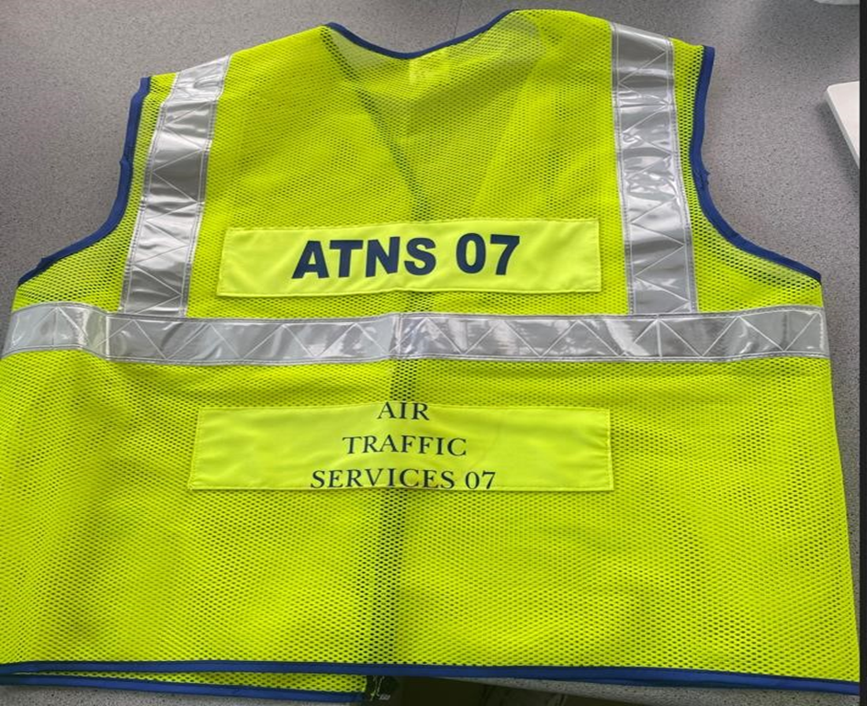

 | Size of reflector jackets
AIR TRAFFIC SERVICES 01 | Medium
AIR TRAFFIC SERVICES 02 | Medium
AIR TRAFFIC SERVICES 03 | Large
AIR TRAFFIC SERVICES 04 | Large
AIR TRAFFIC SERVICES 05 | X-Large
AIR TRAFFIC SERVICES 06 | XX-Large
ATNS VISITOR 01 | Medium
ATNS VISITOR 02 | Medium
ATNS VISITOR 03 | Large
ATNS VISITOR 04 | Large

NB: The supplier is to use the the below pricing template, but quote should be submitted in their company letterhead

ANNEXTURE B – COSTING TABLE

QUOTATIONS PROVIDED MUST HAVE THE FOLLOWING INFORMATION IN TABLE FORM

Item | Quantity | Unit Price | Total Price
Reflector Jackets | 10
Subtotal
VAT 15%
VAT Incl

Deliver Address:
ATNS Operations Complex
ATC Control tower
International Trade Avenue
King Shaka International Airport
Tongaat.
440

The Evaluation of the RFQ:

Stage 1 | Acquisition strategy (B-BBEE Level 1 to 4)
Stage 2 | Price and B-BBEE

- TECHNICAL REQUIREMENTS, PRICE AND PREFERENCE POINTS
- The First stage, bids will be evaluated first for Pre-Qualification Criteria (Preferential Procurement Requirements) prescribed in Preferential Procurement Regulations. Only bids that meet Preferential Procurement requirements will be considered for further evaluation.
- Preferential Procurement Reform:

The Preferential Procurement Regulations, 2011 pertaining to the Preferential Procurement Policy Framework Act, Act No 5 of 2003.
- Preferential Procurement in ATNS will be implemented in line with the PPPFA and its amended Regulations. Where feasible, pre-qualification criteria for preferential procurement or subcontracting will be set to advance certain designated groups which are EMEs or QSEs which are at least 51% black owned (in line with the PPPFA). Where not feasible to set preferential procurement as a pre-qualification criteria ATNS shall evaluate suppliers in accordance with the B-BBEE Codes of Good Practice.

- The Second and last Stage, bids will be evaluated in terms of the 80/20 preference point systems. Only bids that provide all documentation requested for Mandatory Requirements will be evaluated in accordance with the 80/20 preference point system.
Stage 1- Price/B-BBEE Evaluation.
- Tenderers will be evaluated in terms of the 80/20 preference point system, where a maximum of 80 points are allocated for price and a maximum of 20 points are allocated in respect of the level of B-BBEE contribution of the Tenderer.
- Points are allocated in terms of the BBBEE Codes of Good Practice guideline as indicated in the table below. Bidders must submit valid BBBEE Certificates which will be verified.

- Quotations will be evaluated in terms of Preferential Procurement Policy Framework Act using the 80:20 points system. 80 points will be awarded for price and 20 points for BEE points claimed.
Points for price | 80
Points for B-BBEE (Max of 20): | 20
B-BBEE status Level of Contributor | Number of Points  (80/20 system)
1 | 20
2 | 18
3 | 14
4 | 12
5 | 8
6 | 6
7 | 4
8 | 2
Non-Compliant contributor | 0
- SUBMISSION INSTRUCTIONS:

    - Potential service providers are requested to provide a quotation that addresses all the items listed in the specification section as stated above.

    - Failing to comply with the instruction will lead to bids being disqualified.

    - Each quotation should also include the following information:

- The expiration date for the Quotation, if any.
- Details of the contact person dealing with the quotation.
- CSD Summary Report.
- Black Economic Empowerment status of the service provider or legal identity of B-BBEE partner as well as the physical and postal address of the B-BBEE partner and capital structure.

Should it be necessary for a supplier to obtain clarity on any matter arising from or referred to in this RFQ document, please refer your enquiries, in writing, to the contact person(s) listed below. ATNS reserves the right to place responses to such queries on the website.

Procurement OFFICER: | Molete Makhutle
Telephone: | 011 607 1000
E-mail: | Moletem@atns.co.za

- SUBMISSION OF QUOTATION:

The RFQ Documents shall be delivered to the below:

Email to moletem@atns.co.za

PART A

INVITATION TO BID
YOU ARE HEREBY INVITED TO BID FOR REQUIREMENTS OF THE (NAME OF DEPARTMENT/ PUBLIC ENTITY)
BID NUMBER: |  |  |  | CLOSING DATE: |  | 07 November |  | CLOSING TIME: |  |  | 15:00
DESCRIPTION | REQUEST FOR QUOTATION FOR SUPPLY AND DELIVERY OF REFLECTOR JACKETS AT ATNS KING SHAKA INTERNATIONAL AIRPORT.
BID RESPONSE DOCUMENTS MAY BE DEPOSITED IN THE BID BOX SITUATED AT (STREET ADDRESS)
RFQ must be emailed to: molete@atns.co.za
BIDDING PROCEDURE ENQUIRIES MAY BE DIRECTED TO |  |  |  |  | TECHNICAL ENQUIRIES MAY BE DIRECTED TO:
CONTACT PERSON |  |  | Molete Makhutle |  | CONTACT PERSON
TELEPHONE NUMBER |  |  | 0116071000 |  | TELEPHONE NUMBER
FACSIMILE NUMBER |  |  |  |  | FACSIMILE NUMBER
E-MAIL ADDRESS |  |  | moletem@atns.co.za |  | E-MAIL ADDRESS
SUPPLIER INFORMATION
NAME OF BIDDER
POSTAL ADDRESS
STREET ADDRESS
TELEPHONE NUMBER |  | CODE |  |  |  | NUMBER
CELLPHONE NUMBER
FACSIMILE NUMBER |  | CODE |  |  |  | NUMBER
E-MAIL ADDRESS
VAT REGISTRATION NUMBER
SUPPLIER COMPLIANCE STATUS |  | TAX COMPLIANCE SYSTEM PIN: |  |  | OR |  | CENTRAL SUPPLIER DATABASE No: | MAA
B-BBEE STATUS LEVEL VERIFICATION CERTIFICATE |  | TICK APPLICABLE BOX]  Yes No |  |  | B-BBEE STATUS LEVEL SWORN AFFIDAVIT |  |  |  | [TICK APPLICABLE BOX]  Yes No
[A B-BBEE STATUS LEVEL VERIFICATION CERTIFICATE/ SWORN AFFIDAVIT (FOR EMES & QSEs) MUST BE SUBMITTED IN ORDER TO QUALIFY FOR PREFERENCE POINTS FOR B-BBEE]
- ARE YOU THE ACCREDITED REPRESENTATIVE IN SOUTH AFRICA FOR THE GOODS /SERVICES /WORKS OFFERED? |  | Yes No  [IF YES ENCLOSE PROOF] |  |  | - ARE YOU A FOREIGN BASED SUPPLIER FOR THE GOODS /SERVICES /WORKS OFFERED? |  |  |  | Yes No  [IF YES, ANSWER THE QUESTIONNAIRE BELOW ]
QUESTIONNAIRE TO BIDDING FOREIGN SUPPLIERS
IS THE ENTITY A RESIDENT OF THE REPUBLIC OF SOUTH AFRICA (RSA)? YES NO
DOES THE ENTITY HAVE A BRANCH IN THE RSA? YES NO
DOES THE ENTITY HAVE A PERMANENT ESTABLISHMENT IN THE RSA? YES NO
DOES THE ENTITY HAVE ANY SOURCE OF INCOME IN THE RSA? YES NO
IS THE ENTITY LIABLE IN THE RSA FOR ANY FORM OF TAXATION? YES NO
IF THE ANSWER IS “NO” TO ALL OF THE ABOVE, THEN IT IS NOT A REQUIREMENT TO REGISTER FOR A TAX COMPLIANCE STATUS SYSTEM PIN CODE FROM THE SOUTH AFRICAN REVENUE SERVICE (SARS) AND IF NOT REGISTER AS PER 2.3 BELOW.

PART B

TERMS AND CONDITIONS FOR BIDDING
- BID SUBMISSION:
  - BIDS MUST BE DELIVERED BY THE STIPULATED TIME TO THE CORRECT ADDRESS. LATE BIDS WILL NOT BE ACCEPTED FOR CONSIDERATION.
  - ALL BIDS MUST BE SUBMITTED ON THE OFFICIAL FORMS PROVIDED–(NOT TO BE RE-TYPED) OR IN THE MANNER PRESCRIBED IN THE BID DOCUMENT.
  - THIS BID IS SUBJECT TO THE PREFERENTIAL PROCUREMENT POLICY FRAMEWORK ACT, 2000 AND THE PREFERENTIAL PROCUREMENT REGULATIONS, 2017, THE GENERAL CONDITIONS OF CONTRACT (GCC) AND, IF APPLICABLE, ANY OTHER SPECIAL CONDITIONS OF CONTRACT.
  - THE SUCCESSFUL BIDDER WILL BE REQUIRED TO FILL IN AND SIGN A WRITTEN CONTRACT FORM (SBD7).

- TAX COMPLIANCE REQUIREMENTS
- BIDDERS MUST ENSURE COMPLIANCE WITH THEIR TAX OBLIGATIONS.
- BIDDERS ARE REQUIRED TO SUBMIT THEIR UNIQUE PERSONAL IDENTIFICATION NUMBER (PIN) ISSUED BY SARS TO ENABLE THE ORGAN OF STATE TO VERIFY THE TAXPAYER’S PROFILE AND TAX STATUS.
- APPLICATION FOR TAX COMPLIANCE STATUS (TCS) PIN MAY BE MADE VIA E-FILING THROUGH THE SARS WEBSITE WWW.SARS.GOV.ZA.
- BIDDERS MAY ALSO SUBMIT A PRINTED TCS CERTIFICATE TOGETHER WITH THE BID.
- IN BIDS WHERE CONSORTIA / JOINT VENTURES / SUB-CONTRACTORS ARE INVOLVED, EACH PARTY MUST SUBMIT A SEPARATE TCS CERTIFICATE / PIN / CSD NUMBER.
- WHERE NO TCS PIN IS AVAILABLE BUT THE BIDDER IS REGISTERED ON THE CENTRAL SUPPLIER DATABASE (CSD), A CSD NUMBER MUST BE PROVIDED.
- NO BIDS WILL BE CONSIDERED FROM PERSONS IN THE SERVICE OF THE STATE, COMPANIES WITH DIRECTORS WHO ARE PERSONS IN THE SERVICE OF THE STATE, OR CLOSE CORPORATIONS WITH MEMBERS PERSONS IN THE SERVICE OF THE STATE.”

NB: FAILURE TO PROVIDE / OR COMPLY WITH ANY OF THE ABOVE PARTICULARS MAY RENDER THE BID INVALID.

SIGNATURE OF BIDDER: ……………………………………………

CAPACITY UNDER WHICH THIS BID IS SIGNED: ……………………………………………
(Proof of authority must be submitted e.g. company resolution)

DATE: …………………………………………...

- PROTECTION OF PERSONAL INFORMATION

  - The Service Provider shall ensure that its employees, representatives and officers, comply with the provisions of the Protection of Personal Information Act, 2013 (“POPIA”) and all other applicable data protection laws and, without limitation to the aforegoing, shall ensure the security and confidentiality of all Personal Information processed by that Party is in accordance with POPIA and all other applicable data protection laws.

  - The Service Provider must only process personal information of the Company and third parties on behalf of the Company, with the Company’s knowledge or authorisation, treat such information which comes to their knowledge as confidential and must not disclose it unless required by law or in the course of the proper performance of the Service Provider’s duties. The Service Provider must comply with the responsible party’s obligations in clause section 19 of POPIA.

  - Where the Service Provider, its agents, subcontractors, officers, directors, shareholders, representatives, or employees has/have access to any Personal Information held by the Company for any reason in connection with this Agreement or is/are supplied with or otherwise provided with Personal Information by the Company or on behalf of the Company for any purpose, or are supplied with or otherwise provided with Personal Information relating to the Services, the Service Provider shall:

    - process such Personal Information only for purposes of performing its/their obligations under this Agreement and shall not otherwise modify, amend or alter the contents of such Personal Information or disclose or permit the disclosure of such Personal Information to any third party, unless specifically authorised to do so by the Company or as required by law or any regulatory authority, and shall take all such steps as may be necessary to protect and safeguard such Personal Information;
    - without prejudice to the generality of the foregoing, ensure that appropriate, reasonable technical and organisational measures shall be taken by it/them to prevent –

      - the unauthorised or unlawful processing of such Personal Information; and
      - the accidental loss or destruction of, or damage to, such Personal Information; and
      - promptly notify the Company when it becomes aware of any unauthorised, unlawful or dishonest conduct or activities, or any breach of the terms of this Agreement relating to Personal Information.

  - The Service Provider shall be liable for all claims, demands, actions, costs, expenses (including but not limited to reasonable legal costs and disbursements), fines, losses and damages arising from or incurred by reason of any wrongful processing of any Personal Information by the Service Provider (including its agents, subcontractors, officers, representatives or employees) for any breach of its obligations or warranties.

  - Both Parties will comply with their obligations under POPIA in relation to personal information for which they are the responsible party.

  - The Service Provider must notify the Company immediately where there are reasonable grounds to believe that personal information has been accessed or acquired by any unauthorised person (Data Breach) and must assist the Company, at its own cost: a) with any investigation or notice to the Regulator or data subjects that the Company may make in relation to a Data Breach; and b) in responding to any directions by the Regulator to publicise the Data Breach, including assisting the Company to make public announcements if required.

  - The Service Provider indemnifies the Company against any civil or criminal action or administrative fine or other penalty or loss as a result of the Service Provider’s breach of this clause.
POPIA CONSENT

  - The Service Provider, by submitting its proposal/ quotation, consents to the use of his/her personal information contained therein and confirms that:

    - The information is voluntarily supplied, without undue influence from any party; and
    - The information is necessary for the purposes of the engagement with ATNS.

  - The tenderer acknowledges that he /she is aware of his/her right to:

    - Access the information at any reasonable time for the purposes of rectification thereof;
    - Object to the processing of the information;
    - Lodge a compliant with the Information Regulator.

