TABLET SPECIFICATIONS

The supplier shall supply forty (40) tablets l. The tablet shall comply with the following specifications:

Item(s) | Specifications
Processor | Processor: Quad core, 1.83 GHz processing speed or better and 2MB cache or better
Operating system | Android
Internal Storage | Minimum 32 GB
RAM | 2 GB or better
Screen size | 10 inch or better
Resolution | 1920 x 1080 pixels or better
Keyboard | Detachable keyboard
Camera | - Front – Minimum 2 MP  Back – Minimum 5 MP
Support | USB, WiFi, HDMI and Bluetooth  audio and video
Battery | - Rechargeable battery,  up to 8 hours (8000 mAh) or better
SD card | Incorporate a Micro SD card slot
Connectivity | WIFI, 3G/4G/LTE
Mouse | wireless mouse
Software | Licensed Microsoft Office “Student Version”

MOBILE CHARGING UNIT

Tablets mobile charging trolley sync and charge

• Stores 40 tablets
• AC cooling fan
• Individual AC plugs for each tablet
• Heavy duty casters
• Double front and rear doors for easy access
• Well ventilated to keep units cool during charging

LAPTOP SPECIFICATIONS

The supplier shall provide two (2) laptops and that the laptops shall adhere to the following specifications:

Item(s) | Specifications
Processor | Minimum Core i5 Processor
Internal Storage | Minimum 500 GB
RAM | 4GB or better
Graphic Card: | at least 512 MB video memory
Display: 15 inch or higher | 15”or higher
 | Full HD (1920 x 1080 pixels) or better
Operating system | Windows 10 Pro
Application software | Licensed Microsoft Office suite
Wireless mouse | Yes
Carry bag | Yes

SERVER SPECIFICATIONS – C3 HYBRID

Item(s) | Specifications
Processor | Core i5
Storage | 2 TB
RAM | 4GB or more
Users | 300 Users
Wi-Fi Access Point bgn/ac | Yes - 2X External Antennas
External Mobile Interface | 3/4G
Ethernet WAN Interface | Yes - 1Gbps Ethernet
Battery backup | Optional
Educational content | - Learning Management System (Moodle)  - Offline Educational content  - Encyclopedia  - Dictionary
DBE Content | Primary or Secondary Department of Basic Education Content to be loaded on the server by the Service Provider
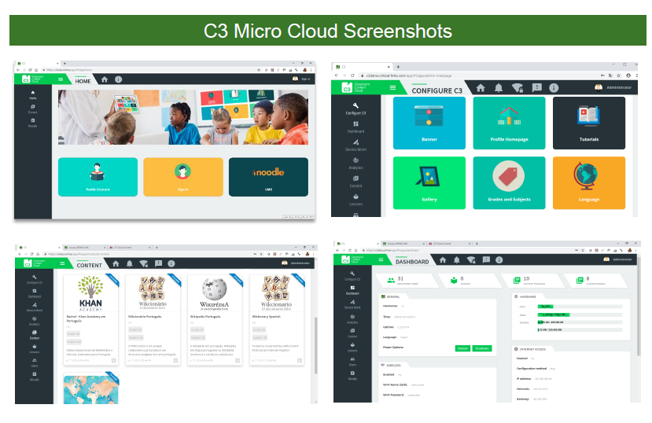
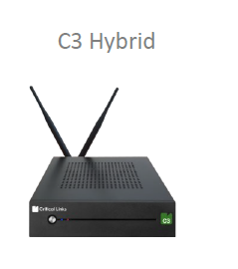
PRINTER SPECIFICATIONS

The supplier shall provide one (1) printer, with one (1) spare cartridge, and these printers shall adhere to the following specifications:

- Printing technology: laser
- Printing output type: monochrome
- Functions: copying, scanning and printing
- Printer speed: up to 30 ppm or better
- Copier speed: up to 30 ppm or better
- Scanning resolution: 1200 x 1200 dpi or better
- Processor: Minimum dual core or better
- Standard memory: 512 MB or higher
- Incorporate a PC connection

PROJECTOR SPECIFICATIONS

The supplier shall provide a one (1) projector, with one (1) wall mounted screen, and the projector shall adhere to the following specifications:

- Lumens: 3000
- Resolution: minimum 1920x1080 pixels
- Contrast ratio: minimum 1000:1
- Zoom ratio: minimum 1.5
- Interface: at least HDMI, USB and RS232

PROJECTOR SCREEN

HD projector screen with REMOTE for opening and closing which will accommodate the computer, video, slide, and overhead projection in the classroom.

- 65 Round Housing Case
- Matt White Fabric
- Fabric Thickness: 0.4mm
- Electronic Motor – 220 – 240 V AC
- Wired Remote for Control
- Black Framed and Black-Backed Screen.
- Screen size: 2366*1429mm

DOCUMENT CAMERA/VISUALIZER SPECIFICATIONS - ELPDC13
Image Pick-Up Device | 1/ 2,7 " CMOS sensor
Effective Pixels | 1920 Horizontal x 1080 Vertical
Frame Rate | Max. 30 fps
Optical | Zoom: Digital 16; Focus: Auto
Shooting area | A3 sized: 297 x 420 mm
Image Resolution output | SXGA(1280*1024)/XGA(1024*768)/WXGA 16:10 (1280*800)/WXGA 16:9 (1360*768)/1080p (1920*1080), 480p/ 720p/ 1080p
Image adjustments | Auto Exposure, Black and White, Brightness Adjustment, Contrast Adjustment, Image Rotation, Microscope mode
Connectivity interfaces | USB 1.1 Type B, VGA in, VGA out, HDMI out, built-in microphone, SD memory card, blank
PC-free image viewer | View images from internal or supported external memory
Image storage | SD/SDHC compatibility (128MB-32GB)
Features | Auto focus, Freeze, Parallel video output, SD card viewer, Split screen, Zoom
Security | Kensington lock, Security bar, Security cable hole
Power consumption | 13 Watt, 0,5 Watt (standby)
Product dimensions | Folded: 367 x 122 x 120 mm (Width x Depth x Height), Operating: 270 x 317 x 447 mm (Width x Depth x Height)
Illumination | LED lights
Included software | Easy Interactive Tools, TWAIN driver for Epson Document Camera (for Windows)

NB – INSTALLATION

Disclaimer: Where applicable, all software required by the various ICT equipment shall be installed by the supplier. All software shall be licensed at the cost of the supplier. Projector and screen to be mounted. Content server to be uploaded with the Department of Basic Educations (DBE) educational content.

