AIR TRAFFIC AND NAVIGATION SERVICES SOC. LTD

REPUBLIC OF SOUTH AFRICA

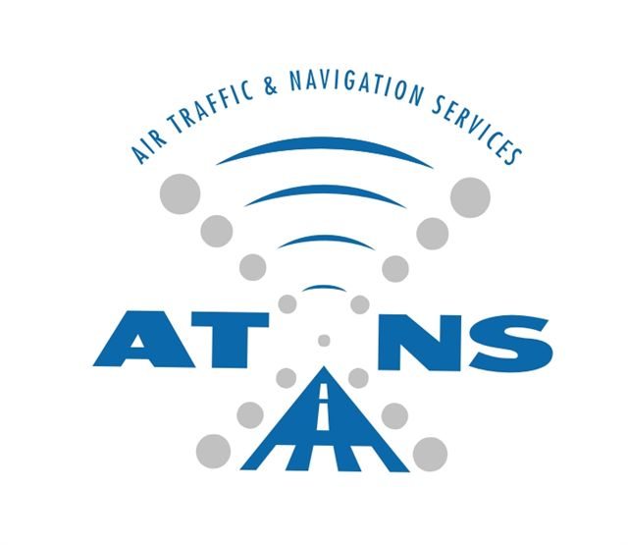

APPOINTMENT OF AN EXPERIENCED SECURITY SERVICE PROVIDER FOR SUPPLY AND INSTALLATION OF AN ELECTRONIC SECURITY SYSTEM, ALARM MONITORING AND ARMED RESPONSE AT THE ATNS AVIATION TRAINING ACADEMY.

REQUEST FOR PROPOSAL: ATNS/ATA/RFP024/FY22.23/ATA SECURITY SERVICES
APPENDIX B
BUILDING LAYOUT

JULY 2022

The information contained within this document is confidential to ATNS in all respects and it is hereby acknowledged that the information as provided shall only be used for the preparation of a response to this document. The information furnished will not be used for any other purpose than stated and that the information will not directly or indirectly, by agent, employee or representative, be disclosed either in whole or in part, to any other third party without the express written consent by the Company or it’s representative.

APPENDIX B

ATA building Layout
