AIR TRAFFIC AND NAVIGATION SERVICES SOC. LTD
REPUBLIC OF SOUTH AFRICA

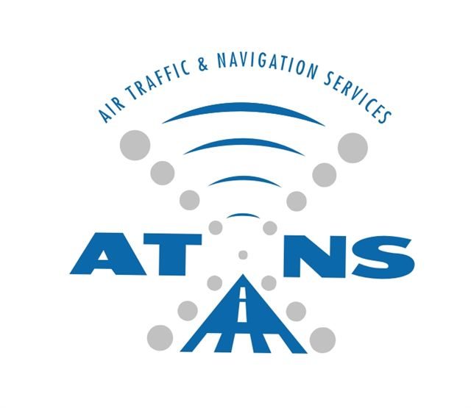

APPOINTMENT OF A SERVICE PROVIDER FOR SUPPLY, DELIVERY, INSTALLATION, TESTING AND COMMISSIONING OF AN AERONAUTICAL INFORMATION MANAGEMENT (AIM) SYSTEM

MANDATORY REQUIREMENTS

OCTOBER 2022

The information contained within this document is confidential to ATNS in all respects and it is hereby acknowledged that the information as provided shall only be used for the preparation of a response to this document. The information furnished will not be used for any other purpose than stated and that the information will not directly or indirectly, by agent, employee or representative, be disclosed either in whole or in part, to any other third party without the express written consent by the Company or its representative

GENERAL INSTRUCTIONS TO BIDDERS
The Bidder shall submit all responses, diagrams, project management documentation and drawings according to the GENERAL INFORMATION AND INSTRUCTIONS TO BIDDERS document and in the English language.
ALL RESPONSES TO THE REQUIREMENTS IN THIS DOCUMENT SHALL BE PROVIDED AS FOLLOWS:
BIDDERS SHALL RESPOND IN FULL TO EACH ITEM IN THE FORMAT PROVIDED AND REFERENCES (CHAPTER, SECTION, PAGE NUMBER, PARAGRAPH NUMBER) TO DOCUMENTS AND RELEVANT INFORMATION SUPPORTING THE RESPONSES SHALL BE INDICATED IN THE SPACE PROVIDED. THIS INFORMATION WILL BE THE ONLY RESPONSE USED FOR THE EVALUATION AND ASSESSMENT.
Responses, provided in the space allowed, that are not clear or inadequate or the lack thereof shall be interpreted as “Not Compliant” even though the compliance column is declared as “Comply” and/or the Bidder’s offer meets the requirement. Bidder’s shall ensure that each response correctly addresses the requirement stated. Responses not addressing the requirement of the specific paragraph shall be interpreted as “Not Compliant”.
Bidder’s shall declare compliance to each and every paragraph of this document in the column labelled “Compliance” as follows:
C: Fully Compliant = Pass;
NC: Non Compliant = Fail.

Bidder’s shall, for paragraphs declared “PC” or “NC”, include a statement as to the nature of the variation and may additionally supply supporting information in the space provided to demonstrate how the proposal meets the needs of ATNS.
For paragraphs marked “(M)”, indicates that the requirement is mandatory and proposals not compliant with the requirement shall be disqualified for further evaluation.

6.2.4 The manufacturer of the AIM System software must provide at least 2 (two) verifiable references for AIS-to-AIM operational projects of a comparable size (or larger) than that requested in this project; such references must specifically establish compliance with the AIXM 5.1 specification of the corresponding deliverables. (M)
COMPLIANCE (C/NC)
Responding with C/NC without substantiation will not be accepted.
[INSERT FULL RESPONSE FOR EVALUATION HERE]

[INSERT INDEXED REFERENCE TO ADDITIONAL INFORMATION HERE]

6.2.5 The system shall be setup to work as a hub at OR Tambo International Airport (FAOR) which should be extended to various South African international airports, and all operational regional airports and also expandable to neighbouring states. The bidder shall therefore provide at least one reference for an operational hub system they have deployed. (M)
COMPLIANCE (C/NC)
Responding with C/NC without substantiation will not be accepted.
[INSERT FULL RESPONSE FOR EVALUATION HERE]

[INSERT INDEXED REFERENCE TO ADDITIONAL INFORMATION HERE]

